**Pizza Shop**

**Contents**

**1.Introduction..........................................................................................................**8

Pizza Login Page................................ ................................................................8

Forgot Password...........................................................................................................10

Reset Your Password......................................................................................................11

**2. Super Admin Dashboard…………………………………………………………****…..12**

1. My Profile Icon...........................................................................................13

1.1 My Profile................................................................................................14

1.2 Change Password................................................................................14

1.3 LogOut.....................................................................................................15

2. Navigation Pane (Left Pane) .................................................................16

3. Tiles and Charts........................................................................................[16](bookmark://TilesAndCharts)

3.1 Total Orders Tile....................................................................

3.2 Total Customers Tile............................................................

3.3 Waiting List Count Tile.......................................................

3.4 New Customers Tile............................................................

3.5 Sales Figures Combination Chart....................................

3.6 Customer Growth Over The Year...................................

3.7 Waiting Tokens.......................................................................

3.8 Popular Food Category.......................................................

3.9 Top Selling and Least Selling Items.............................

**2.1 Users………………………………………….………………………………………****18**

Users List.…………………………………………………………...............................................

Add New User……………………………………………………………………………………………….19

Edit User..............................................................................................................23

Delete User...........................................................................................................25

**2.2. Roles and Permission……………………...…………………………………****27**

2.2.1. Role.………………………………………………………….........................................................

2.2.2 permissions…………………………………………………………………………………………………….

**2.3 Menu................................……………………...………………………………….****29**

2.3.1 Items>> Category............................................................................................................30

Add Category...........................................................................................................

Edit Category...........................................................................................................

Delete Category.....................................................................................................

2.3.2 Items>> Items................................................................................................................34

Add Item.....................................................................................................................

Edit Item.....................................................................................................................

Delete Item................................................................................................................

Delete Selected Item/Items................................................................................

2.3.3 Modifiers>>Modifier Group.........................................................................................40

Add Modifier Group...............................................................................................

Edit Modifier Group...............................................................................................

Delete Modifier Group..........................................................................................

2.3.4 Modifiers>>Modifier...........................................................................................................47

Add Modifier..............................................................................................................

Edit Modifier..............................................................................................................

Delete Modifier.........................................................................................................

Delete Selected Modifier/Modifiers..................................................................

**2.4. Tables And Sections.......................…………….…………………………………****52**

2.4.1 Sections.........................................................................................................................................54

Add Section..............................................................................................................

Edit Section...............................................................................................................

Delete Section..........................................................................................................

2.4.2 Tables.................................................................................................................................................58

Add Table..............................................................................................................

Edit Table...............................................................................................................

Delete Table..........................................................................................................

Delete Selected Table/Tables.......................................................................................

**2.5. Taxes And Fees………………......................……...……………………………….****62**

List of Taxes/Fees.…………………………………………………………....................................

Add Tax………………………………………………………………………………….........

Edit Tax………………………………………………………………………………….........

Delete Tax…………………………………………………………………………………....

**2.6. Orders...............................……………………...…………………………………****66**

Order List in the Orders Module in Super Admin Dashboard............................

**2.7. Customers...............................……………………...……………………………****70**

Steps to Create a Customer as an Account Manager................................................

Customer List in Super Admin Dashboard..................................................................

Customer History......................................................................................................

**3. Account Manager Dashboard……………………………………………………****74**

**1. My Profile Icon.........................................................................................****75**

1.1 My Profile................................................................................................76

1.2 Change Password................................................................................77

1.3 LogOut.....................................................................................................77

**2. Navigation Pane (Left Pane) .................................................................****78**

**3. Tiles and Charts........................................................................................****78**

3.1 Total Orders Tile....................................................................

3.2 Total Customers Tile............................................................

3.3 Waiting List Count Tile.......................................................

3.4 New Customers Tile............................................................

3.5 Sales Figures Combination Chart....................................

3.6 Customer Growth Over the Year...................................

3.7 Waiting Tokens.......................................................................

3.8 Popular Food Category.......................................................

3.9 Top Selling and Least Selling Items.............................

**3.1 Users………………………………………….………………………………………****80**

Users List.…………………………………………………………...............................................

Add New User……………………………………………………………………………………………….

Edit User..............................................................................................................

Delete User..........................................................................................................

**3.2 Menu................................……………………...………………………………………****84**

3.2.1 Items>> Category............................................................................................................85

Add Category...........................................................................................................

Edit Category...........................................................................................................

Delete Category.....................................................................................................

3.2.2 Items>> Items......................................................................................................................87

Add Item.....................................................................................................................

Edit Item.....................................................................................................................

Delete Item................................................................................................................

Delete Selected Item/Items.................................................................................

3.2.3 Modifiers>>Modifier Group..............................................................................................89

Add Modifier Group...............................................................................................

Edit Modifier Group...............................................................................................

Delete Modifier Group..........................................................................................

3.2.4 Modifiers>>Modifier...............................................................................................................90

Add Modifier..............................................................................................................

Edit Modifier..............................................................................................................

Delete Modifier.........................................................................................................

Delete Selected Modifier/Modifiers................................................................

**3.3. Tables And Section.......................……………...…………………………………****93**

**3**.3.1Sections.................................................................................................................................................93

Add Section..............................................................................................................

Edit Section...............................................................................................................

Delete Section..........................................................................................................

3.3.2Tables......................................................................................................................................................94

Add Table..............................................................................................................

Edit Table...............................................................................................................

Delete Table..........................................................................................................

Delete Selected Table/Tables........................................................................

**3.4. Taxes And Fees………………......................……...………………………………****96**

List of Taxes/Fees.…………………………………………………………....................................

Add Tax………………………………………………………………………………….........

Edit Tax………………………………………………………………………………….........

Delete Tax…………………………………………………………………………………....

**3.5. Orders...............................……………………...…………………………………****100**

Order List in the Orders Module in Super Admin Dashboard............................

**3.6. Customers...............................……………………...……………………………****103**

Steps to Create a Customer as an Account Manager................................................

Customer List in Super Admin Dashboard..................................................................

Customer History......................................................................................................

**3.7. Order App..............................……………………...…………………………………**106

**3.7.1 Table module in order app……………………………………………………………………………**

List Of Tables as per the Sections**............................................................................**

Table Assignment.....................................................................................................

Table Merging..........................................................................................................

Waiting Token..........................................................................................................

**3.7.2 Menu module in order app**………………………………………………………………….115

Table Section.....................................................................

QR Code ............................................................................

Customer Details................................................................

Order Wise Comment.......................................................

Items..................................................................................

Sub Total........................................................................

Total................................................................................

Save.................................................................................

Complete..........................................................................

**3.7.3 Waiting List menu in order app........................................................................**130

Waiting List.........................................................................

Adding Customers to the Waiting List/Creating the waiting token...

Edit Customers details to the Waiting List/Editing the waiting token...

Delete the waiting token..........................................................................

Assigning a Table to a Customer with a Generated Waiting Token .........

3.7.4 KOT in order app……………………………………………………………………………….136

**4. Chef Dashboard...............................................................................................................**141

4.1 KOT.......................................................................................................................................141

**1. Introduction**

The Pizza Shop is designed to streamline and automate various restaurant management processes, including user management, table/section management, menu customization, role-based access control, tax and fee handling, inventory tracking, and order processing. It also features a comprehensive dashboard tailored for different roles, such as the super admin, chef, and Account Manager, allowing for efficient oversight and decision-making.

Pizza Shop aims to support the daily operations of the restaurant through multiple interconnected modules. It enhances both front-end and back-end management by providing specialized interfaces for different roles and their corresponding tasks. The Pizza Shop is designed to centralize the management of restaurant operations, making it more efficient and reducing the potential for human error.

**Pizza Shop login page:**

**Description:**

This page will appear when the user lands on the platform. This page will have a banner on the left side and login section on the right side.–

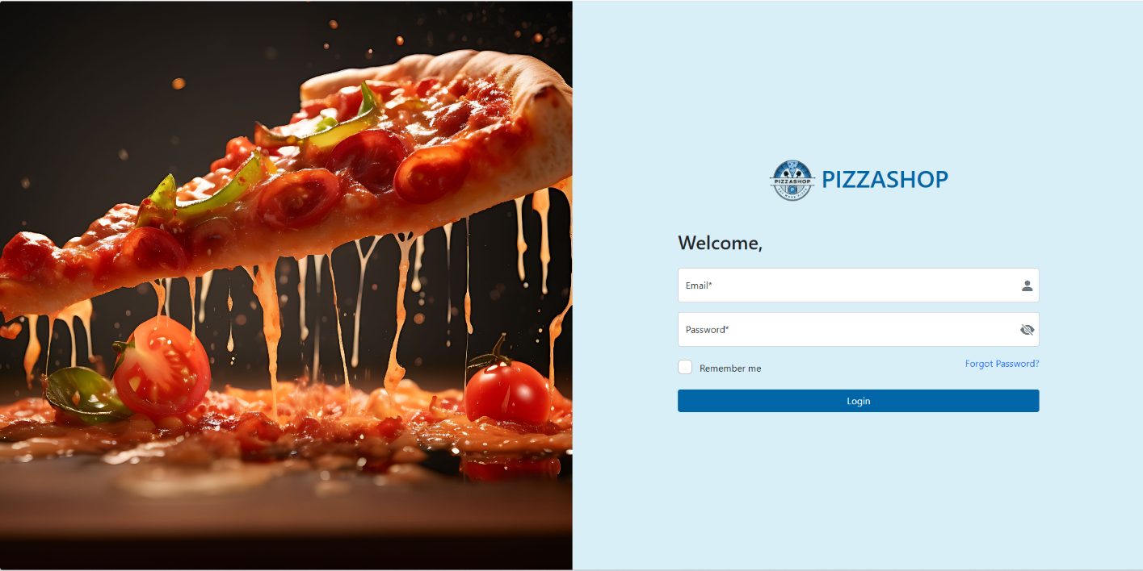Fig. Pizza Shop Login Page

Users can login to the Platform using their email address and password.

**Features: -**

|  |  |  |  |
| --- | --- | --- | --- |
| **#** | **Features** | **Type** | **Description** |
| 1. | E-Mail | Input | Users will enter his/her E-Mail address in this text box. |
| 2. | Password | Input | Users will enter their password in this text box. |
| 3. | Remember Me | Check Box | Allows the user to stay signed in on the device. When checked, the user's session will remain active even after closing the browser, reducing the need to log in repeatedly. |
| 4. | Login | Button | After entering the correct email address and password, clicking on this button will allow the user to sign into the platform. |
| 5. | Forgot Password | Link | If a User Forgets his/her password, he or she must select “Forgot password?” |

**Authentication Mechanism**

* The system shall authenticate users by verifying their credentials (username and password) against stored records.
* Authentication shall be implemented using **JWT (JSON Web Token)** to ensure stateless and secure communication between the client and the server.

**Validation for** Pizza Shop Login Page: -

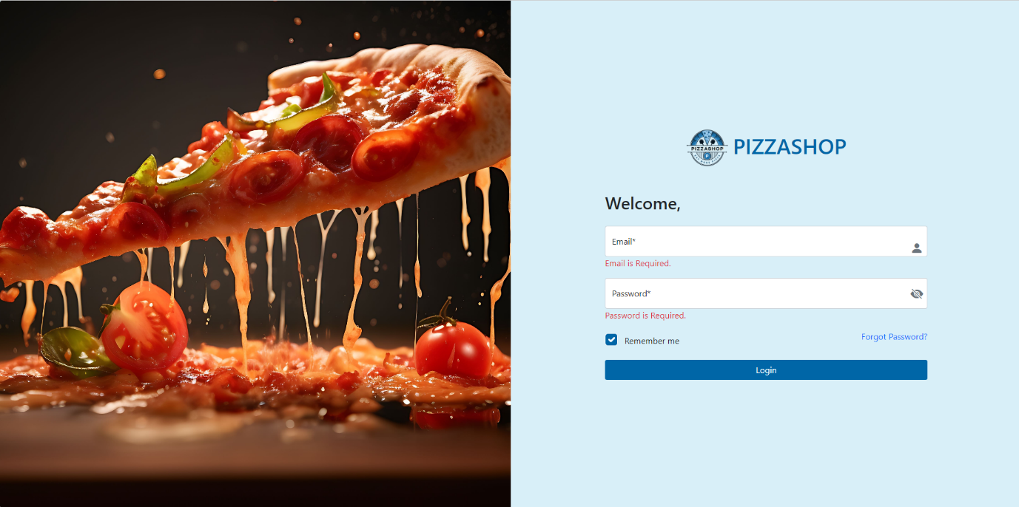Fig.Validation For Pizza Shop LogIn Page

**Validation Rules:**

1. If the **Email** field is left empty and the **Login** button is clicked, the system must display the error message: **"Email is required."**
2. If the **Password** field is left empty and the **Login** button is clicked, the system must display the error message: **"Password is required."**
3. Error messages must appear directly below their respective fields in red text.
4. The system prevents form submission until all required fields are filled.

**Note: - Remember Me option will be available for 30 days.**

**Forgot Password**

**Description**:

Users who have forgotten their password may request it by entering their email address. The system will check their email address existence, if it exists then reset password link will be sent to their email address. Reset password link will expire in 24 hours.

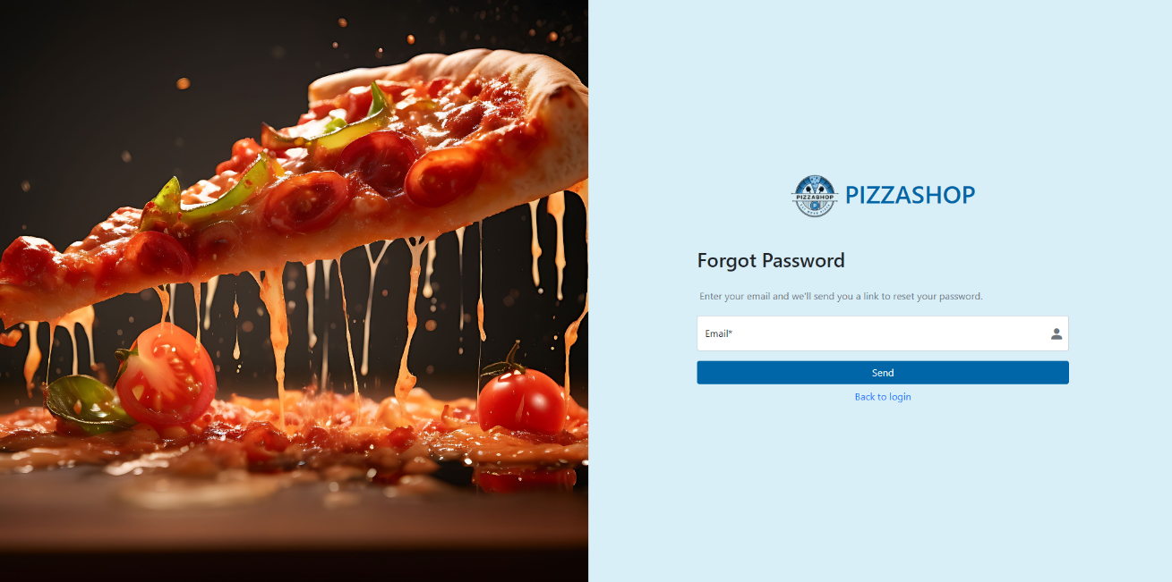

Fig. Forgot Password

**Features:**

|  |  |  |  |
| --- | --- | --- | --- |
| **#** | **Features** | **Type** | **Description** |
| 1. | E-Mail | Input | Users will enter his/her E-Mail address in this Text box. |
| 2. | Send | Button | Clicking on this button, the system will check if the email address entered exists or not in the platform. If it exists, then a Reset Password link will be sent to this email address. |
| 3. | Back to Login | Link | Clicking on this link will redirect the user back to the login page. |

**Note: -** When an email is entered during login and the user clicks on "Forgot Password," the email should be auto-populated on the "Forgot Password" page.

**Reset Password Link**: - Reset password link will be sent to their email address, for example as in the below image.

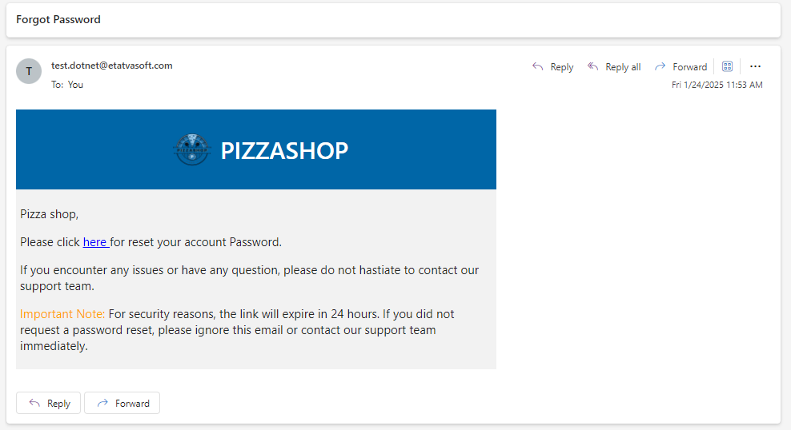

Fig. Reset Password Link sent in email

**When the user clicks on the here it will be redirected to the Reset Your Password Page.**

**Reset Your Password**

**Description:**

Users will receive a link for this page via email when requested through forgot password page. When Page is loaded Link will be checked for expiration. After clicking on the link, the user will be redirected to the below page.

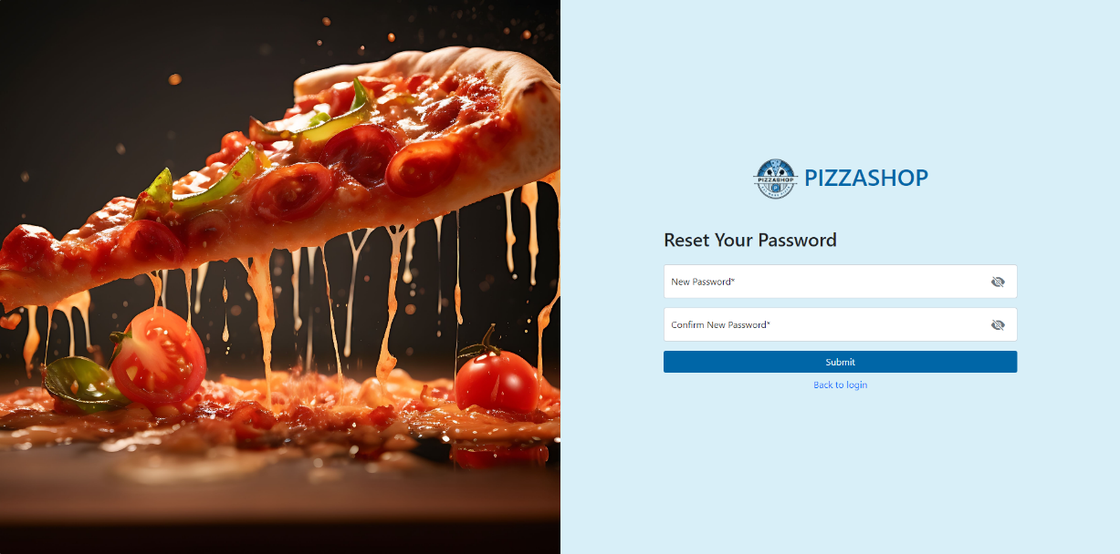

Fig. Reset Your Password

**Features:**

|  |  |  |  |
| --- | --- | --- | --- |
| **#** | **Features** | **Type** | **Description** |
| 1. | New Password | TextBox | Allows the user to enter a new password. Includes an eye icon to toggle password visibility. |
| 2. | Confirm New Password | TextBox | Allows the user to re-enter the new password for confirmation. Includes an eye icon to toggle password visibility |
| 3. | Submit | Button | Submits the new password for validation and updates the user's password upon success. |
| 4. | Back to login | Hyperlink | Redirects the user back to the login page. |

2. Super Admin Dashboard

**Description**:

Once the login is successfully completed, the admin will be automatically directed to the landing page. The admin dashboard in the Restaurant Management System is designed to provide restaurant administrators with powerful tools for managing daily operations effectively. By offering comprehensive functionality and a user-friendly interface, it empowers admins to make informed decisions that enhance the overall efficiency and profitability of the restaurant.

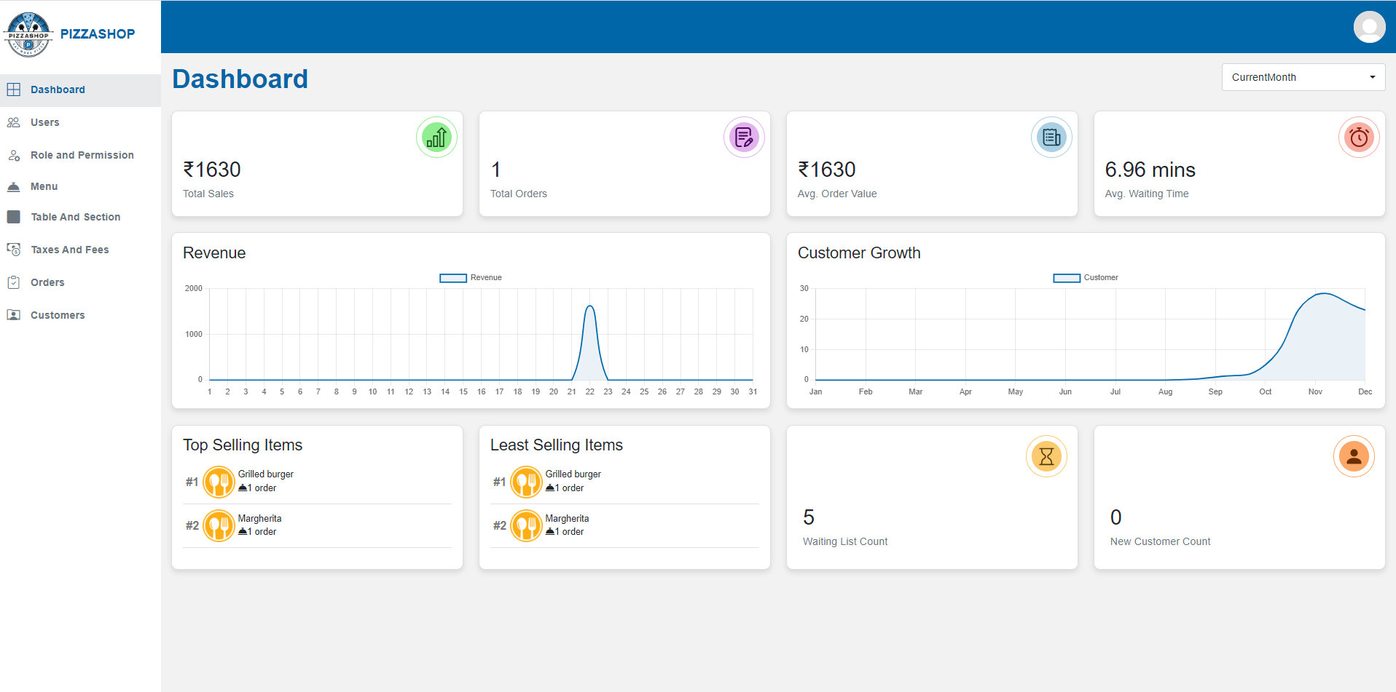Fig. Super Admin Dashboard

**Features of Super Admin Dashboard**

**1. My Profile Icon (My Profile)**

**Description:**

This section describes the functionality associated with the user profile icon in the navigation bar of the Pizza Shop. When a user clicks on the profile icon, a popup will display with username and the three clickable options: "My Profile", "Change Password" and "Logout."

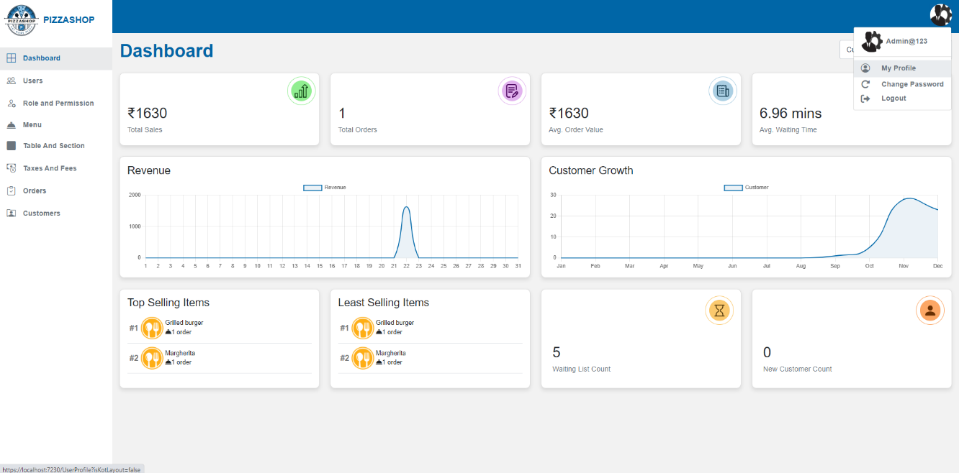

Fig. My Profile popup

**1.1 My Profile**: Redirects to the user's profile page.

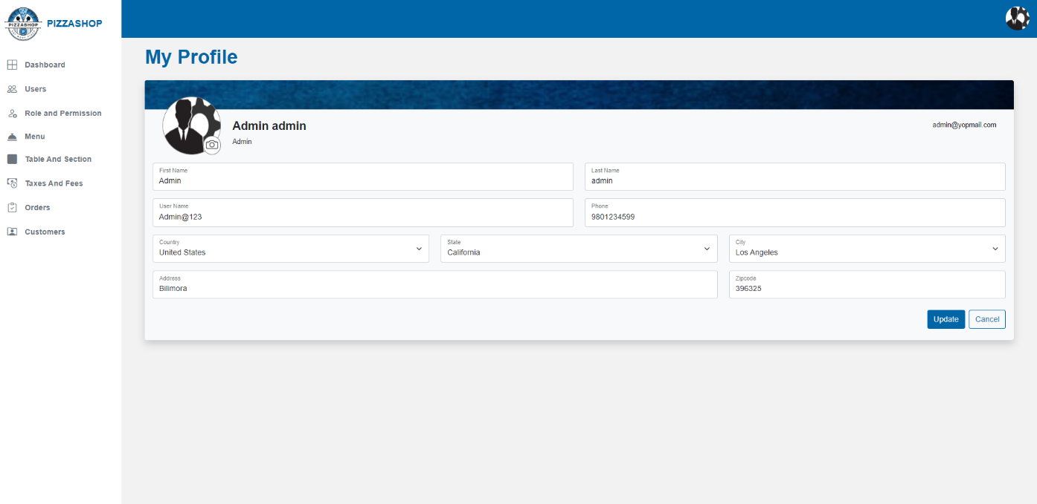Fig. My Profile

**Features:**

|  |  |  |  |
| --- | --- | --- | --- |
| **#** | **Feature** | **Type** | Description |
| 1. | First Name | Textbox | This will show first-name of the user. |
| 2. | Last Name | Textbox | This will show the last name of the user. |
| 3. | Username | Textbox | This will show the Username of the logged in user. |
| 4. | Phone | Textbox | This will show the phone number of the user. |
| 5. | Country | Textbox | It will show the country of the user. |
| 6. | State | Textbox | It will show the state of the user. |
| 7. | City | Textbox | It will show the city of the user. |
| 8. | Address | Textbox | It will show the first line of address. |
| 9. | Zip Code | Textbox | It will show zip code associated with the user address. |
| 10. | Update | Button | Updates the user’s profile. |
| 11. | Cancel | Button | Closes my profile page. |

**1.2 Change Password:** Redirects to the change password page.

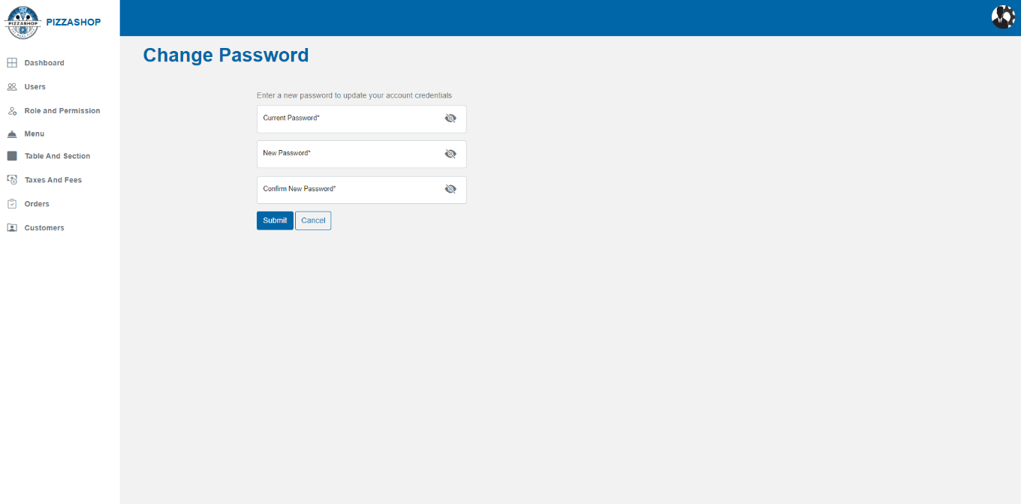 Fig. Change Password

**Features:**

|  |  |  |  |
| --- | --- | --- | --- |
| **#** | **Feature** | **Type** | **Description** |
| 1. | Current Password | Textbox | This will show the current password. |
| 2. | New Password | Textbox | This will show the new password. |
| 3. | Confirm New Password | Textbox | This will show the confirm new password. |
| 4. | Submit | Button | This will update the new password. |
| 5. | Cancel | Button | This will close the change password page. |

**Note: -** After entering the new password and clicking on **Submit**, the user's password will be updated, and they will be redirected to the **Login** page.

**1.3 Logout:** Logs the user out of the system and redirects to the login page.

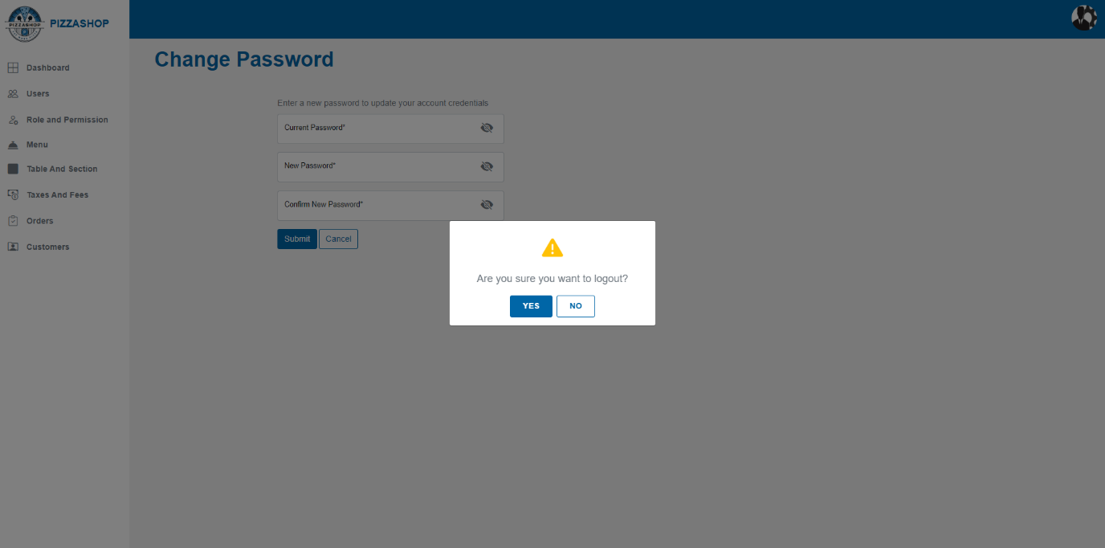Fig. Logout

|  |  |  |  |
| --- | --- | --- | --- |
| **#** | **Feature** | **Type** | **Description** |
| 1. | Confirmation box | Confirmation box | This will ask, “Are you sure you want to logout?”. |
| 2. | Yes | Textbox | This will log the user out and redirect the user to the Pizza Shop Log in Page. |
| 3. | No | Button | This will close the confirmation box, and user will remain Logged in. |

**2. Navigation Pane (Left Pane)**:

The navigation pane is located on the left side of the screen and provides quick access to various modules within the system. Each menu item in this pane leads to a specific page:

## **Features:**

|  |  |  |  |
| --- | --- | --- | --- |
| **#** | **Feature** | **Type** | **Description** |
| 1. | Dashboard | Hyperlink | Opens the main dashboard, displaying an overview of key metrics and system activity using tiles and charts. |
| 2. | Users | Hyperlink | Navigates to the **Users** page, where the admin can view, add, edit, or delete users. |
| 3. | Role and Permission | Hyperlink | Leads to the Roles page, allowing the admin to manage access levels for different user roles. |
| 4. | Menu | Hyperlink | Opens the **Menu** page, allowing the admin to add, edit, or delete menu items/category/modifier group/modifier. |
| 5. | Taxes and Fees | Hyperlink | Opens the Taxes/Fees page, where applicable taxes and fees can be added, edit and delete by the admin. |
| 6. | Tables and Sections | Hyperlink | Directs to the **Sections/Tables** page, where the admin can view, add, update, delete and search the tables and sections. |
| 7. | Orders | Hyperlink | Brings the user to the **Orders** page, displaying all current and past orders with options for order management. |
| 8. | Customers | Hyperlink | Opens the **Customers** page, where customer information can be viewed and managed. |

**3. Tiles and Charts**

**Description:**

The **Super Admin Dashboard** provides a quick, high-level overview of the key metrics in the Pizza Shop. Each tile on the dashboard represents a different metric that helps the Super Admin monitor customer activity, demand, and order statistics effectively. This dashboard enables the Super Admin to monitor restaurant operations, customer activity, and trends at a glance.

## **Features:**

|  |  |  |  |
| --- | --- | --- | --- |
| **#** | **Feature** | **Type** | **Description** |
| 1. | Total sales | Tile | This feature calculates and displays the total revenue generated by the restaurant for a given period (today, Last 7 days, Last 30 days, Current Month or a custom date). |
| 2. | Total Orders | Tile | * Displays the total number of orders placed in the Pizza Shop. Show total orders for today, Last 7 days, Last 30 days, Current Month or a custom date as per the options selected from the dropdown. * Update automatically as new orders are placed. |
| 3. | Avg. Order Value | Tile | * This feature calculates and displays the average value of orders placed within a specific time frame (Today, Last 7 days, Last 30 days, Current Month or a custom date). |
| 4. | Avg. Waiting Time | Tile | * This feature calculates and displays the average waiting time for customers from the time an order is placed until it is served. |
| 5. | Revenue | Chart | * The Revenue chart displays the restaurant's total revenue trends over a selected period, helping the management analyse financial performance. * The system shall plot revenue trends over time (Today, Last 7 days, Last 30 days, Current Month or a custom date). * The system shall fetch and display the total revenue data from the database based on selected time intervals. |
| 6. | Customer Growth | Chart | * The Customer Growth chart visualizes the growth in the number of customers over a specific time frame, enabling the management to track customer acquisition and retention. * The system shall plot the number of unique customers visiting the restaurant over time. |
| 7. | Top Selling and Least Selling Items List | List | * Two lists show the top-selling and least-selling items based on order frequency over a selected period (today, Last 7 days, Last 30 days, Current Month or a custom date). * Display two separate lists showing the food items with the highest and lowest demand. |
| 8. | Waiting List Count | Tile | * Shows the current number of customers in the waiting list. Display the count of active waiting tokens for tables as per the option selected from dropdown like today, Last 7 days, Last 30 days, Current Month or a custom date as per the options selected from the dropdown. * Update in real-time as customers are added to or removed from the waiting list. |
| 9. | New Customers | Tile | * Show the count of first-time visitors. * Filter by time (today, Last 7 days, Last 30 days, Current Month or a custom date) to view new customer growth trends. * Update automatically as new customer profiles are created. |

**2.1 User**

**Description: -**

This User module is a part of an Admin Dashboard designed to manage various aspects of the application, including user management.

This module will allow Super Admin to manage users effectively through functionalities such as searching, adding, editing, and deleting user accounts.

**Note: - 1. Super Admin can create User as per different role such as Super Admin, Chef, Account Manager.**

**2. We can have N number of super admins. Super admin cannot be deleted by anyone. Can only be deleted from database directly but the other admin can be added and deleted by super admin.**

**Users List:** Here is list of all active/inactive users.

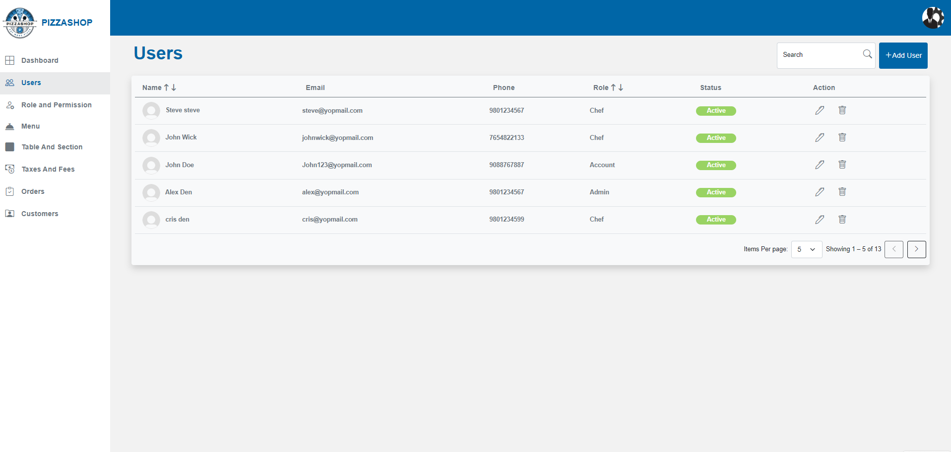Fig. Users List

## **Features of user list:**

|  |  |  |  |
| --- | --- | --- | --- |
| **#** | **Feature** | **Type** | **Description** |
| 1. | Search | Textbox | Admin can search for a specific user by username. |
| 2. | Add User | Button | By clicking on this, Add New User page will appear on the screen and admin can create new user from **Add New User** Page. |
| 3. | Name | Text | This column will show the user’s name. |
| 4. | Email | Text | This column will show the user’s email. |
| 5. | Phone | Text | This column will show the user’s phone number. |
| 6. | Role | Text | This column will show the user’s role. |
| 7. | Status | Text | This column will show the user’s status: Active, Inactive.When creating a user, the system shall allow assigning the user's status as either:   * **Active** * **Inactive**   If a user's status is set to **Inactive** during creation, the system shall prevent the user from logging into the Pizza Shop platform. |
| 8. | Action | Button | This column contains two Icons edit, delete. |
| 9. | Sorting | Dropdown/Clickable Column Headers | Admin can sort users by Name and Role in ascending or descending order. Sorting is implemented server-side, ensuring efficient performance even with large datasets. |
| 10. | Pagination | Dropdown & Navigation Buttons | Admin can select the number of items displayed per page (5, 10, 15). Navigation buttons allow switching between pages. Pagination is managed server-side to handle large datasets effectively. |

**Add New User:**

Super Admin can create User as per different role such as Super Admin, Chef, Account Manager. By clicking on the **Add User** button, the Add New User page will appear on the screen.

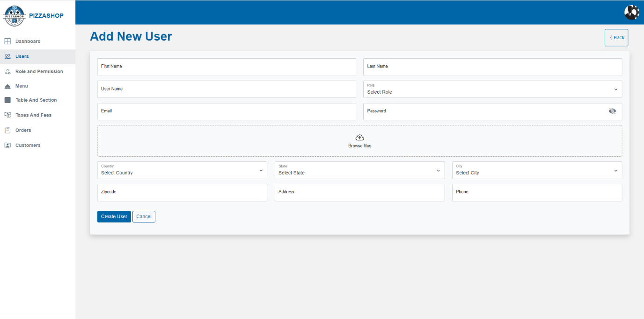Fig. Add New User

## **Features of New User**:

|  |  |  |  |
| --- | --- | --- | --- |
| **#** | **Feature** | **Type** | **Description** |
| 1. | First Name | Textbox | This will show first-name of the user. |
| 2. | Last Name | Textbox | This will show the last name of the user. |
| 3. | Username | Textbox | This will show the Username of the logged in user. |
| 4. | Role | Dropdown | This will show the role of the user. Role dropdown dynamically display the roles that are hierarchy lower than the current logged-in user.  Note: - There are three roles - admin, account manager, chef.  Roles are Predefined in database no screen to add roles. |
| 5. | Email | Textbox | This will show the email of the user. |
| 6. | Password | Textbox | Users can reset their password using this field. |
| 7. | Upload profile image | Button | Click on this button to upload an image. |
| 8. | Country | Dropdown | It will show the country of the user. |
| 9. | State | Dropdown | It will show the state of the user. |
| 10 | City | Dropdown | It will show the city of the user. |
| 11 | Address | Textbox | It will show first line of Address. |
| 12 | Zipcode | Textbox | It will show Zip code associated with user address. |
| 13 | Address | Textbox | It will show the address of the user. |
| 14 | Phone | Textbox | This will show the phone number of the user. |
| 15 | Create User | Button | By clicking on this it validates the input fields to ensure all required fields are filled and correctly formatted. If validation passes, the new user will be created in the system. Display a confirmation message indicating that the “User added successfully.” |
| 16 | Cancel | Button | Discard any changes made in the form. Close the form and return the administrator to the user listing page without making any changes. |
| 17 | Back | Button | It will redirect to the “Users "page. |

Once New user is created, email will send to user email address with password. At first login user must change their password because it is mandatory.

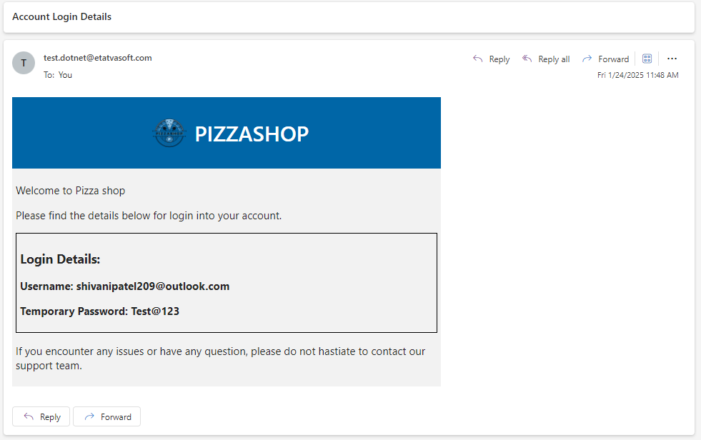

Fig. outlook mail Account

Note: -

1. If the user selects a state before selecting a country or selects the city before selecting the state and country, a validation message should appear on the screen stating, 'Please select country first,' as shown in the image below.

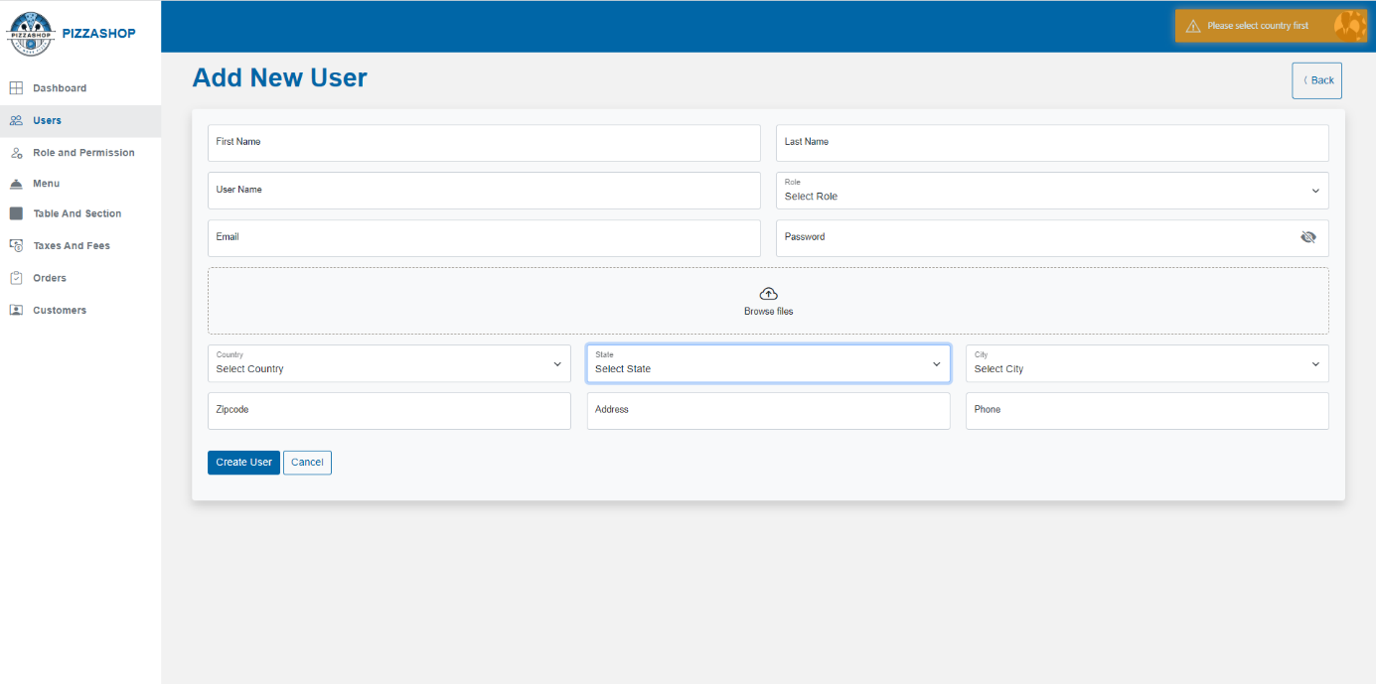Fig. Country, State, City validation

2. If the user selects a city before selecting a state, a validation message should appear on the screen stating, 'Please select state first,' as shown in the image below.

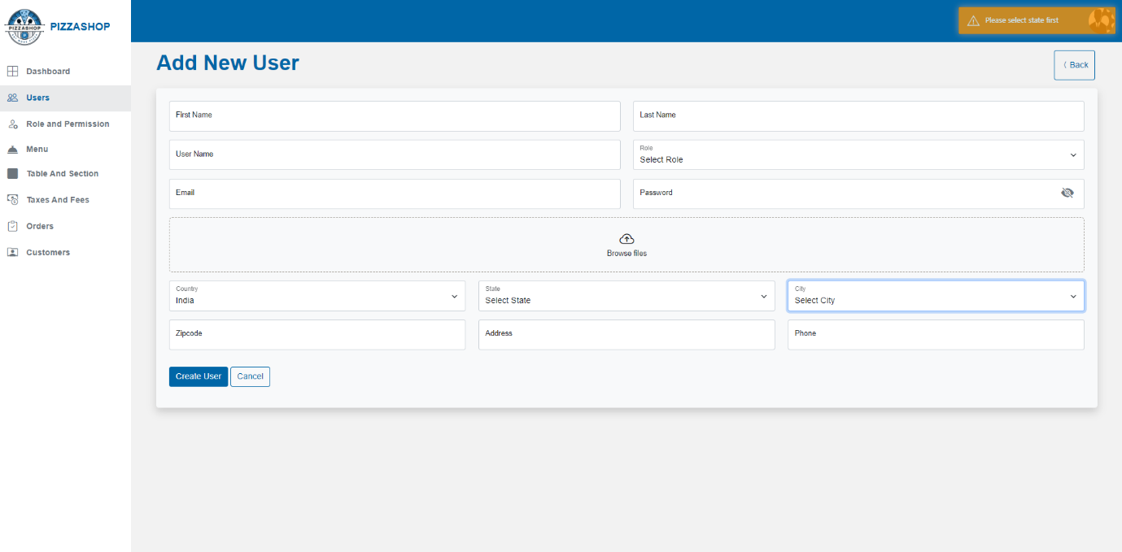Fig. State, City validation

3. Successful message on creating the user successfully should display like as shown in the image below.

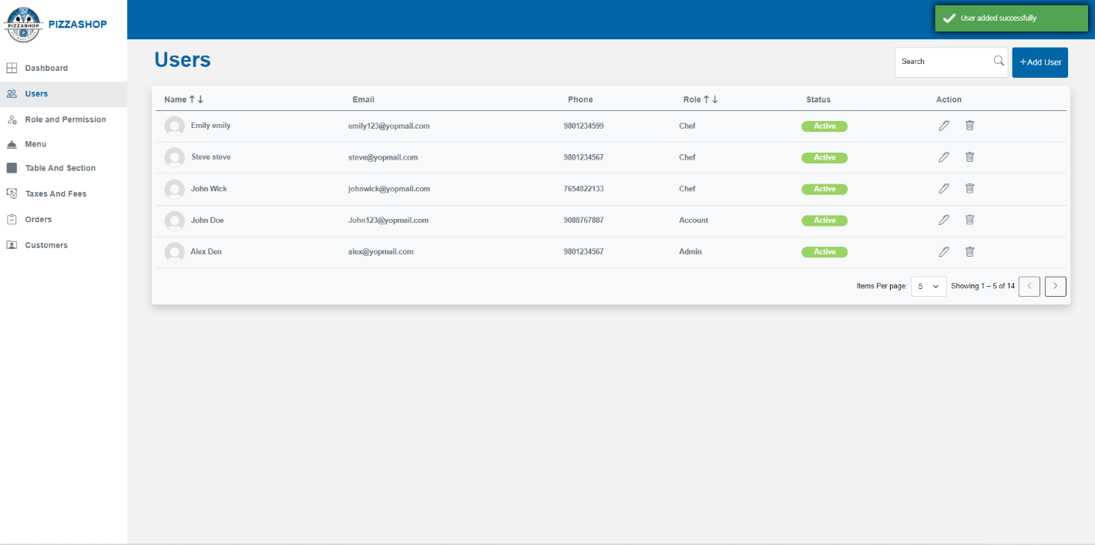Fig.Successfull Message

4. If the super admin tries to add the user with the email already exist the error message should display as shown in the below image.

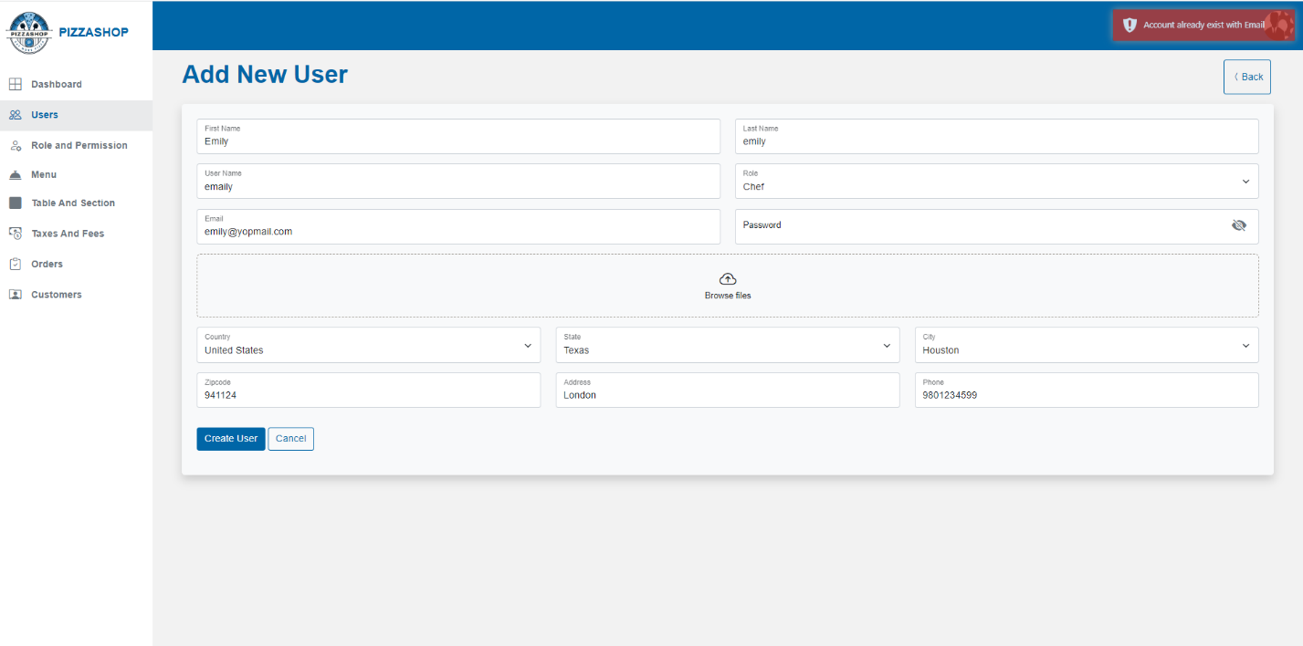Fig. Error Message

**Edit User: -**

Admin can edit the specific user from the list on clicking the "Pencil" icon from the Action column on Users page. On clicking the edit icon, the “Edit User” page will appear as shown in the below image.

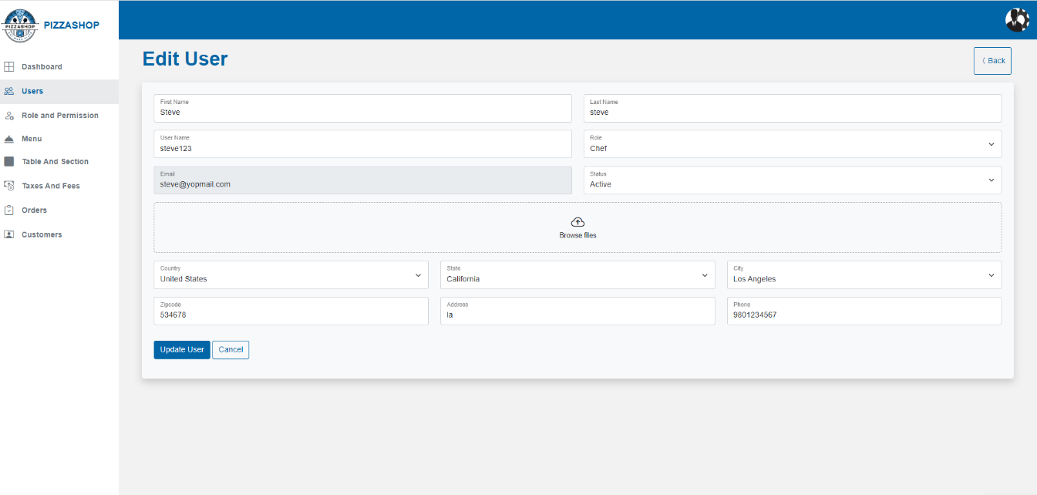

Fig. Edit User

### **Features of Edit User:**

|  |  |  |  |
| --- | --- | --- | --- |
| **#** | **Feature** | **Type** | **Description** |
| 1. | First Name | Textbox | This will show first-name of the user. |
| 2. | Last Name | Textbox | This will show the last name of the user. |
| 3. | Username | Textbox | This will show the role of the user. Role dropdown dynamically display the roles that are hierarchy lower than the current logged-in user. |
| 4. | Role | Textbox | This will show the Username of the logged in user. |
| 5. | Status | Dropdown | This will show the status of the user: Active, Inactive. |
| 6. | Email | Textbox | This will show the email of the user. |
| 7. | Phone | Textbox | This will show the phone number of the user. |
| 8. | Country | Dropdown | It will show the country of the user. |
| 9. | State | Dropdown | It will show the state of the user. |
| 10. | City | Dropdown | It will show the city of the user. |
| 11. | Address | Textbox | It will show first line of Address. |
| 12. | Zipcode | Textbox | It will show Zip code associated with user address. |
| 13. | Upload profile image | Button | Clicking on this button to upload an image. |
| 19. | Update User | Button | By clicking on this it validates the input fields to ensure all required fields are filled and correctly formatted. If validation passes, it will update the user details in the system. Display a confirmation message indicating that the “User updated successfully.” |
| 20. | Cancel | Button | Discard any changes made in the form. Close the form and return the administrator to the user listing page without making any changes. |
| 21. | Back | Button | It will redirect to the “Users "page. |

**Delete User: -**

Admin can delete the specific user from the list on clicking the "Trash" icon from the Action column on Users page. On clicking on trash icon, a confirmation box will show asking that “Are you sure you want to delete User?” and contains “Yes” and “No” Buttons. This box will require the administrator to confirm their action before proceeding with the deletion.

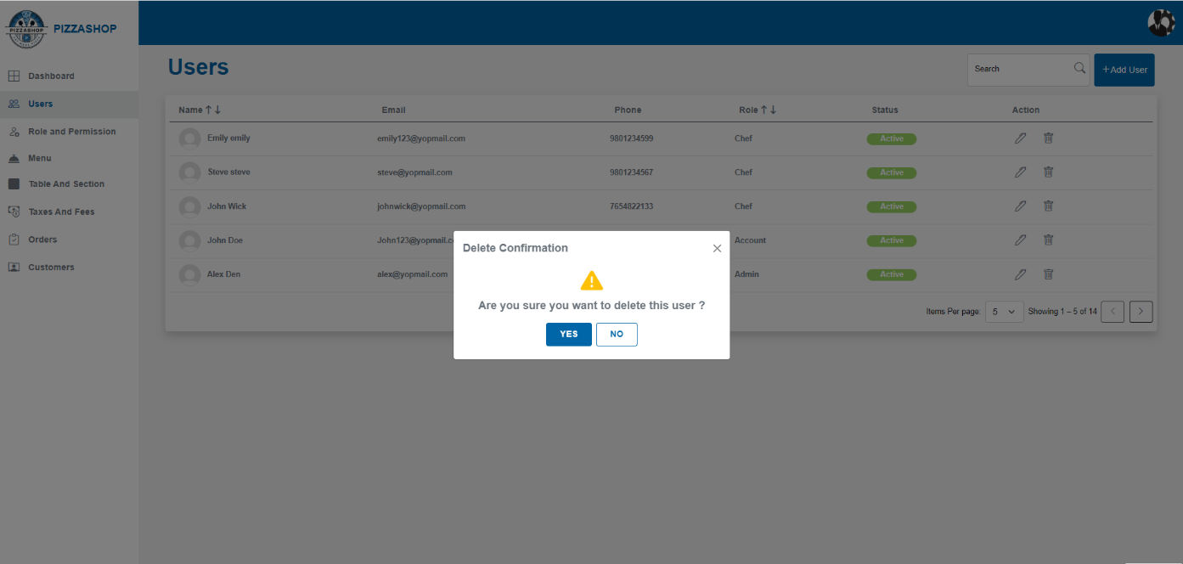Fig. Delete User

### **Features of Delete User:**

|  |  |  |  |
| --- | --- | --- | --- |
| **#** | **Feature** | **Type** | **Description** |
| 1. | Message | Label | The confirmation box will display a clear message, such as: "Are you sure you want to delete this user?” |
| 2. | Yes | Button | 1.Proceed with the deletion of the user account from the system.  2. Display a success message indicating that” user has been deleted successfully”.  3. Refresh the user listing to reflect the change, removing the deleted user from the list. |
| 3. | No | Button | 1. Close the confirmation box.  2. Return the Super Admin to the user listing page without making any changes. |
| 4 | X | Button | This will close the confirmation box. |

**Note:** Error Handling: 404 Error - Page Not Found

The **404 Error: Page Not Found** occurs when a user attempts to access a page or resource that does not exist. This error ensures that users are notified about the missing content.

**Purpose:**

* To inform users that the requested page is unavailable.
* To prevent user frustration by offering guidance or redirection options.
* To maintain a professional user experience even when errors occur.

**Functional Requirements:**

1. Display a user-friendly **404 Error Page** when the requested URL does not match any available routes or resources.
2. The **404 Page** must include:
   1. An error message, e.g., **"404 - Page Not Found"**.
   2. A brief explanation, e.g., **"Sorry, the page you're looking for might have been removed, had its name changed, or is temporarily unavailable."**
3. Ensure the **404 Page** aligns with the application's theme and branding.

**Non-Functional Requirements:**

* The **404 Page** must load quickly and display consistently across devices and screen sizes.
* Error messages must be clear, concise, and user-friendly.

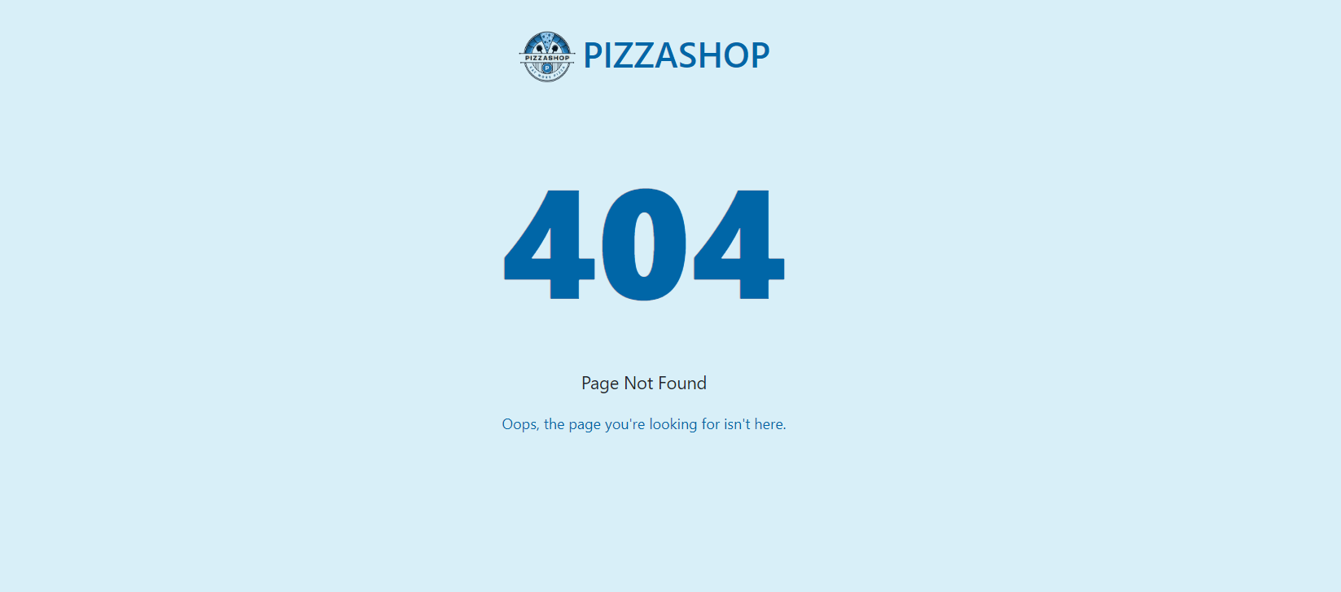

Fig. 404 Page Not Found

**2.2 Roles and Permission**

Description: -

Roles and permissions define the access levels and functionalities available to different users within the Pizza Shop. This structure ensures that users can perform only those actions that are relevant to their responsibilities, enhancing security and operational efficiency.

Roles and permissions are crucial for organizing access control and functionality based on user roles. **These roles determine what each type of user can view, add, modify and delete within the system.**

**2.2.1 Roles**

This page will show all the roles available on the platform. On edit admin can change access for the role. These roles are predefined in database.

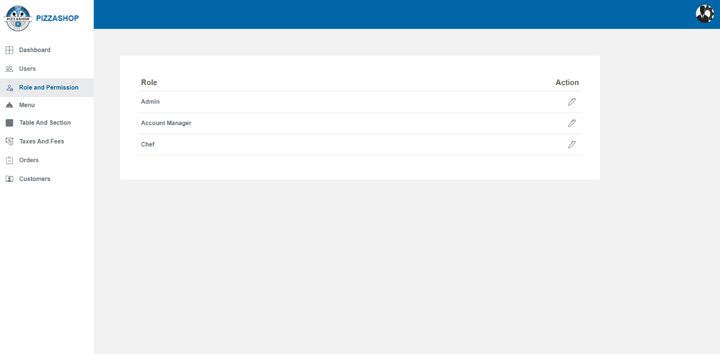Fig. Roles

**Features:**

|  |  |  |  |
| --- | --- | --- | --- |
| **#** | **Feature** | **Type** | **Description** |
| 1. | Role | Textbox | This will show the roles for the user. |
| 2. | Action | Icon | This will contain the pencil icon for editing the permissions. By clicking on the trash icon, the admin can change access for the role. |

**2.2.2 Permissions**

Description: -

Admin can grant the permissions to different users for the role that are relevant to their responsibilities.

On clicking on the pencil icon from the Action the below interface will appear on the screen. The admin can give the permissions to different users for Can View, Can Add/Edit, Can Delete.

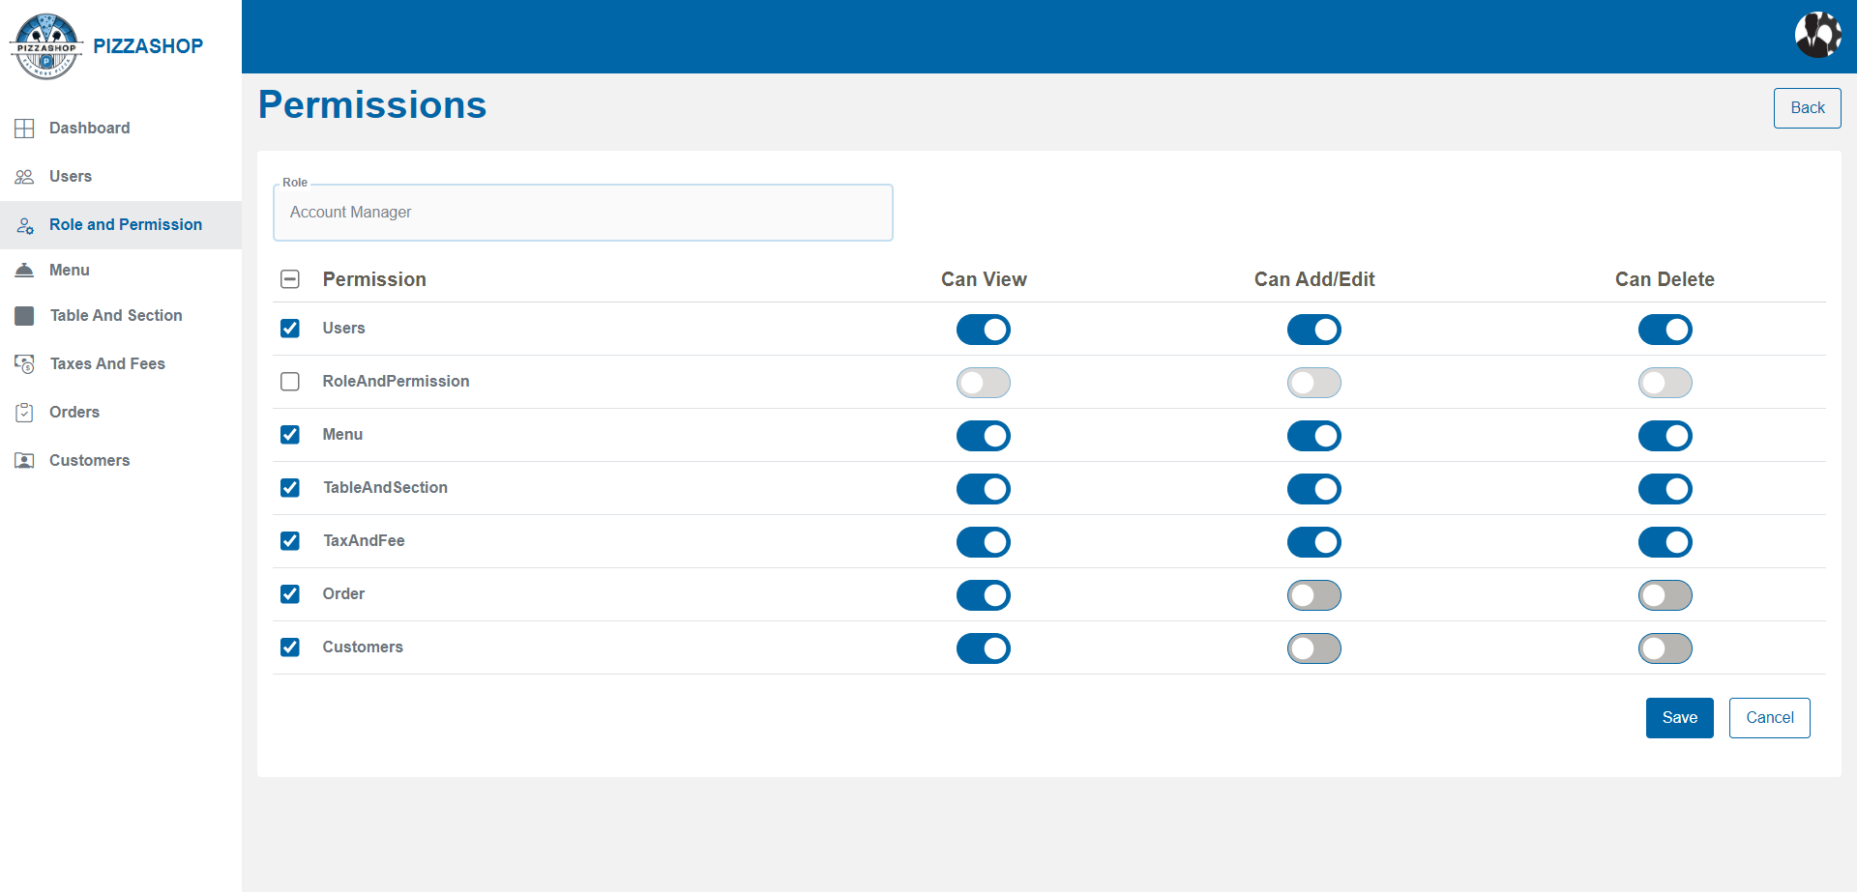Fig. Permissions

**Features:**

|  |  |  |  |
| --- | --- | --- | --- |
| **#** | **Feature** | **Type** | **Description** |
| 1. | Role | Textbox | This will display the role name for which the permissions are being edited or granted. |
| 2. | Permission | Textbox | This will show the name of the modules for permission granted by the Admin. |
| 3. | Can View | Button | A toggle switch (ON/OFF) indicating whether the user has permission to view items within the module. |
| 4. | Can Add/Edit | Button | A toggle switch (ON/OFF) indicating whether the user has permission to Add and Edit items within the module. |
| 5. | Can Delete | Button | A toggle switch (ON/OFF) indicating whether the user has permission to Delete items within the module. |
| 6. | Save | Button | This will save the permission for the user. |
| 7. | Cancel | Button | This will close the permissions page. |
| 8. | Back | Button | It will redirect to the “Users "page. |

Note: 1. Users can perform only the actions relevant to their responsibilities and the permissions assigned to them by the super admin based on their roles and responsibilities.

2. When clicking on the toggle button for 'Can View,' 'Can Add/Edit,' or 'Can Delete,' the permission should be updated and applied correctly.

**2.3 Menu**

**Description:**

A menu in a restaurant is a list of food and beverage items available for customers to order. The admin can view the list of food items, add the categories. The admin can also edit or delete both categories and items and set the availability of food items. Additionally, the admin can search for food items.

The Module Menu serves as the central navigation point for accessing various components of the restaurant management system, including items and modifiers. In the items we have Category and in Modifiers we have Modifier Group.

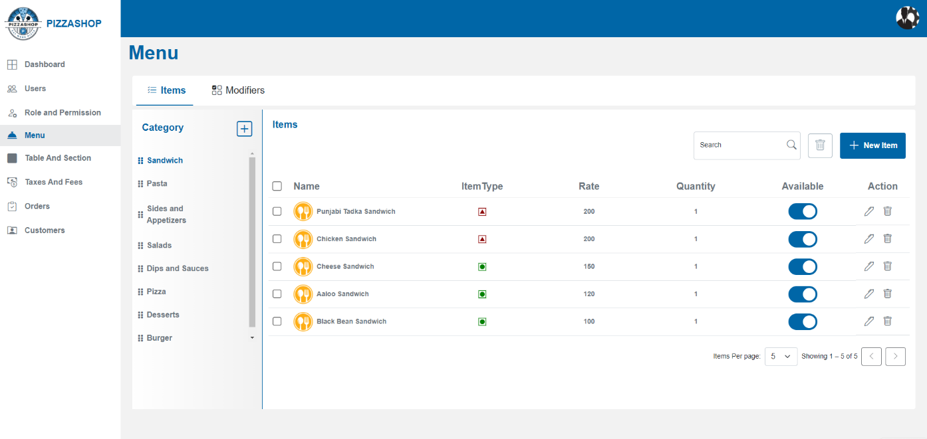Fig. Menu

### **Features of Menu:**

|  |  |  |  |
| --- | --- | --- | --- |
| **#** | **Feature** | **Type** | **Description** |
| 1. | Category | Label | Heading for Category. |
| 2. | Category>>Plus symbol | Button | By clicking this “Add Section” popup will appear on the screen to add the section. |
| 3. | Items>>Search | Textbox | Admin can search the food item by item name. |
| 4. | Delete | Button | Admin can delete the selected Item(s). |
| 5. | New Item | Button | By clicking on this “Add New Menu Item” popup will appear on the screen. Admin can create a new category. |
| 6. | Name | Text | This column will show the item name. |
| 7. | Item Type | image | This column will show the item’s type: Vegetarian, Non-vegetarian. |
| 8. | Rate | Text | This column will show the price of the item. |
| 10. | Quantity | Text | This column will show the quantity of the item. |
| 11. | Available | Button | This will show the availability of food items. |
| 12. | Action | Icons | Action contains the icons for editing and deleting the Items. 1. Pencil Icon - By clicking on the pencil icon, the "Edit Menu Item” popup will appear on the screen. 2. By clicking on the delete icon “Delete Confirmation” popup will appear on the screen. |
| 13. | Pagination | Dropdown & Navigation Buttons | Admin can select the number of items displayed per page (5, 10, 15). Navigation buttons allow switching between pages. Pagination is managed server-side to handle large datasets effectively. |

**2.3.1 Items>> Category: -**

Food categories are classifications used to organize various types of food based on their characteristics, ingredients, preparation methods. Admin can add, edit and delete the categories.

**Add Category: -**

Admin can add a new category to the restaurant by clicking the plus icon. On clicking the plus icon, the “Add Category” popup will appear on the screen.

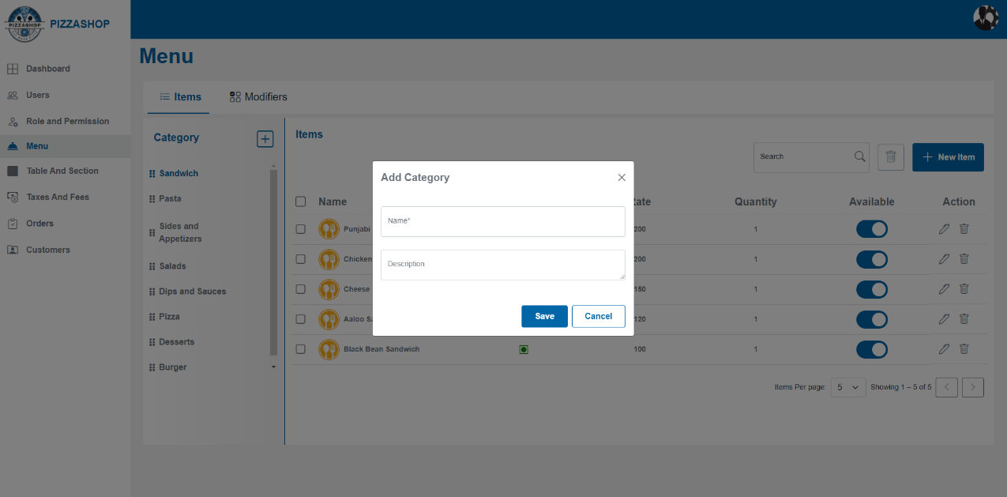

Fig. Add Category

### **Features of Add Category:**

|  |  |  |  |
| --- | --- | --- | --- |
| **#** | **Feature** | **Type** | **Description** |
| 1. | Name | Textbox | This will show the food Category Name. |
| 2. | Description | Textbox | This will show the food category description. |
| 3. | Save | Button | By clicking on this it validates the input fields to ensure all required fields are filled and correctly formatted. If validation passes, this will add the new Category. |
| 4. | Cancel | Button | This will discard any changes made in the form and close the Add category popup. |
| 5. | X | Button | This will close the Add category popup. |

All the added categories will display below the Category heading like Burgers, Desserts is displaying in the below image. And on hovering over the category name the edit icon should be visible and clickable. On clicking on the category name all the food items that are added in that category should show in the list below Items.

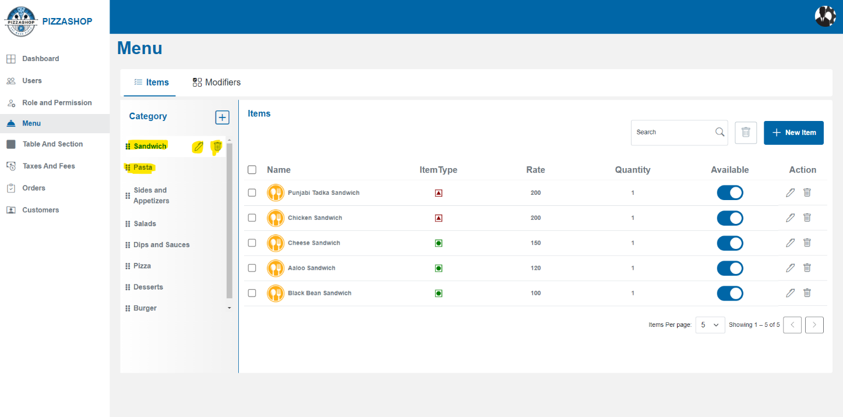Fig. Category

**Edit category: -**

Admin can edit the details of an existing Category by clicking the pencil icon besides the name of the category. On clicking the pencil icon, the “Edit Category” popup will appear on the screen.

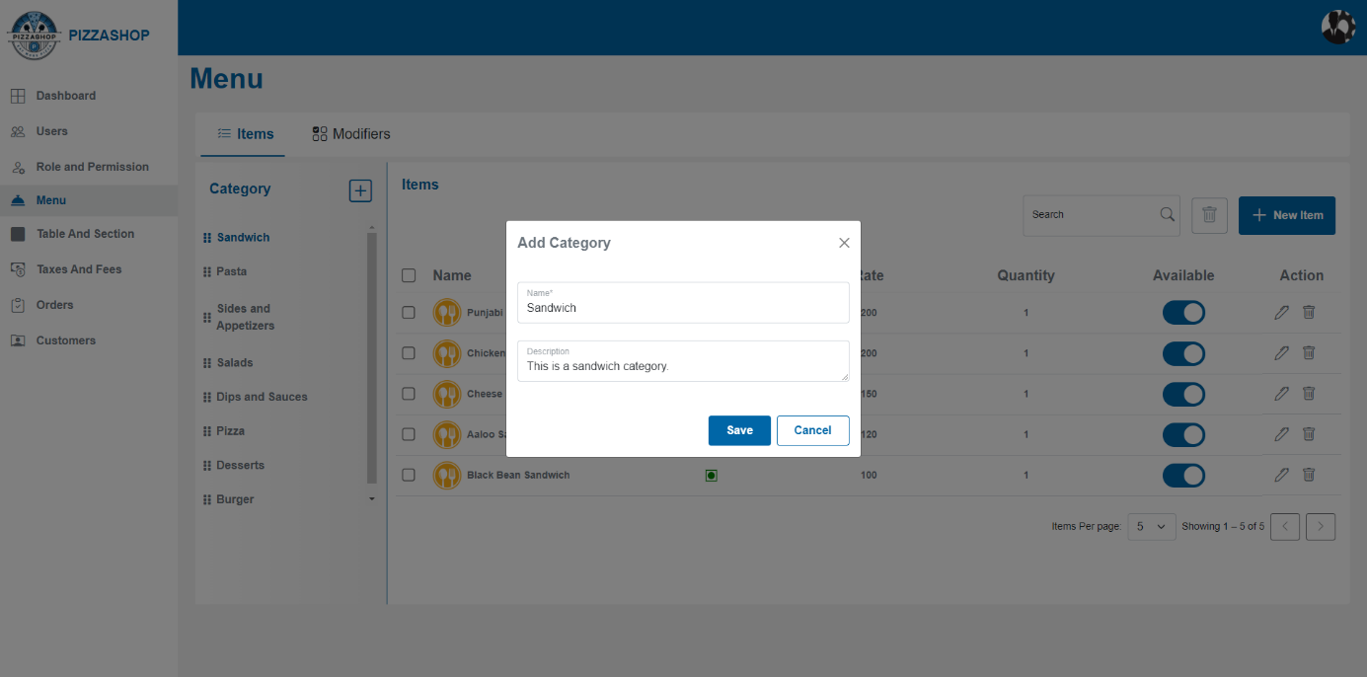Fig. Edit Category

### **Features of Edit Category:**

|  |  |  |  |
| --- | --- | --- | --- |
| **#** | **Feature** | **Type** | **Description** |
| 1. | Category Name | Textbox | This will show the food Category Name. |
| 2. | Description | Textbox | This will show the food category description. |
| 3. | Save | Button | This will save the Category. |
| 4. | Cancel | Button | This will discard any changes made in the form and close the Edit category popup. |
| 5. | Delete | Button | This will open the “Delete Confirmation” popup. |
| 6. | X | Button | This will close the Edit category popup. |

**Delete category: -**

Admin can delete the details of an existing Category by clicking the trash icon besides delete icon in the category section. On clicking the trash icon, the “Delete Confirmation” popup will appear on the screen.

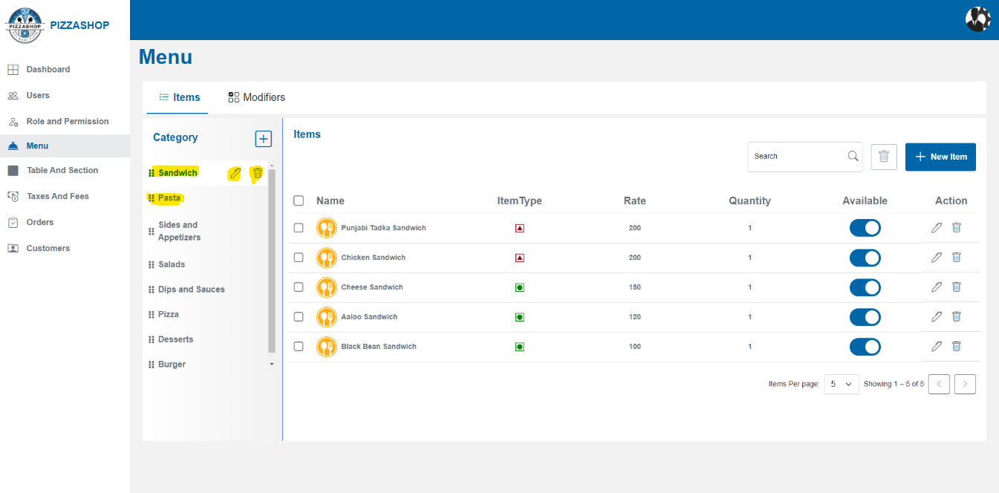Fig.Delete Category

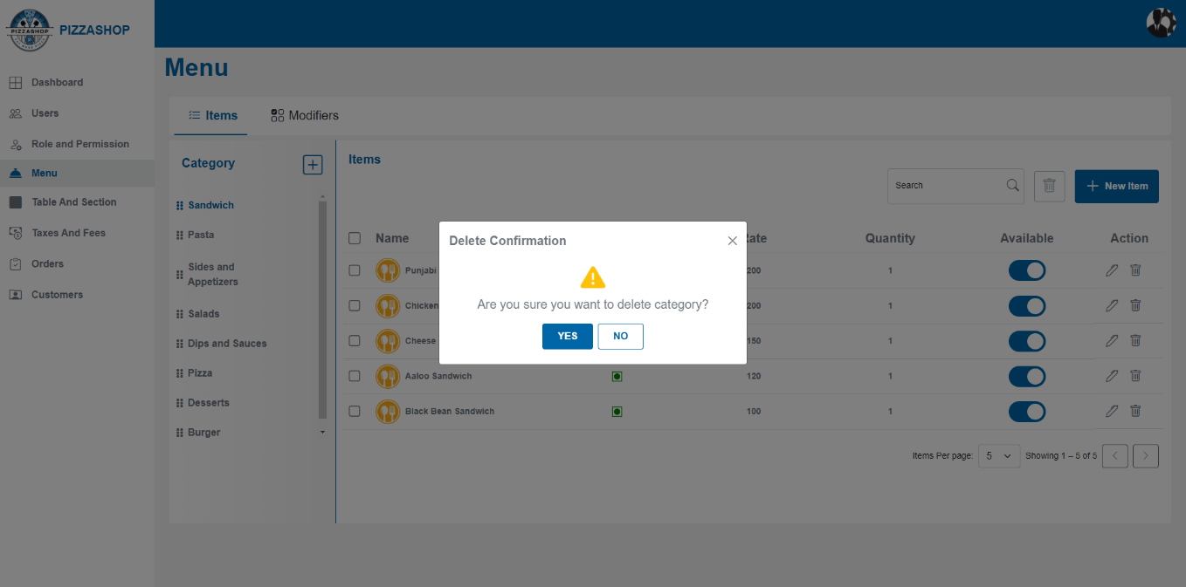Fig. Delete Category

### **Features of Delete Category:**

|  |  |  |  |
| --- | --- | --- | --- |
| **#** | **Feature** | **Type** | **Description** |
| 1. | Message | Label | The confirmation box will display a clear message, such as: " Are you sure you want to delete this category?” |
| 2. | Yes | Button | 1.Proceed with the cancelation of the category from the system.  2. Display a success message indicating that the "Category deleted successfully”. |
| 3. | No | Button | Close the confirmation box. |
| 4. | X | Button | This will close the confirmation box. |

### **Note: - Cascading Delete Behaviour in Master-Child (Category- Items) Relationships**

|  |  |  |
| --- | --- | --- |
| **#** | **Entity** | **Description** |
| 1. | **Master Table:** Category | Represents categories such as *Pizza*, *Pasta*, etc. Each category serves as a grouping entity for related menu items. |
| 2. | **Child Table:** Menu Items | Represents specific menu items (e.g., *Pepperoni Pizza*, *Margherita Pizza*) associated with a category. |

### **Delete Behaviour (Soft Delete):**

* **Soft Delete Implementation:** Instead of physically deleting records, both **Category** and **Menu Items** will have an additional field, typically named IsDeleted (Boolean) .
* When a **Category** is marked as deleted (IsDeleted = true):
  + **Cascade Soft Delete:** All related **Menu Items** under that category will also be **marked as deleted** (IsDeleted = true).

**2.3.2 Items>>Items: -**

Food items are the core components of the restaurant menu, representing the dishes available for customers to order. Each food item can be associated with a category and may include various modifiers for customization. Admin can see the types of food category items by clicking on the food category**.**

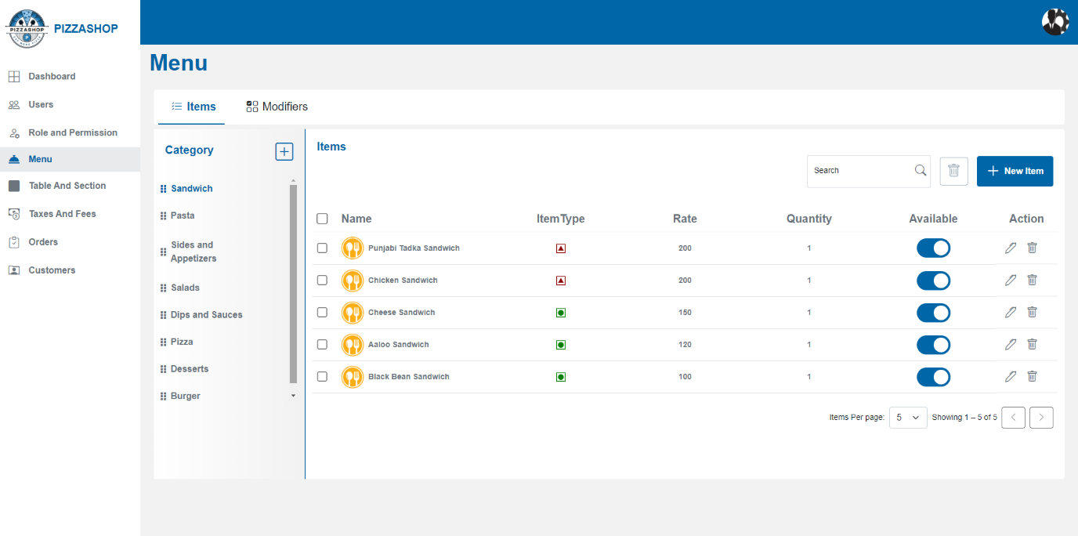Fig. Items in Sandwich Category

# **Add Item**: -

Admin can add a new item to the restaurant by clicking the “New Item” button. On clicking the New Item button, the “Add New Menu Item” popup will appear on the screen.

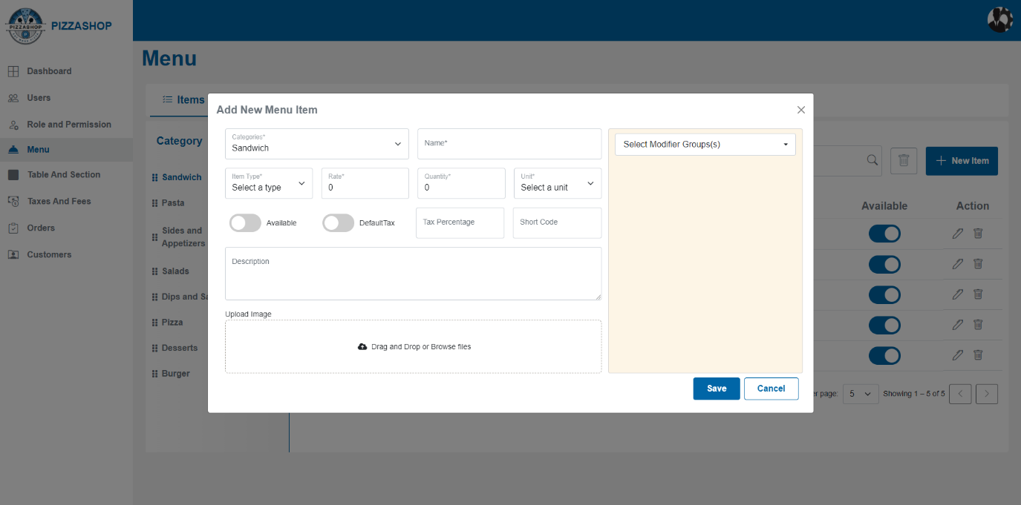Fig. Add New Menu Item

### **Features of Add New Menu Item:**

|  |  |  |  |
| --- | --- | --- | --- |
| **#** | **Feature** | **Type** | **Description** |
| 1. | Category | Dropdown | This will show the categories for the food item. |
| 2. | Name | Textbox | This will show the name of the food item. |
| 3. | Item Type | Dropdown | This will show the Item type like Vegetarian, Non-Vegetarian, Vegan. |
| 4. | Rate | Textbox | This will show the price of the Item. |
| 5. | Quantity | Textbox | This will show the quantity of the item. |
| 6. | Unit | Dropdown | This will show the measurement unit for the item. |
| 7. | Available | Button | This will show the availability of the item. It defines whether an item is in stock or not. |
| 8. | Default Tax | Button | This will show the default tax on the item. |
| 9. | Tax Percentage | Textbox | This will show the additional tax percentage for the item. |
| 10. | Short Code | Textbox | This will show the short code, it is just a field if admin wants to add any nickname code for the item. |
| 11. | Description | Textbox | This will show the description for the food item. |
| 11. | Upload Image | Textbox | Clicking on this button to upload an image. |
| 12. | Select Modifier Group(s) | Dropdown | By this admin can select the modifier group(s) for the item. |
| 13. | Save | Button | By clicking on this it validates the input fields to ensure all required fields are filled and correctly formatted. If validation passes, the new menu item will be saved in the system. Display a confirmation message indicating that the “Menu Item added successfully”. |
| 14. | Cancel | Button | Discard any changes made in the form and close the “Add New Menu Item” popup. |
| 15. | X | Button | This will close the “Add New Menu Item” popup. |

After adding the new menu item, it should show in the items as per the category selected as showing in the below image.

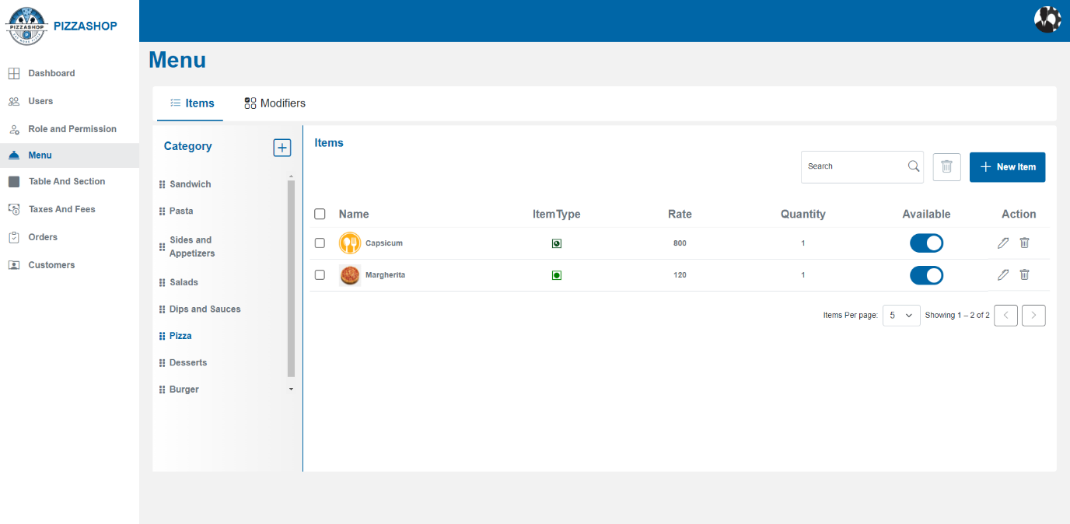Fig. Display the list of all items as per the category

# **Edit Item: -**

Admin can edit the existing item by clicking the pencil icon from Action. On clicking the pencil icon, the “Edit Menu Item” popup will appear on the screen.

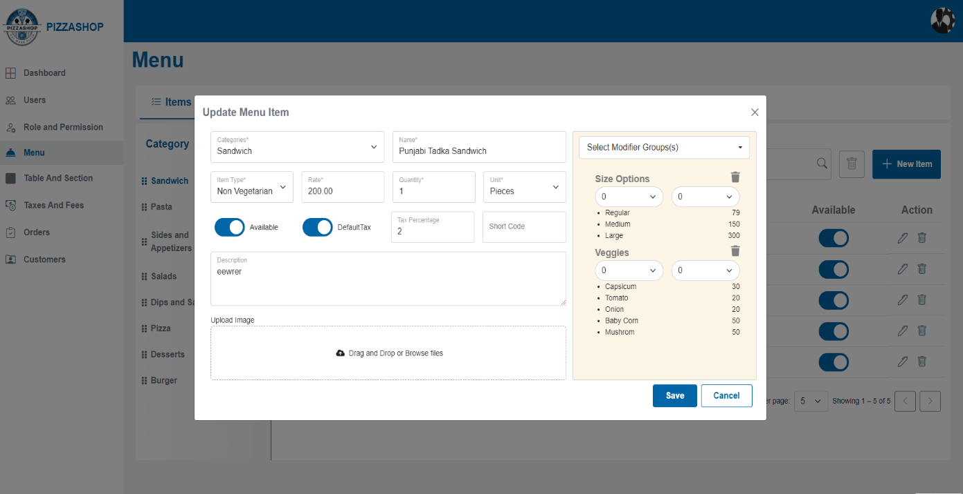Fig. Edit Menu Item

**Features:**

|  |  |  |  |
| --- | --- | --- | --- |
| **#** | **Feature** | **Type** | **Description** |
| 1. | Category | Dropdown | This will show the categories for the food item. |
| 2. | Name | Textbox | This will show the name of the food item. |
| 3. | Item Type | Dropdown | This will show the Item type like Vegetarian, Non-Vegetarian, Vegan. |
| 4. | Rate | Textbox | This will show the price of the Item. |
| 5. | Quantity | Textbox | This will show the quantity of the item. |
| 6. | Unit | Dropdown | This will show the measurement unit for the item. |
| 7. | Available | Button | This will show the availability of the item. |
| 8. | Default Tax | Button | This will show the default tax on the item. |
| 9. | Tax Percentage | Textbox | This will show the tax percentage for the item. |
| 10. | Description | Textbox | This will show the description for the food item. |
| 11. | Upload Image | Textbox | Clicking on this button to upload an image. |
| 12. | Select Modifier Group(s) | Dropdown | By this admin can select the modifier group(s) for the item. |
| 13. | Save | Button | By clicking on this it validates the input fields to ensure all required fields are filled and correctly formatted. If validation passes, the new menu item will be saved in the system. Display a confirmation message indicating that the “Menu Item added”. |
| 14. | Cancel | Button | Discard any changes made in the form and close the “Edit Menu Item” popup. |
| 15. | X | Button | This will close the “Edit Menu Item” popup. |

# **Delete Item: -**

Admin can delete the existing item by clicking the trash icon from Action. On clicking the trash icon, the “Delete Confirmation” popup will appear on the screen.

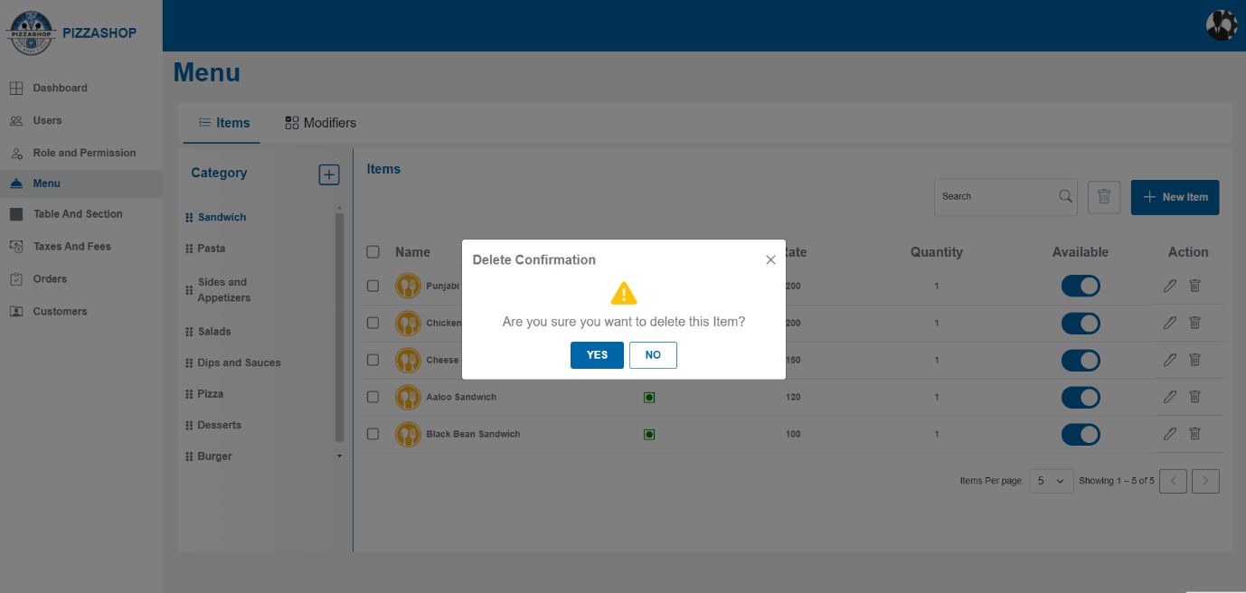Fig. Delete Item

**Features:**

|  |  |  |  |
| --- | --- | --- | --- |
| **#** | **Feature** | **Type** | **Description** |
| 1. | Message | Label | The confirmation box will display a clear message, such as: " Are you sure you want to delete this item?” |
| 2. | Yes | Button | 1.Proceed with the cancelation of the menu item from the system.  2. Display a success message indicating that the "Menu item deleted successfully”. |
| 3. | No | Button | 1. Close the **“**Delete Confirmation**”** popup. |
| 4. | X | Button | This will close the **"** Delete Confirmation**”** popup. |

# **Delete Selected Item/Items: -**

Super Admin can delete selected Item/Items. Admin selects an Item/items from the list by checking the checkbox(s) besides the item and clicks the "Delete" button next to search. Using this functionality Admin can delete all the items by selected them at once.

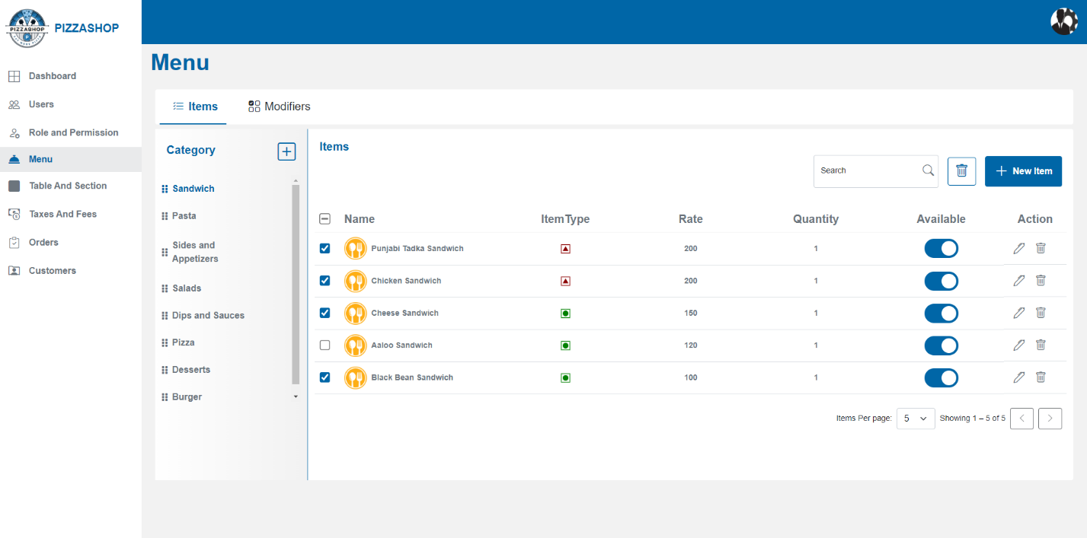Fig. Delete selected item/items

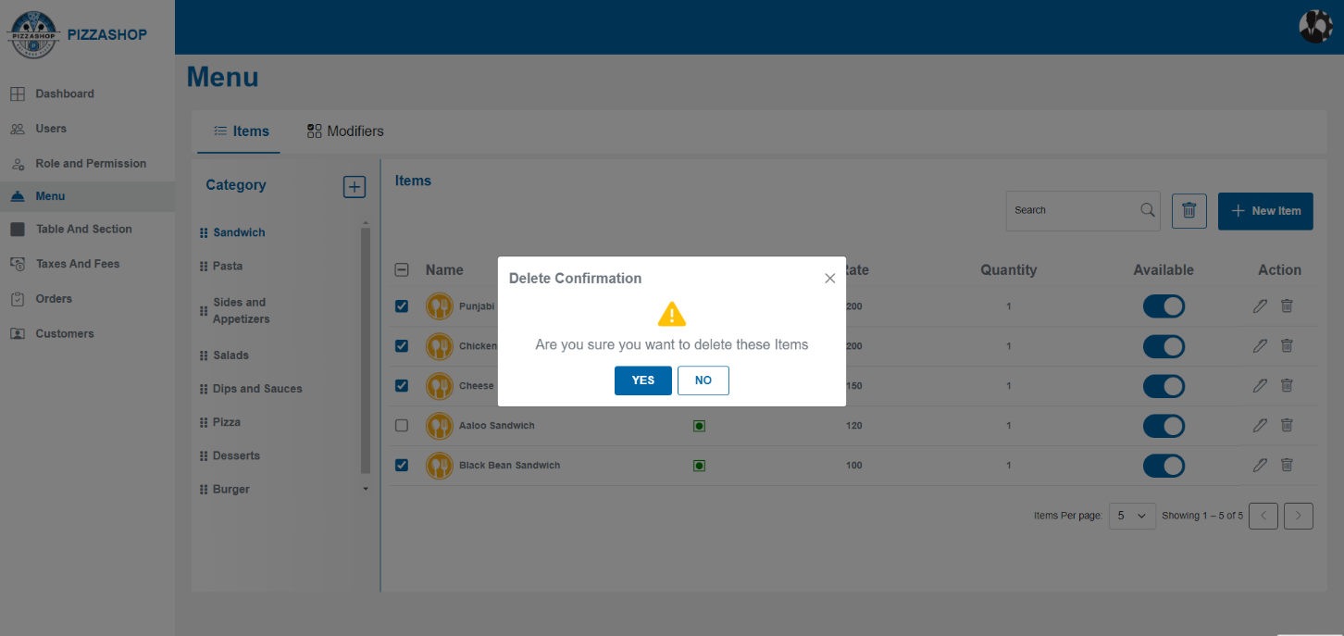Fig.Delete selected Item/Items

**Features:**

|  |  |  |  |
| --- | --- | --- | --- |
| **#** | **Feature** | **Type** | **Description** |
| 1. | Message | Label | The confirmation box will display a clear message, such as: "Are you sure you want to delete these items?” |
| 2. | Yes | Button | 1.Proceed with the deletion of the Item/Items from the system.  2. Display a success message indicating that the "Menu item deleted successfully.”.  3. Refresh the items listing to reflect the change, removing the deleted item/items from the list. |
| 3. | No | Button | 1. Close the confirmation box. |

**2.3.3 Modifiers>>Modifier Group: -**

A **modifier group** is a category of related options that allows customers to customize their order. Each group contains specific choices or modifiers that pertain to a particular aspect of the item. For example, for a pizza, modifier groups could be:

* **Size Options**: Small, Medium, Large.
* **Crust Options**: Thin, Thick, Gluten-Free.
* **Sauce Options**: Tomato, BBQ, Alfredo.
* **Cheese Options**: Mozzarella, Cheddar, No Cheese.
* **Topping Options**: Pepperoni, Mushrooms, Onions, etc.

Display the types of food Modifier Group**.**

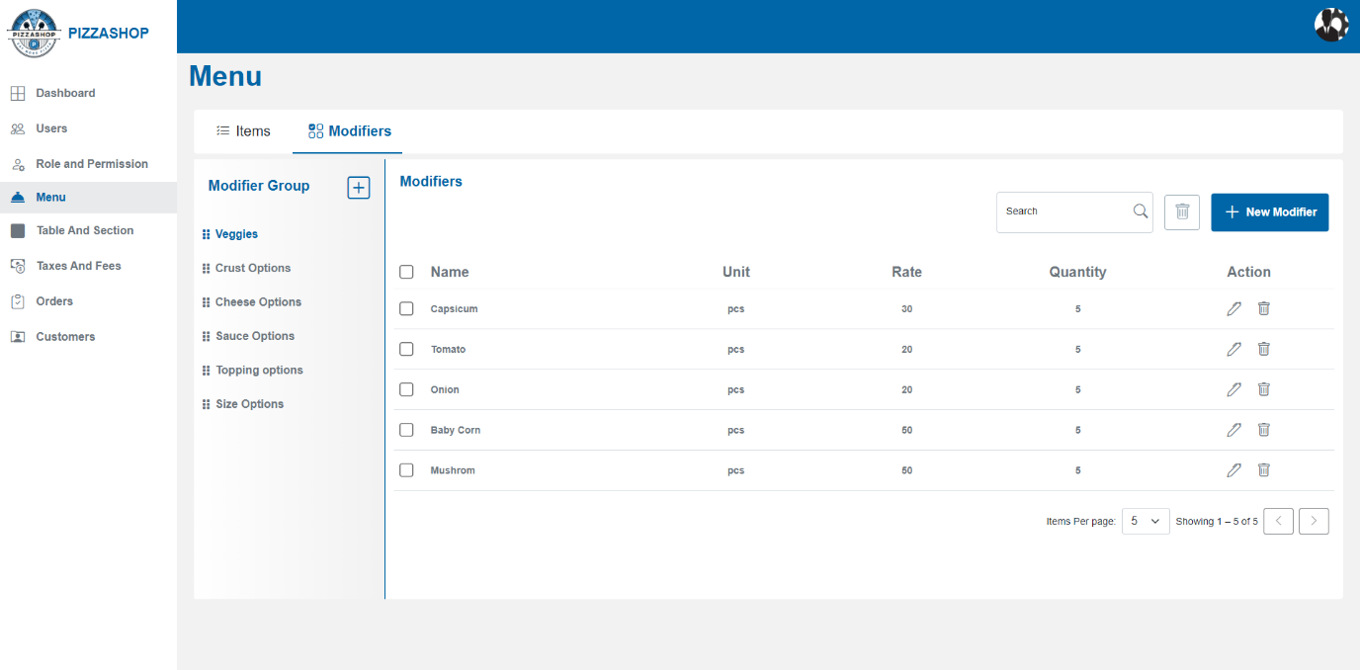Fig. Modifier Group and Modifier

### **Features of Modifier Group and Modifier: -**

|  |  |  |  |
| --- | --- | --- | --- |
| **#** | **Feature** | **Type** | **Description** |
| 1. | Modifier Group | Label | Heading for Modifier Group. |
| 2. | Modifier Group >>Plus symbol | Button | By clicking this “Add Modifier Group” popup will appear on the screen to add the modifier group. |
| 3. | Modifier >>Search | Textbox | Admin can search the modifier-by-modifier name. |
| 4. | Delete | Button | Admin can delete the selected modifier. |
| 5. | New Modifier | Button | By clicking on this “Add New Modifier” popup will appear on the screen. Admin can create a new modifier. |
| 6. | Name | Text | This column will show the modifier name. |
| 7. | Unit | image | This column will show the measurement unit of the modifier. |
| 8. | Rate | Text | This column will show the rate of the modifier. |
| 9. | Quantity | Text | This column will show the quantity of the modifier. |
| 10. | Action | Icons | Action contains the icons for editing and deleting the Items. 1. Pencil Icon - By clicking on the pencil icon, the "Edit New Modifier” popup will appear on the screen. 2. By clicking on the delete icon “Delete Confirmation” popup will appear on the screen. |

# **Add Modifier Group**: -

Admin can add a new modifier group to the restaurant by clicking the plus icon besides the Modifier Group. On clicking the plus icon, the “Add Modifier Group” popup will appear on the screen.

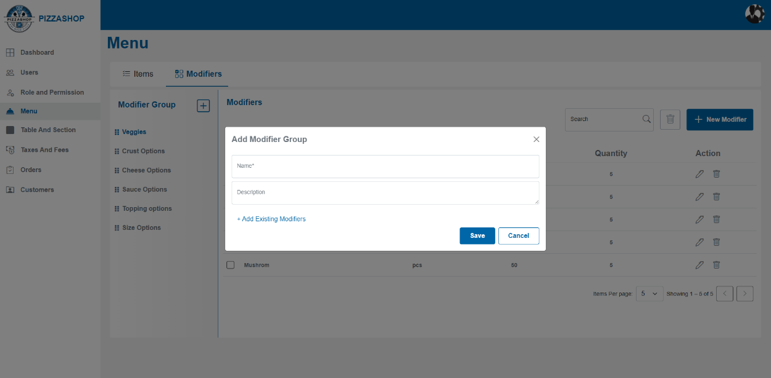

Fig. Add Modifier Group

**Features:**

|  |  |  |  |
| --- | --- | --- | --- |
| **#** | **Feature** | **Type** | **Description** |
| 1. | Name | Textbox | This will show the food modifier Name. |
| 2. | Description | Textbox | This will show the food modifier description. |
| 3. | Save | Button | By clicking on this it validates the input fields to ensure all required fields are filled and correctly formatted. If validation passes, the modifier group will be saved in the system. Display a confirmation message indicating that the “Modifier group was created successfully”. |
| 4. | Cancel | Button | Discard any changes made in the form and close the “Add Modifier Group” popup. |
| 5. | X | Button | This will close the “Add Modifier Group” popup. |
| 6. | Add Existing Modifiers | Button | By clicking on the Add Existing Modifiers the popup will appear on the screen and the admin can add existing modifiers also. |

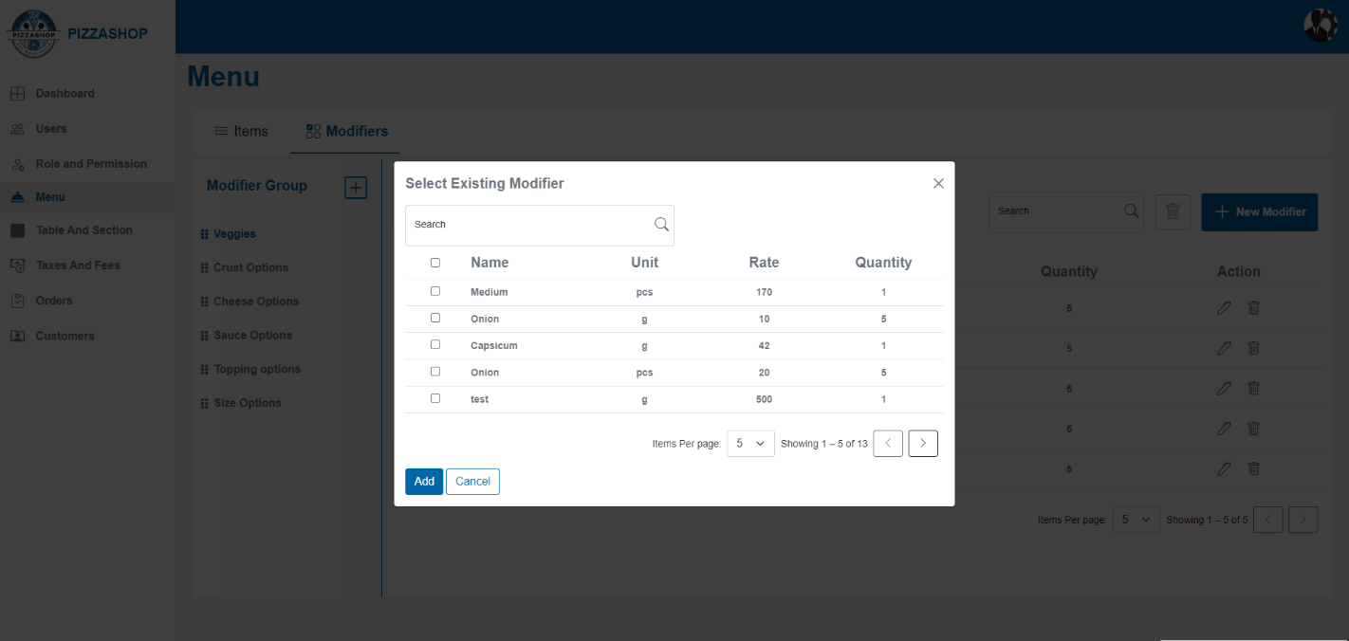Fig. Select Existing Modifier

**Features of select existing Modifier:**

|  |  |  |  |
| --- | --- | --- | --- |
| **#** | **Feature** | **Type** | **Description** |
| 1. | Search | Textbox | * A search bar allows users to quickly filter modifiers by typing keywords. * A search icon triggers the search operation. |
| 2. | Checkbox Selection | Checkbox | * Each row has a checkbox for selecting or deselecting a modifier. * A master checkbox in the header allows selecting or deselecting all modifiers at once. |
| 3. | Name | Text | This will show the Modifier name (e.g., Medium, Onion, Tomato). |
| 4. | Unit | Text | This will show the Measurement unit (e.g., pcs, g). |
| 5. | Rate | Text | This will show the price or cost per unit (e.g., 170, 10). |
| 6. | Quantity | Text | This will show the quantity for each modifier. |
| 7. | Pagination Controls: | **Items Per Page Dropdown:**  Navigation Buttons: | Allows users to select the number of rows displayed per page (5, 10, 20).  Forward (>), backward (<), and page controls enable users to navigate through multiple pages of modifiers. |
| 8. | Add | Button | The **Add** button confirms the selection and adds the chosen modifiers to the modifier group. |
| 9. | Cancel | Button | The **Cancel** button closes the dialog without saving any changes. |
| 10. | X | Button | This will close the “Select Existing Modifier”popup. |

All the added modifier groups will display below the Modifier Group heading like Veggies, Size options, Topping Options etc are displaying in the below image. And on hovering over the modifier group name the edit icon and delete icon should be visible and clickable. On clicking on the modifier group name all the modifiers that are added in that modifier group should show in the list under Modifier.

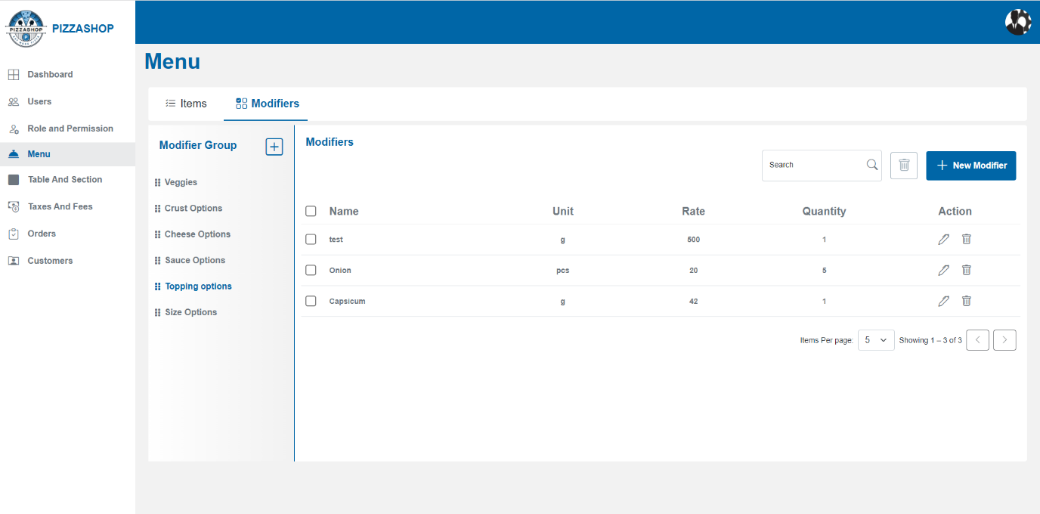Fig. Modifiers

# **Edit Modifier Group**: -

Admin can edit the details of an existing Modifier group by clicking the pencil icon besides the name of the modifier. By clicking on the pencil icon, the “Edit Modifier Group” popup will appear on the screen.

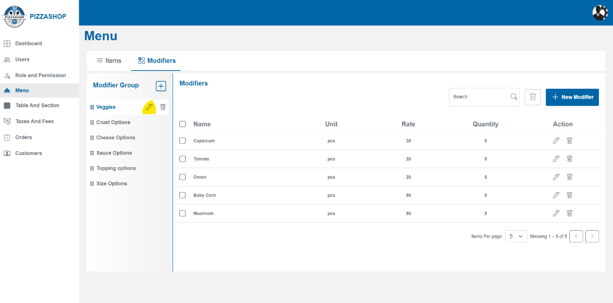Fig.Edit Icon besides the modifier group

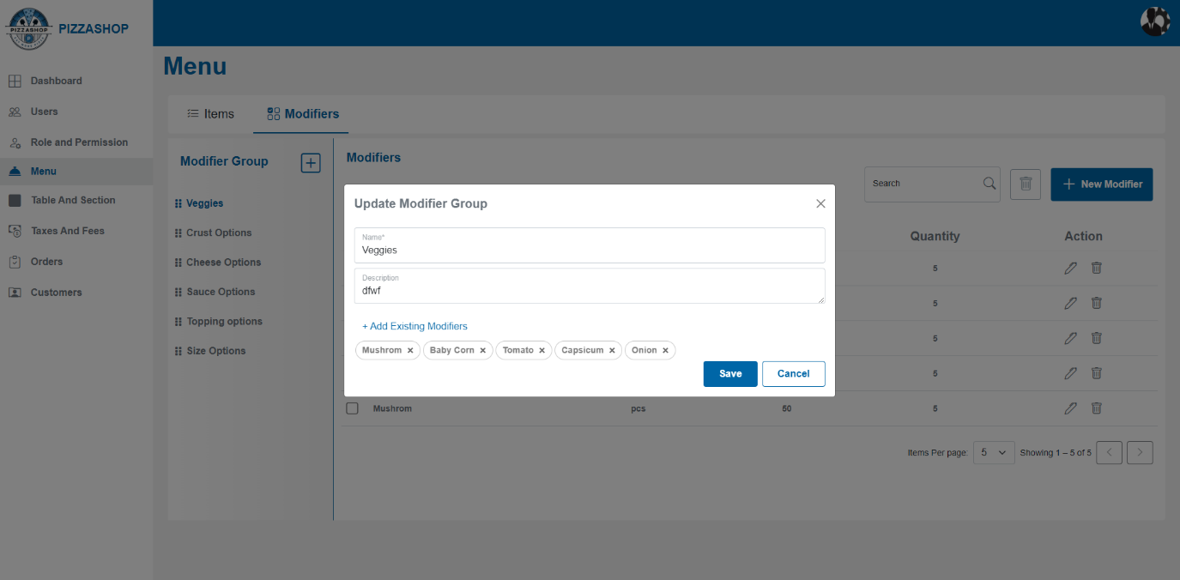Fig. Edit Modifier Group

**Features:**

|  |  |  |  |
| --- | --- | --- | --- |
| **#** | **Feature** | **Type** | **Description** |
| 1. | Name | Textbox | This will show the food modifier Name. |
| 2. | Description | Textbox | This will show the food modifier description. |
| 3. | Add Existing Modifiers | Button | By clicking this admin can add existing modifiers also. |
| 4. | Save | Button | By clicking on this it validates the input fields to ensure all required fields are filled and correctly formatted. If validation passes, the modifier group will be saved in the system. Display a confirmation message indicating that the “Modifier group was created successfully”. |
| 5. | Cancel | Button | Discard any changes made in the form and close the “Edit Modifier Group” popup. |
| 6. | X | Button | This will close the “Edit Modifier Group” popup. |

# **Delete Modifier Group**: -

Admin can delete the modifier group by clicking the trash icon besides the name of the modifier group and pencil icon. By clicking on the trash icon, the “Delete Confirmation” popup will appear on the screen.

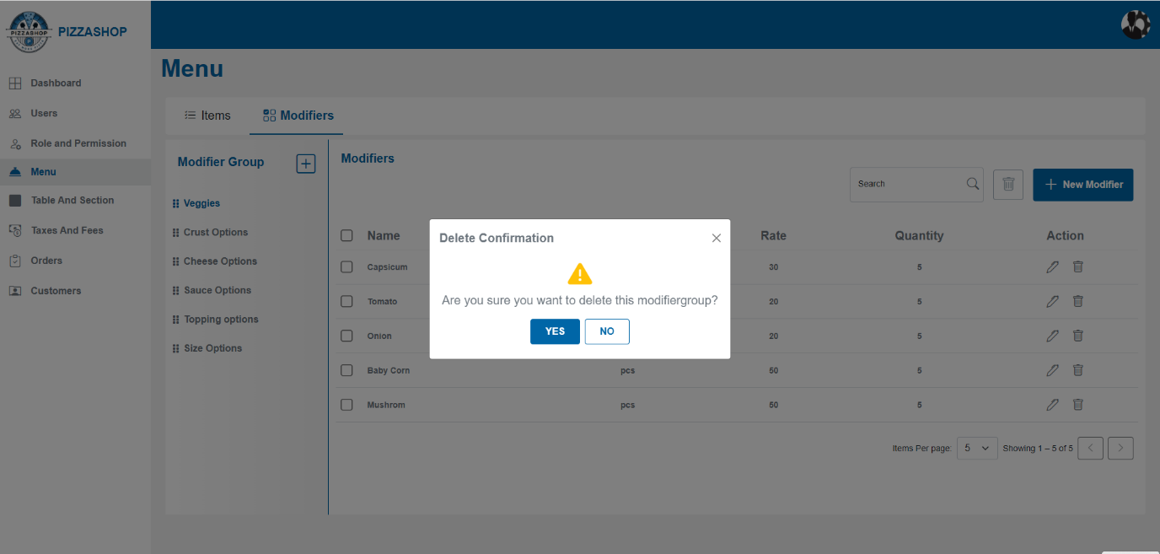Fig. Delete Modifier Group

**Features:**

|  |  |  |  |
| --- | --- | --- | --- |
| **#** | **Feature** | **Type** | **Description** |
| 1. | Message | Label | The confirmation box will display a clear message, such as: " Are you sure you want to delete 1 menu item?” |
| 2. | Yes | Button | 1.Proceed with the cancelation of the menu item from the system.  2. Display a success message indicating that the "Menu item deleted successfully”. |
| 3. | No | Button | Close the confirmation popup. |
| 4. | X | Button | This will close the confirmation popup. |

**Note: - Cascading Delete Behaviour in Master-Child Relationships for Modifier Group and Modifier.**

|  |  |  |
| --- | --- | --- |
| **#** | **Entity** | **Description** |
| 1. | **Master Table:** Modifier Group | Represents a group of modifiers, such as *Toppings*, *Sauces*, or *Crust Type*, associated with menu items. |
| 2. | **Child Table:** Modifier | Represents specific options within a Modifier Group, such as *Olives*, *Mushrooms*, or *Tomato Sauce* |

### **Delete Behaviour (Soft Delete Implementation)**

1. **Soft Delete Concept:**
   1. Both **Modifier Groups** and **Modifiers** use a **soft delete** approach.
   2. Instead of being physically deleted, records will be flagged with a column like IsDeleted (Boolean).
2. **Behaviour When a Modifier Group is Deleted:**
   1. When a **Modifier Group** is soft deleted (IsDeleted = true)
      1. All **related Modifiers** in that group will also be **soft deleted** (IsDeleted = true).
      2. The relationship ensures **data integrity** and prevents orphaned modifiers.

**2.3.4 Modifiers>>Modifier: -**

A **modifier** is an individual choice within a modifier group. These are the specific customizations that the customer can choose from. For example:

* In the **Crust Options** group: Thin Crust, Thick Crust, or Gluten-Free Crust are individual **modifiers**.
* In the **Topping Options** group: Pepperoni, Mushrooms, or Onions are individual **modifiers**.

### **Example:**

For a pizza order:

* **Crust** (modifier group): Thin, Thick, Gluten-Free (modifiers)
* **Toppings** (modifier group): Pepperoni, Mushrooms, Onions, Extra Cheese (modifiers)

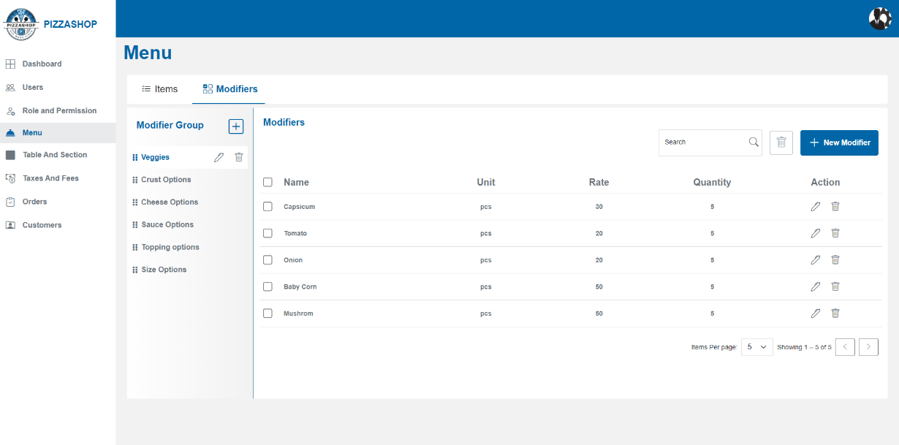

Fig. Modifier

# **Add Modifier: -**

Admin can add a new modifier by clicking the “New Modifier” button. On clicking the New Modifier button, the “Add New Modifier” popup will appear on the screen.

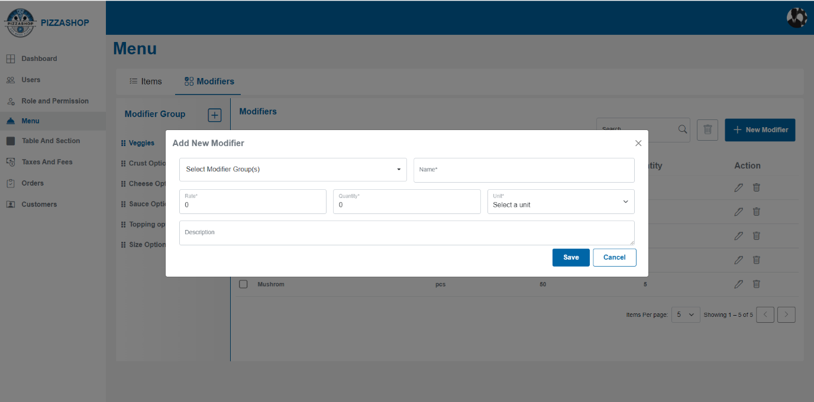Fig. Add New Modifier

**Features:**

|  |  |  |  |
| --- | --- | --- | --- |
| **#** | **Feature** | **Type** | **Description** |
| 1. | Select Modifier Group(s) | Dropdown | This will show the modifier groups for the modifier. |
| 2. | Name | Textbox | This will show the name of the modifier. |
| 3. | Rate | Textbox | This will show the price of the modifier. |
| 4. | Unit | Dropdown | This will show the measurement units for modifier. |
| 5. | Quantity | Textbox | This will show the quantity of modifiers. |
| 6. | Description | Textbox | This will show the description for modifier. |
| 7. | Save | Button | By clicking on this it validates the input fields to ensure all required fields are filled and correctly formatted. If validation passes, the new modifier will be saved in the system. Display a confirmation message indicating that the “Modifier was created successfully”. |
| 8. | Cancel | Button | Discard any changes made in the form and close the “Add New Modifier” popup. |
| 9. | X | Button | This will close the “Add New Modifier” popup. |

After adding the new modifier, it should show in the Modifier as per the modifier group selected as showing in the below image.

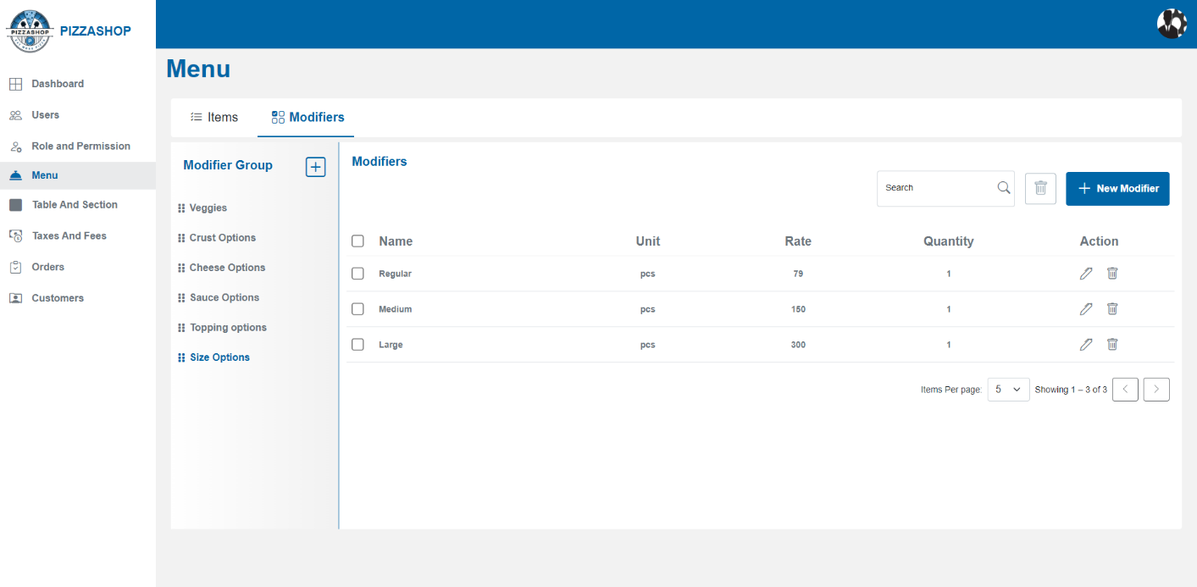 Fig. Modifier group and respected Modifier

# **Edit Modifier: -**

Admin can edit the existing modifier by clicking the pencil icon from Action. On clicking the pencil icon, the “Edit Modifier” popup will appear on the screen.

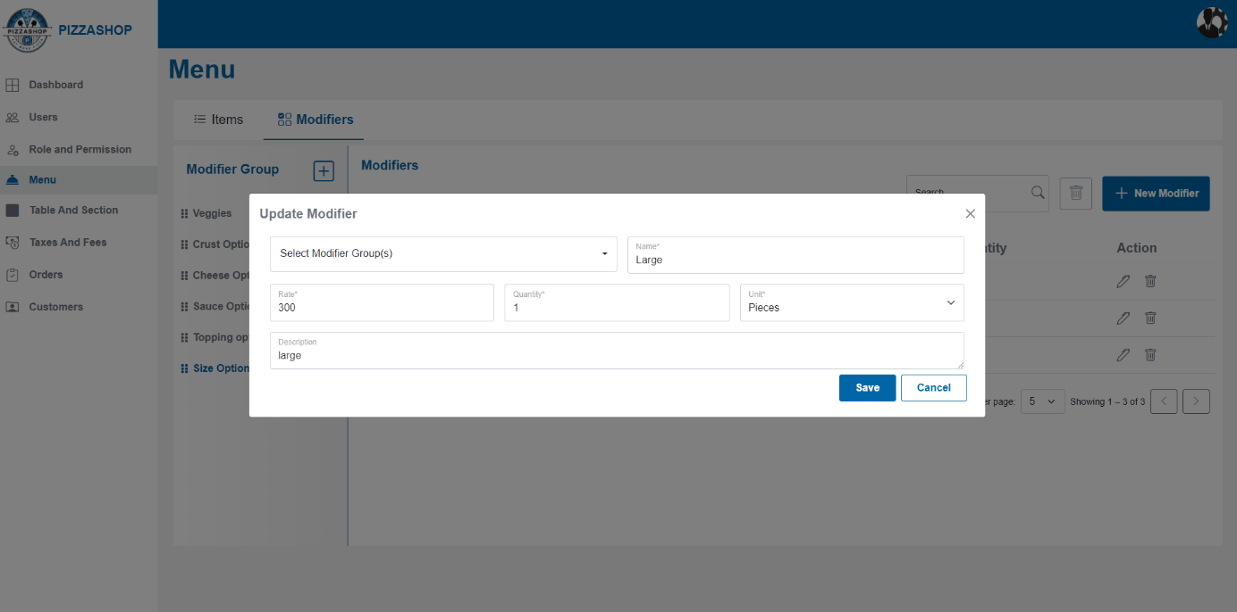Fig. Edit Modifier

**Features:**

|  |  |  |  |
| --- | --- | --- | --- |
| **#** | **Feature** | **Type** | **Description** |
| 1. | Select Modifier Group(s) | Dropdown | This will show the modifier groups for the modifier. |
| 2. | Name | Textbox | This will show the name of the modifier. |
| 3. | Rate | Textbox | This will show the price of the modifier. |
| 4. | Unit | Dropdown | This will show the measurement units for modifier. |
| 5. | Quantity | Textbox | This will show the quantity of modifiers. |
| 6. | Description | Textbox | This will show the description for modifier. |
| 7. | Save | Button | By clicking on this it validates the input fields to ensure all required fields are filled and correctly formatted. If validation passes, the new modifier will be saved in the system and display the confirmation message indicating that the “Modifier was created successfully”. |
| 8. | Cancel | Button | Discard any changes made in the form. And close the "Edit New Modifier” popup. |
| 9. | X | Button | This will close the "Edit New Modifier” popup. |

# **Delete Modifier: -**

Admin can delete the existing modifier by clicking the trash icon from Action. On clicking the trash icon, the “Delete Confirmation” popup will appear on the screen.

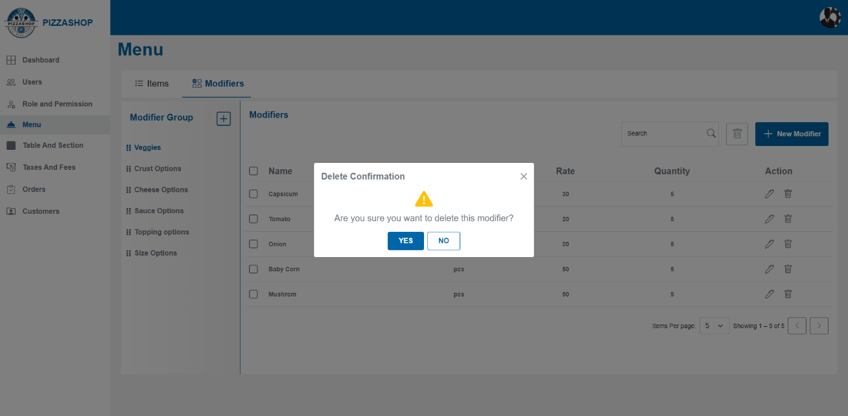

Fig. Delete Modifier

**Features:**

|  |  |  |  |
| --- | --- | --- | --- |
| **#** | **Feature** | **Type** | **Description** |
| 1. | Message | Label | The confirmation box will display a clear message, such as: " Are you sure you want to delete this modifier?” |
| 2. | Yes | Button | 1.Proceed with the cancelation of the modifier from the system.  2. And display the success message indicating that the "Modifier deleted successfully”. |
| 3. | No | Button | Close the confirmation popup. |
| 4. | X | Button | This will close the confirmation popup. |

# **Delete Selected Modifier/Modifiers: -**

Super Admin can delete a selected modifier/modifiers. Admin selects a modifier/modifiers from the list by checking the checkbox(s) besides the modifier and clicks the "Delete" button next to search.

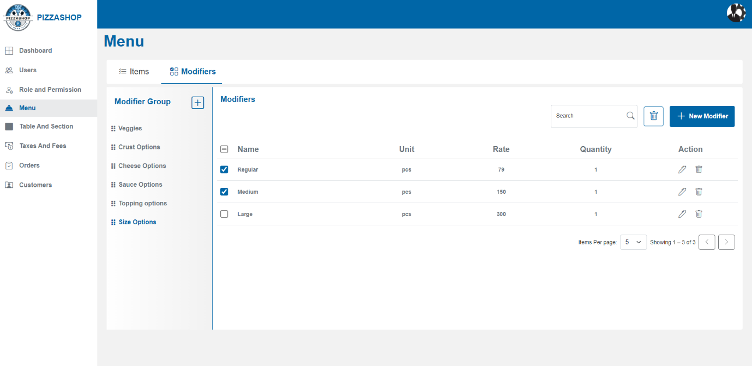Fig. Select modifier/modifiers to delete

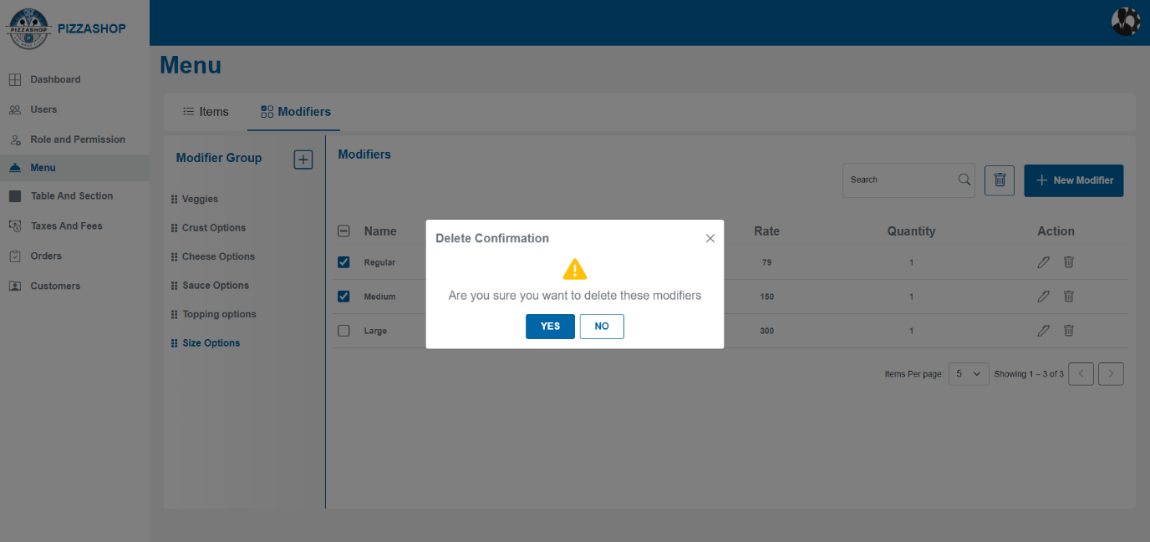Fig. Delete Confirmation

**Features:**

|  |  |  |  |
| --- | --- | --- | --- |
| **#** | **Feature** | **Type** | **Description** |
| 1. | Message | Label | The confirmation box will display a clear message, such as: "Are you sure you want to delete these modifiers?” |
| 2. | Yes | Button | 1.Proceed with the deletion of the modifier/modifiers from the system.  2. Display a success message indicating that the "Modifiers deleted successfully.”.  3. Refresh the modifiers listing to reflect the change, removing the deleted modifier/modifiers from the list. |
| 3. | No | Button | 1. Close the confirmation box. |

**2.4 Tables/Sections**

**Description:**

The Pizza Shop includes various sections of the restaurant (e.g., ground floor, first floor, outdoor seating) where tables are located. This functionality allows for effective management of seating arrangements, making it easy to add, update, and manage sections and tables.

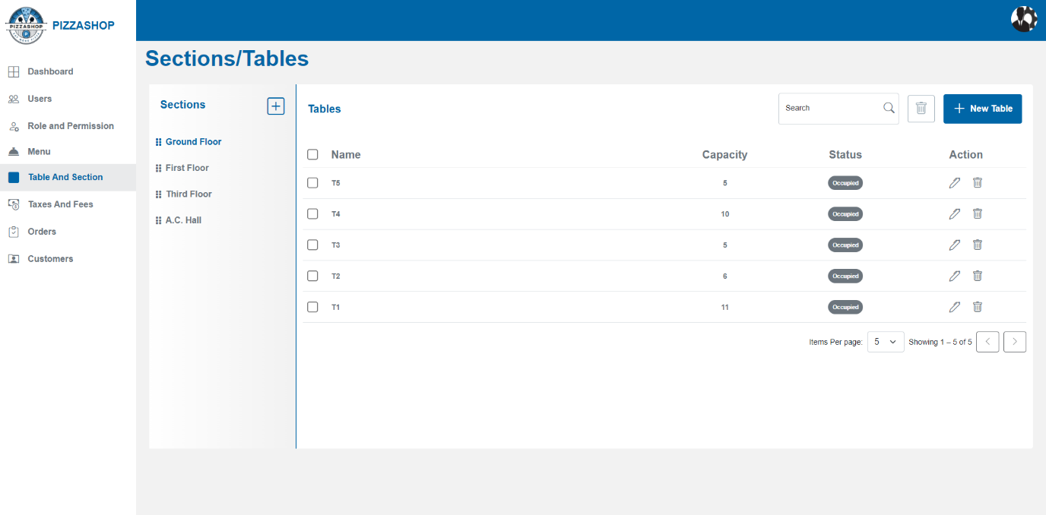Fig. Sections/Tables

### **Features of Tables/Sections:**

|  |  |  |  |
| --- | --- | --- | --- |
| **#** | **Feature** | **Type** | **Description** |
| 1. | Sections | Heading/Label | This is the heading for sections. |
| 2. | Sections>>Plus | Button | By clicking this the “Add Section” popup will appear. |
| 3. | Tables>>Search | Textbox | This will search the table-by-table name. |
| 4. | Tables>> Delete | Button | This will delete the table selected by the checkbox.  Admin can delete a selected table from a section. Admin selects a table from the list by checking the check box and clicks the "Delete" button next to search. |
| 5. | Tables>> New Table | Button | By clicking on this “Add Table” popup will appear. |
| 6. | Tables>> Check Box | Check Box | This will select the table/tables. |
| 7. | Tables>> Name | Text | This column will show the table’s name. |
| 8. | Tables>> Capacity | Text | This column will show the table’s capacity. |
| 9. | Tables>> Status | Text | This column will show the status of the table: Available, Occupied. |
| 10. | Tables>> Action | Clickable Icons | Action contains the icons for editing and deleting the tables. 1. Pencil Icon - By clicking on the pencil icon, the "Edit Table” popup will appear on the screen. 2. By clicking on the delete icon “Delete Confirmation” popup will appear on the screen. |
| 11. | Pagination | Dropdown & Navigation Buttons | Admin can select the number of items displayed per page (5, 10, 15). Navigation buttons allow switching between pages. Pagination is managed server-side to handle large datasets effectively. |

**2.4.1 Sections**

**Description: -**

Sections represent different areas of the restaurant (e.g., ground floor, first floor, outdoor).

### **Add Section: -**

Admin can add a new section to the restaurant by clicking the plus icon and the added sections will show under sections like Ground floor is shown in the below image. By clicking on the plus icon, the Add Section popup will appear as shown in the below image.

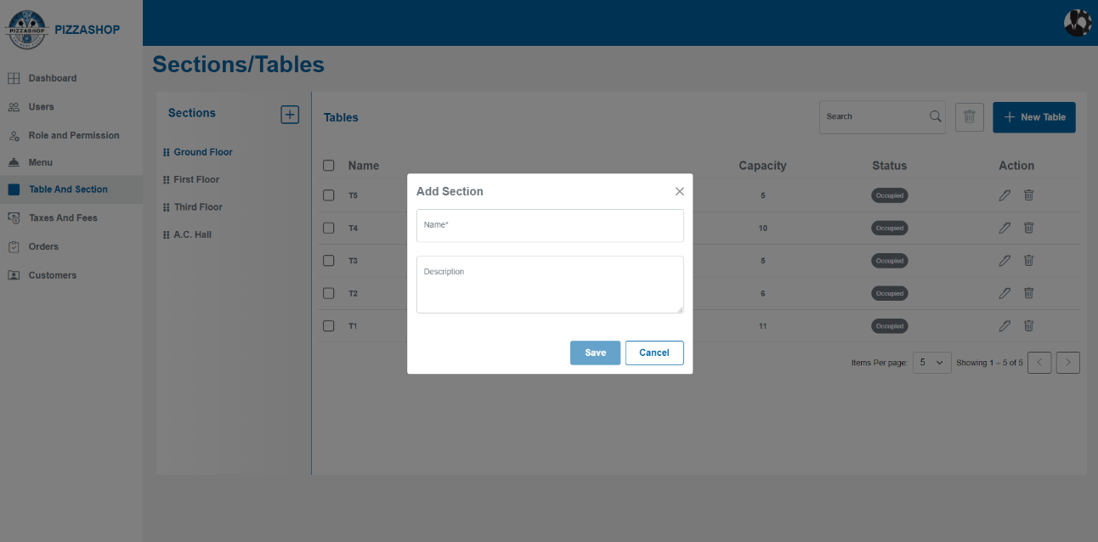

Fig. Add Section

**Features:**

|  |  |  |  |
| --- | --- | --- | --- |
| **#** | **Feature** | **Type** | **Description** |
| 1. | Name | Textbox | This will show the name of the section. |
| 2. | Description | Textbox | This will show the Description of the section. |
| 4. | Save | Button | By clicking on this it validates the input fields to ensure all required fields are filled and correctly formatted. If validation passes, this will add the new section and display the confirmation message indicating that the “Section created successfully”. |
| 5. | Cancel | Button | This will discard any changes made in the form and close “Add Section” popup. |
| 6. | X | Button | This will close the “Add Section” popup. |

### **Edit Section: -**

When the user places the cursor on the section name (e.g. Ground floor) they can see the pencil and trash icon to edit and delete the section as shown in the below image.

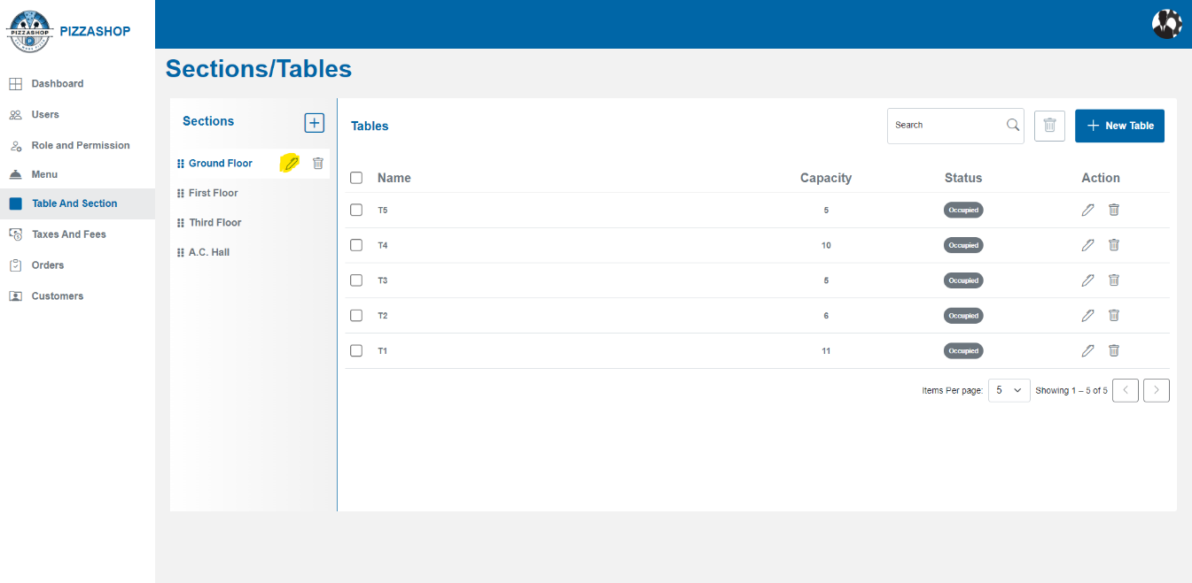

Fig. Edit Icon

Admin can edit the details of an existing section by clicking the pencil icon besides the name of the section.

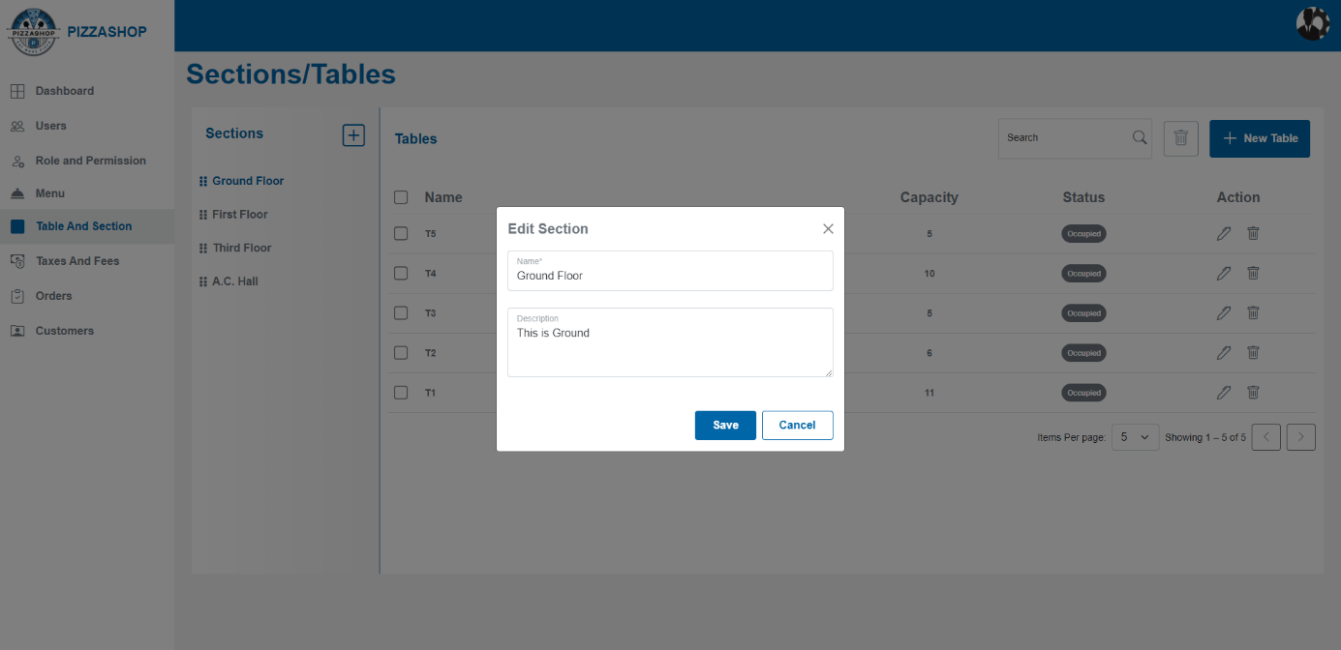Fig. Edit Section

**Features:**

|  |  |  |  |
| --- | --- | --- | --- |
| **#** | **Feature** | **Type** | **Description** |
| 1. | Name | Textbox | This will show the name of the section. |
| 2. | Description | Textbox | This will show the Description of the section. |
| 3. | Save | Button | This will save the modified details of the section and display the confirmation message indicating that the “Section updated successfully”. |
| 4. | Cancel | Button | This will discard any changes made in the form and close “Edit Section” popup. |
| 5. | X | Button | This will close the “Edit Section” popup. |

### **Delete Section: -**

When the user places the cursor on the section name (e.g. Ground floor) they can see the pencil and trash icon to edit and delete the section as shown in the below image.

Admin can delete the section by clicking the trash icon besides the name of the section.

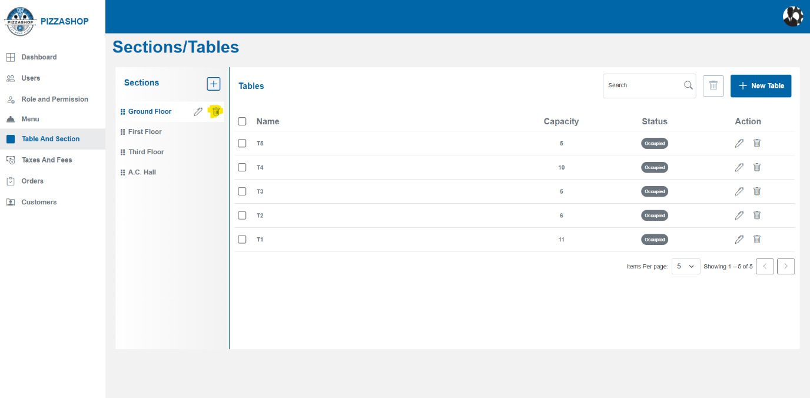

Fig. Delete icon

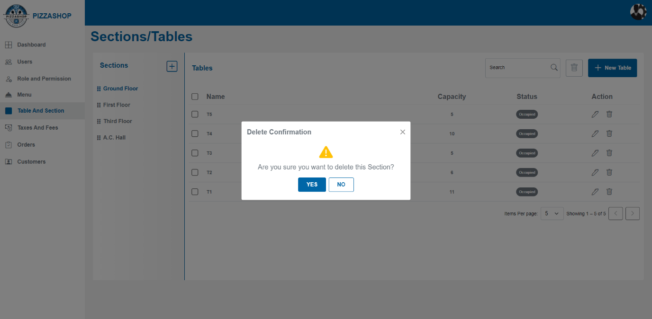Fig. Delete Section

**Features:**

|  |  |  |  |
| --- | --- | --- | --- |
| **#** | **Feature** | **Type** | **Description** |
| 1. | Message | Label | The confirmation box will display a clear message, such as: " Are you sure you want to delete this section?” |
| 2. | Yes | Button | 1.Proceed with the cancelation of the section from the system.  2. Display a success message indicating that the "Section deleted successfully”. |
| 3. | No | Button | 1. This will close the confirmation popup. |
| 4. | X | Button | This will close the confirmation popup. |

**Note:** - 1. If the status of the table is **Occupied**, so the table should not be deleted and the error message should show “**Table cannot be deleted, it is reserved or occupied**.”

**2. Cascading Delete Behaviour in Master-Child Relationships for Sections and Tables.**

|  |  |  |
| --- | --- | --- |
| **#** | **Entity** | **Description** |
| 1. | **Master Table:** Sections | Represents different sections in a restaurant (e.g., Ground Floor, *First Floor*, *VIP Lounge*). |
| 2. | **Child Table:** Tables | Represents individual tables under each section (e.g., *Table 1*, *Table 2*, *VIP Table 1*). |

### **Delete Behaviour (Soft Delete Implementation)**

1. **Soft Delete Concept:**
2. Both **Sections** and **Tables** use a **soft delete** approach.

b. Instead of being physically deleted, records will be flagged with a column like IsDeleted (Boolean).

### **2**. **Behaviour When a Section is Deleted:**

When a **Section** is soft deleted (IsDeleted = true)

a. All **associated Tables** under that section will also be **soft deleted**.

b. This prevents orphaned tables from existing without a parent section.

### **3. Behaviour When a Table is Deleted:**

a. When a **Table** is soft deleted, it will not affect the **Section**.

b. Only the specific table will be marked as deleted.

#### **2.4.2 Tables**

**Description: -**

Tables represent individual seating units within a section.

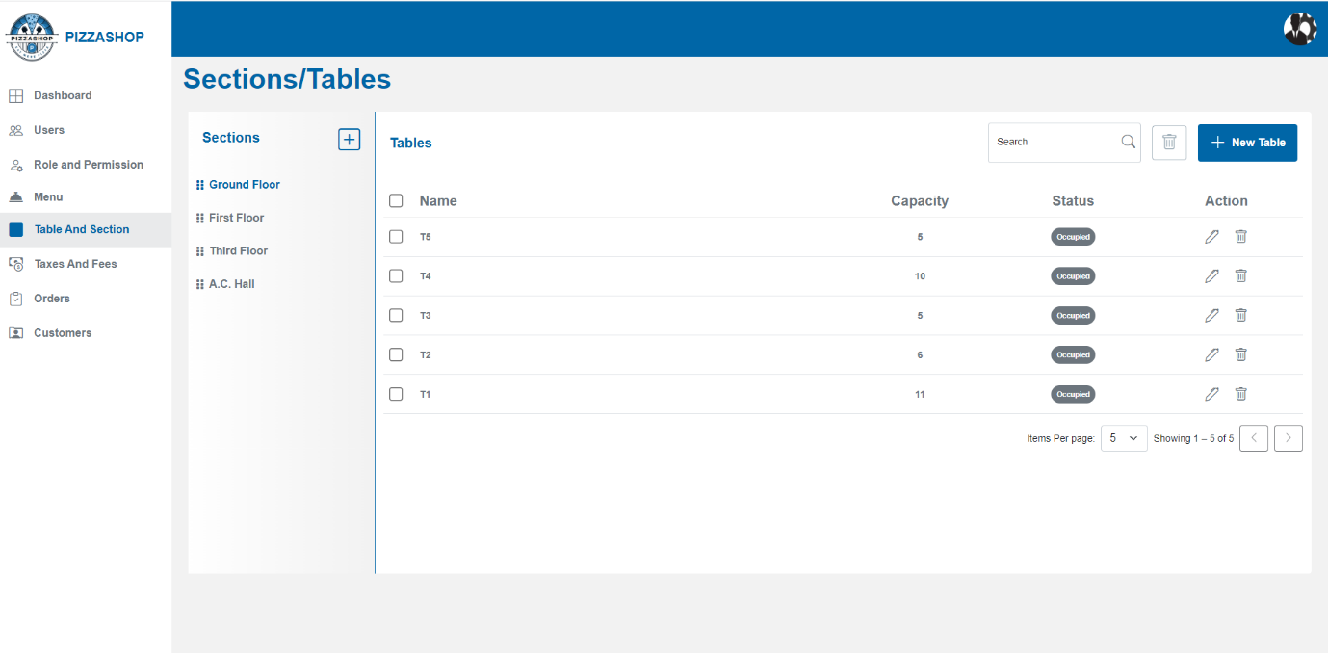Fig. Tables

**Search Table: -**

Admin can search for a specific table by table name.

**Delete Selected Table: -**

Super Admin can delete a selected table or delete all tables at once from a section. Admin selects a table from the list by checking the checkbox(s) beside the table name and clicks the "Delete" button next to search.

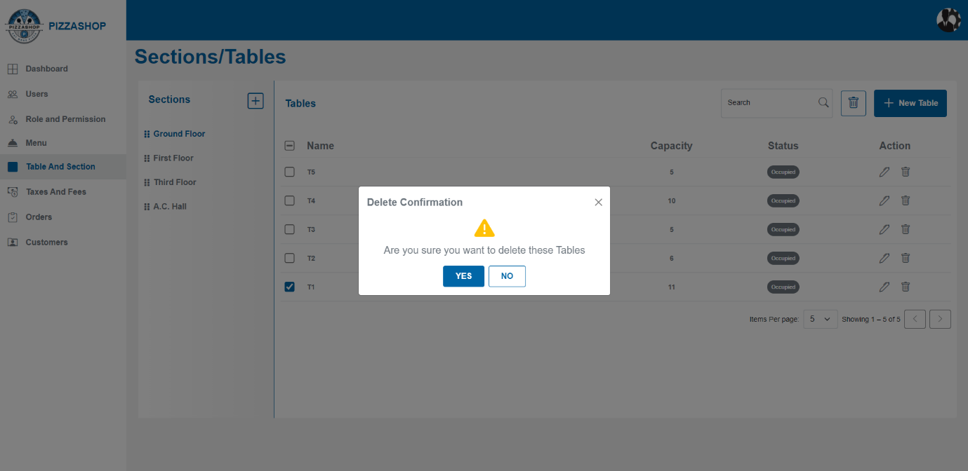Fig. Delete Selected Table T1

**Features:**

|  |  |  |  |
| --- | --- | --- | --- |
| **#** | **Feature** | **Type** | **Description** |
| 1. | Message | Label | The confirmation box will display a clear message, such as: "Are you sure you want to delete these table?” |
| 2. | Yes | Button | 1.Proceed with the deletion of the table from the system.  2. Display a success message indicating that the "Table deleted successfully.”.  3. Refresh the table listing to reflect the change, removing the deleted table from the list. |
| 3. | No | Button | 1. Close the confirmation box. |

### **Add Table: -**

Admin can add a new table to a specific section by clicking on the “New Table” button. On clicking the New Table button “Add Table” popup will appear on the screen.

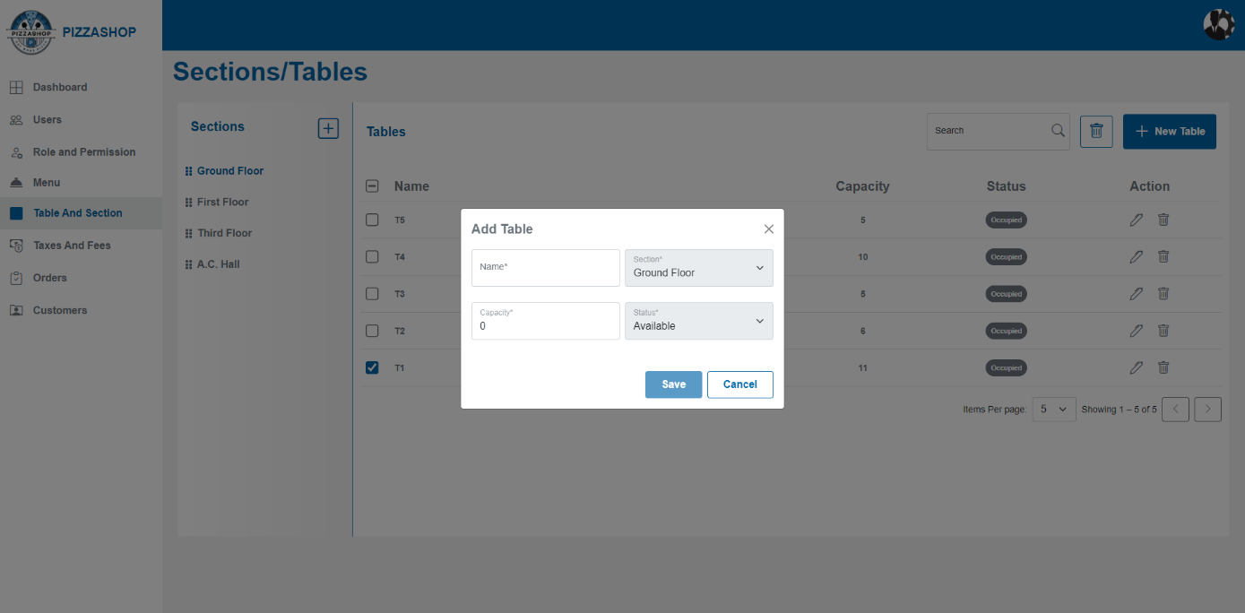Fig. Add Table

**Features:**

|  |  |  |  |
| --- | --- | --- | --- |
| **#** | **Feature** | **Type** | **Description** |
| 1. | Name | Textbox | This will show name of the table |
| 2. | Section | Dropdown | This will show the sections. |
| 3. | Capacity | Textbox | This will show the capacity of the table. |
| 4. | Status | Dropdown | This will show the status of the table. |
| 5. | Save | Button | By clicking on this it validates the input fields to ensure all required fields are filled and correctly formatted. If validation passes, this will add the new table and display the confirmation message indicating that the “Table created successfully”. |
| 6. | Cancel | Button | This will discard any changes made in the form and close the “Add Table” popup. |
| 7. | X | Button | This will close the “Add Table” popup. |

### **Edit Table: -**

Admin can edit the existing table by clicking the pencil icon from the Actions column. On clicking the pencil icon "Edit Table" popup will appear on the screen.

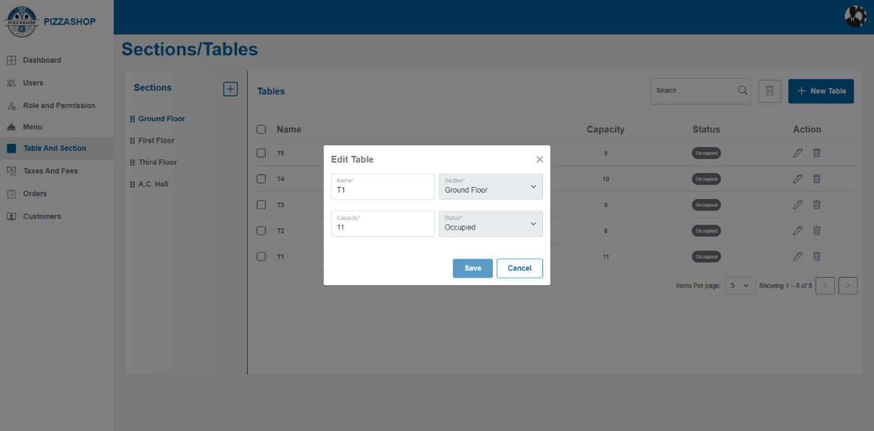Fig. Edit Table

**Features:**

|  |  |  |  |
| --- | --- | --- | --- |
| **#** | **Feature** | **Type** | **Description** |
| 1. | Name | Textbox | This will show name of the table |
| 2. | Section | Dropdown | This will show the sections. |
| 3. | Capacity | Textbox | This will show the capacity of the table. |
| 4. | Status | Dropdown | This will show the status of the table. |
| 5. | Save | Button | By clicking on this it validates the input fields to ensure all required fields are filled and correctly formatted. If validation passes, this will add the new table and display the confirmation message indicating that the “Table updated successfully”. |
| 6. | Cancel | Button | This will discard any changes made in the form and close the “Edit Table” popup. |
| 7. | X | Button | This will close the “Edit Table” popup. |

### **Delete Table: -**

Admin can delete the table by clicking the trash icon from the Actions column. On clicking the trash icon "Delete Confirmation" popup will appear on the screen as shown in the below image.

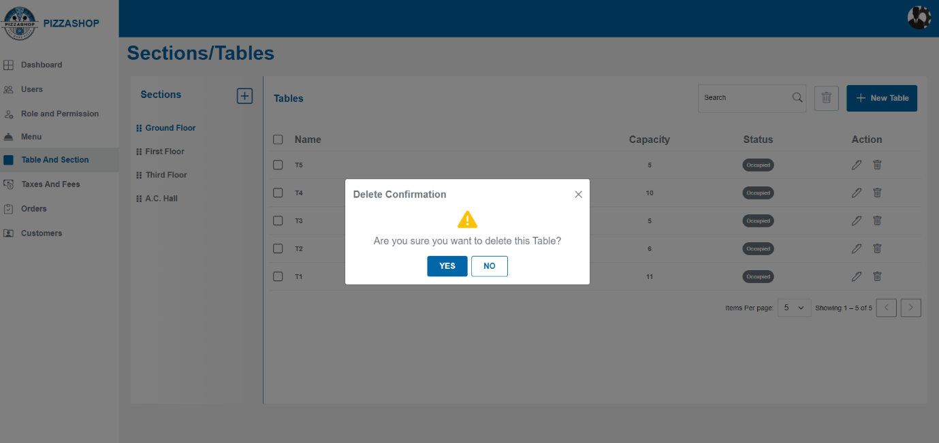Fig. Delete Table

**Features:**

|  |  |  |  |
| --- | --- | --- | --- |
| **#** | **Feature** | **Type** | **Description** |
| 1. | Message | Label | The confirmation box will display a clear message, such as: "Are you sure you want to delete this table?” |
| 2. | Yes | Button | 1.Proceed with the deletion of the table from the system.  2. Display a success message indicating that the "Table deleted successfully.”.  3. Refresh the table listing to reflect the change, removing the deleted table from the list. |
| 3. | No | Button | 1. Close the confirmation box. |
| 4. | X | Button | This will close the “Delete Confirmation” popup. |

**2.5 Taxes And Fees**

**Description:**

In a **Pizza Shop**, taxes and fees play a crucial role in ensuring that the business complies with local regulations and provides accurate pricing to customers. These are typically automated within the system to simplify the billing process.

**Taxes** are mandatory charges applied by the government, which vary based on location and local laws.

**List of Taxes/Fees**

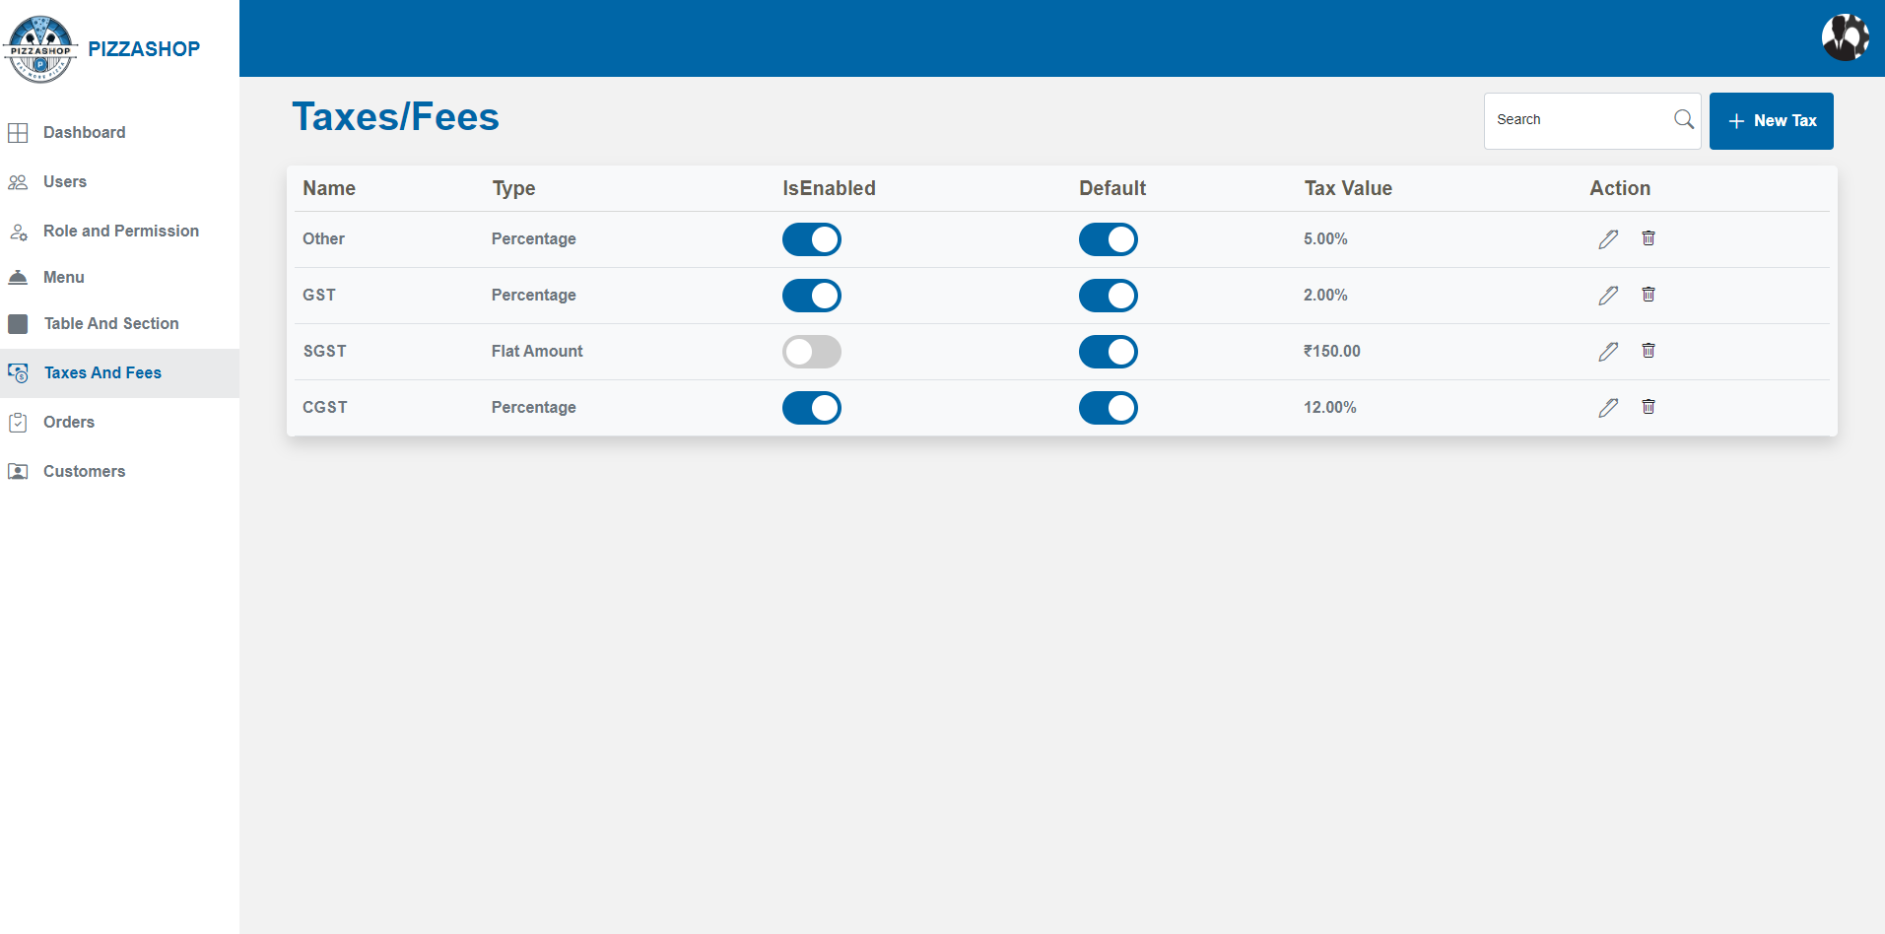Fig. Taxes/Fees

**Features:**

|  |  |  |  |
| --- | --- | --- | --- |
| **#** | **Feature** | **Type** | **Description** |
| 1. | Search | Textbox | Admin can search the tax-by-tax name. |
| 2. | New Tax | Button | By clicking on this “Add Tax” popup will appear. Admin can add the new tax. |
| 3. | Name | Textbox | This will show the name of the tax. |
| 4. | Type | Dropdown | This will show the type of tax. |
| 5. | IsEnabled | Button | If it is enabled means the particular tax will be applicable for every menu item. |
| 6. | Default | Button | If is Default is on means the default taxes will be applicable for every menu item. |
| 7. | Tax Value | Textbox | This will show the amount of the tax based on the type of the tax. |
| 8. | Action | Clickable Icons | Action contains the icons for editing and deleting the taxes. 1. Pencil Icon - By clicking on the pencil icon, the "Edit Tax” popup will appear on the screen. 2. By clicking on the delete icon “Delete Confirmation” popup will appear on the screen. |

**Add Tax: -**

Admin can add new tax by clicking on the “New Tax” button. On clicking the New Tax button “Add New Tax” popup will appear on the screen.

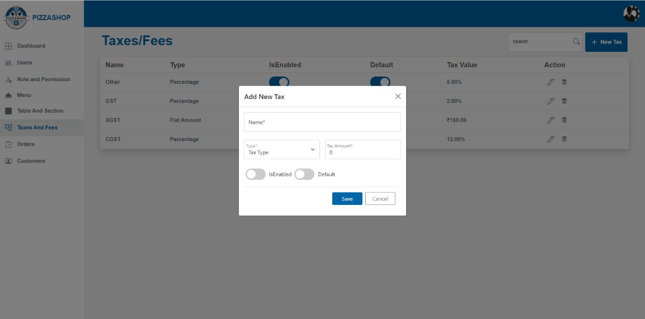Fig. Add New Tax

**Features:**

|  |  |  |  |
| --- | --- | --- | --- |
| **#** | **Feature** | **Type** | **Description** |
| 1. | Name | Textbox | This will show the name of the tax. |
| 2. | Tax Type | Dropdown | This will show the type of tax. |
| 3. | Tax Amount | Textbox | This will show the tax amount. |
| 4. | IsEnabled | Button | If it is enabled and default is on means the particular tax will be applicable for every menu item. |
| 5. | Default | Button | If Default is on means the particular tax will be applicable for every menu item. |
| 6. | Save | Button | This will add the details of the new tax. |
| 7. | Cancel | Button | This will discard any changes made in the form and close the “Add New Tax” popup. |
| 8. | X | Button | This will close the “Add New Tax” popup. |

**Edit Tax: -**

Admin can edit the existing tax by clicking the pencil icon from the Actions column. On clicking the pencil icon "Edit Tax" popup will appear on the screen.

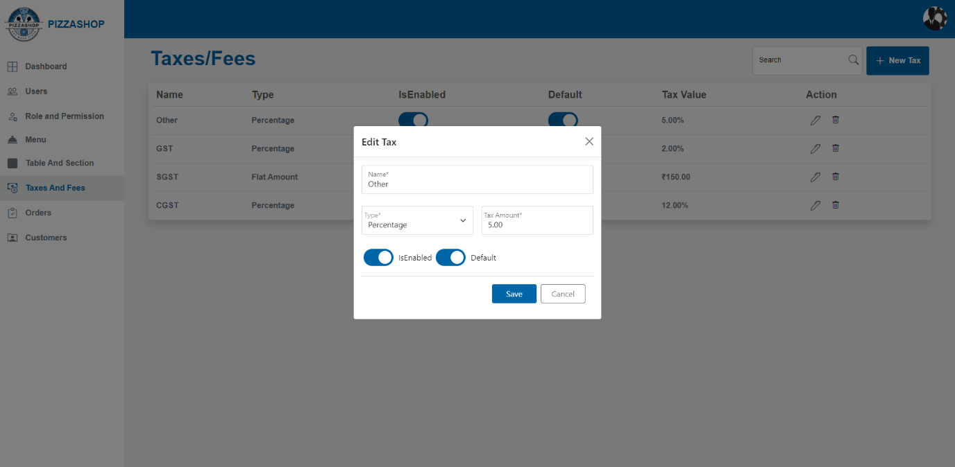Fig. Edit Tax

**Features:**

|  |  |  |  |
| --- | --- | --- | --- |
| **#** | **Feature** | **Type** | **Description** |
| 1. | Name | Textbox | This will show the name of the tax. |
| 2. | Type | Dropdown | This will show the type of tax. |
| 3. | Tax Amount | Textbox | This will show the tax amount. |
| 4. | IsEnabled | Button | If it is enabled means the particular tax will be applicable for every menu item. |
| 5. | Default | Button | If Default is on means the particular tax will be applicable for every menu item. |
| 6. | Save | Button | This will save the modified details of the tax. |
| 7. | Cancel | Button | This will discard any changes made in the form and close the “Edit Tax” popup. |
| 8. | X | Button | This will close the “Edit Tax” popup. |

**Delete Tax: -**

Admin can delete the tax by clicking the trash icon from the Actions column. On clicking the trash icon "Delete Confirmation" popup will appear on the screen as shown in the below image.

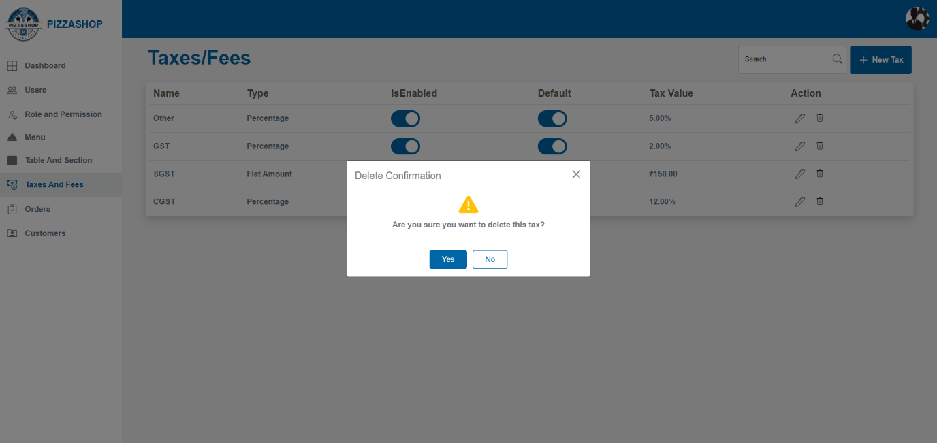Fig. Delete Tax

**Features:**

|  |  |  |  |
| --- | --- | --- | --- |
| **#** | **Feature** | **Type** | **Description** |
| 1. | Message | Label | The confirmation box will display a clear message, such as: "Are you sure you want to delete this tax?” |
| 2. | Yes | Button | 1.Proceed with the deletion of the tax from the system.  2. Display a success message indicating that the "Tax deleted successfully.”.  3. Refresh the tax listing to reflect the change, removing the deleted tax from the list. |
| 3 | No | Button | 1. This will close the confirmation popup. |
| 4 | X | Button | This will close the confirmation popup. |

**2.6 Orders**

**Description:**

In a **Pizza Shop**, **orders** refer to the collection of customer requests for food and beverages made during their dining experience. The orders are typically linked to specific tables of the sections in the restaurant and are handled by staff such as Account Managers or servers.

* In the **Super Admin Dashboard**, there is an **Orders Module** that displays all the orders created by the Account Managers. The **Orders** feature plays an important role, managing everything from customer requests.
* First the Account manager creates the customer order from the **Order App** and then the Orders will display in the **Orders Module** in the **Super Admin Dashboard.**

All customer’s orders created by the **Account Manager** in the **Order App** can be viewed by the **Super Admin** in the **Orders Module**.

**Order List in the Orders Module in Super Admin Dashboard**:

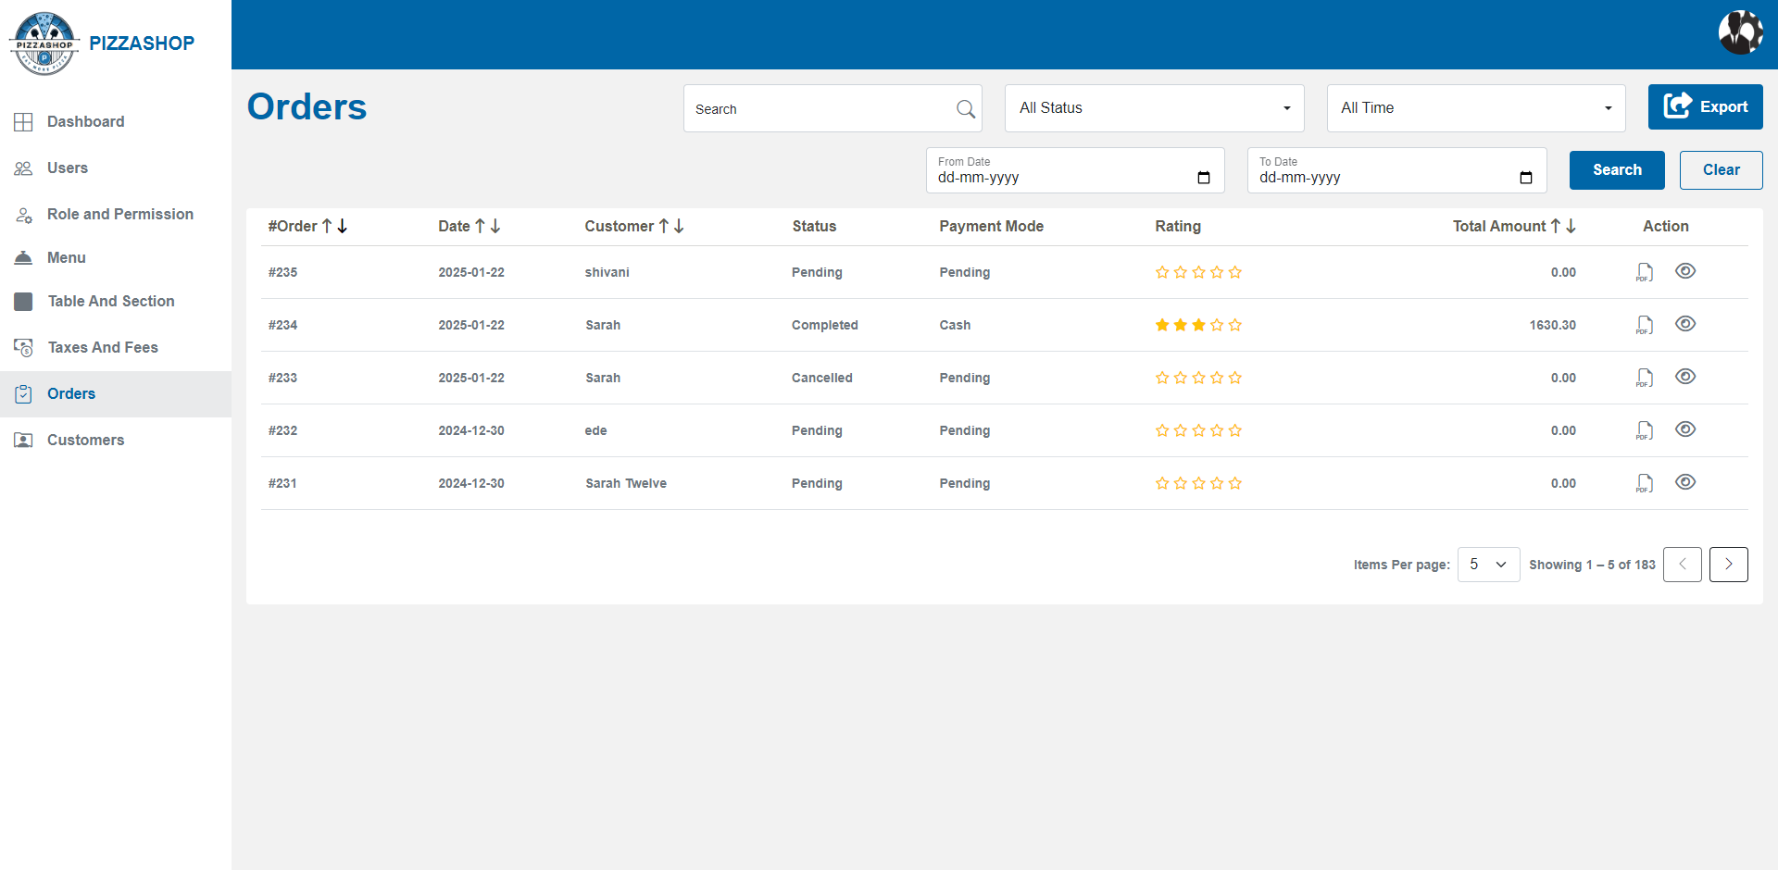Fig. Order List in Super Admin Dashboard

**Features:**

|  |  |  |  |
| --- | --- | --- | --- |
| **#** | **Feature** | **Type** | **Description** |
| 1. | Search | Textbox | This will search the order-by-Order Id and show the search result. |
| 2. | Status | Dropdown | This will show the orders as per the status of order: All Status, Pending, In Progress, Served, Completed, Cancelled, On Hold, Failed. All Status should be the default option in the dropdown. |
| 3. | Date Range | Dropdown | This will show the orders as per the Date Range selected: Last 7 days, Last 30 days, All time, Current Month. All Time should be the default option in the dropdown |
| 4. | Export | Button | This feature allows admin to export order details into an Excel sheet. The excel sheet will show the **order status,** **search text** by which the order has searched and exported and contains the Date, No. Of Records, Total Amount. When the export button is clicked, an Excel file containing the filtered order details will be generated and downloaded to the user's system. |

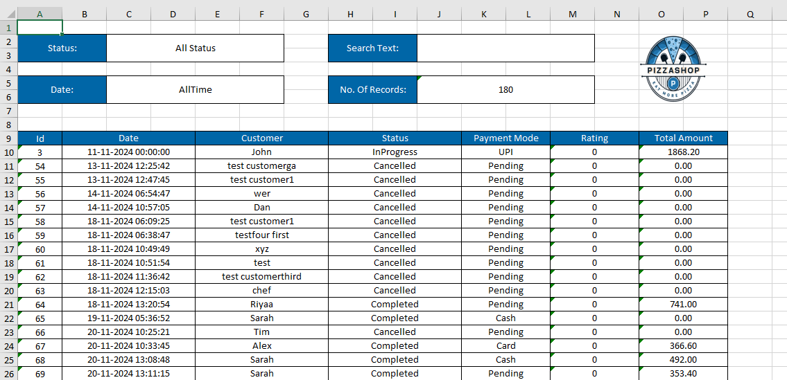

|  |  |  |  |
| --- | --- | --- | --- |
| 5. | From Date | Input Field | Allows the user to select the **starting date** of the range from which orders will be filtered. |
| 6. | To Date | Input Field | Allows the user to select the **ending date** of the range up to which orders will be filtered. |
| 7. | Search | Button | Applies the date filter and refreshes the order list. |
| 8. | Clear | Button | This will clear all the dropdowns and show the default option in the dropdown and clear the searched results of orders. |
| 9. | Order Id | Text | This will show the order id for the customer order. |
| 10. | Date | Text | This will show the date of the order placed by the customer. |
| 11. | Customer | Text | This will show the customer's name. |
| 12. | Status | Text | This will show the status of the order: Pending, Completed, InProgress, Running etc. |
| 13. | Payment Mode | Text | This will show the payment mode: Online, Crad, Cash done by the customer for the order. |
| 14. | Rating | Text | This will show the customer's rating for the order. |
| 15. | Total Amount | Text | This will show the total amount of the order including the taxes like additional or default tax if applicable. |
| 16. | Action | Icon | Action contains the icons for downloading the invoice and viewing the order details. 1. Download file Icon - By clicking on the download file icon, admin can download the invoice as pdf. 2. By clicking on the eye icon admin can see the order details. |
| 17. | Sorting | Dropdown/Clickable Column Headers | Admin can sort orders by Order, Date, Customer, and Total Amount in ascending or descending order. Sorting is implemented server-side, ensuring efficient performance even with large datasets. |
| 18. | Pagination | Dropdown & Navigation Buttons | Admin can select the number of items displayed per page (5, 10, 15). Navigation buttons allow switching between pages. Pagination is managed server-side to handle large datasets effectively. |

**Download Invoice**

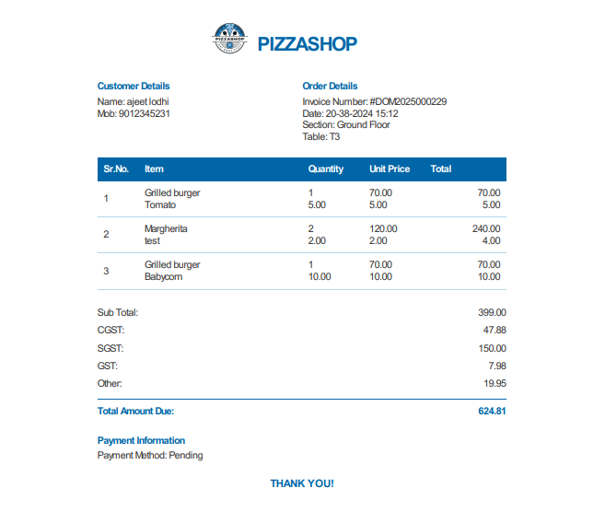Fig. Download invoice As Pdf

**View the Order Details**

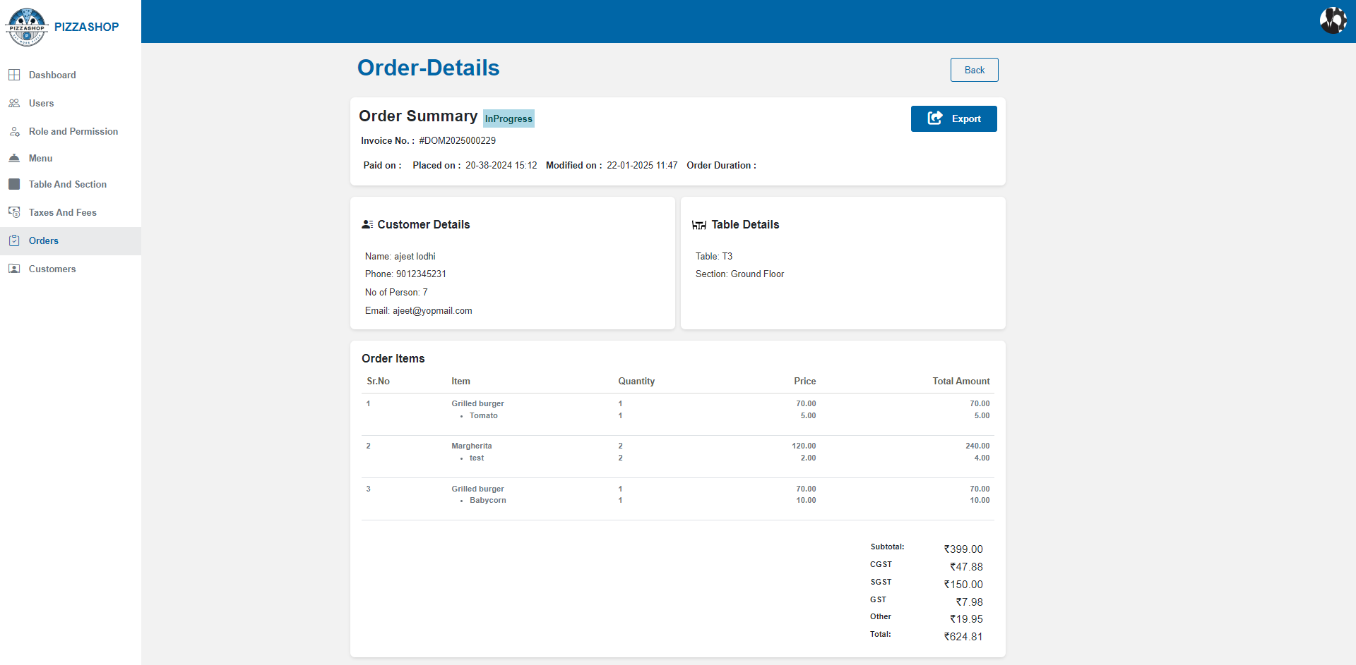Fig. View the order details.

**2.7 Customers**

**Description: -**

In a restaurant management system, **customers** refer to the individuals or groups who visit the restaurant to dine or place orders.

**Steps to Create a Customer as an Account Manager:**

1. Log in as an Account Manager.
2. Navigate to the Order App, where inside in the tables menu you can view all the sections (e.g. ground floor, First floor, Roof Top) of Pizza Shop.
3. Expand the desired section to see the available tables in that area.
4. Select the table and click on the Assign button the customer details popup will appear on the screen.
5. Enter the customer's details in the popup and click the "Assign" button.
6. Once the details are submitted, the customer will be created.
7. The Super Admin can view all customers in the "**Customer**" menu.

**Customer List in Super Admin Dashboard**

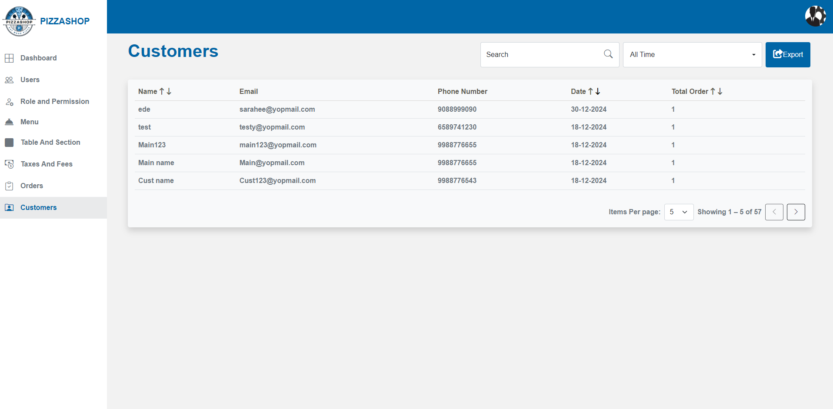Fig. Customers List

**Features:**

|  |  |  |  |
| --- | --- | --- | --- |
| **#** | **Feature** | **Type** | **Description** |
| 1. | Search | Textbox | This will search the customer-by-customer name and show the search result. |
| 2. | Date Range | Dropdown | This will show the customers as per the Date Range selected: All Time, Today, Last 7 days, Last 30 days, All time, Current Month, Custom Date. All Time should be the default option in the dropdown. |

When the user selects the **Custom Date** filter option from the date range dropdown, a modal dialog box titled **"Select Date Range"** will be displayed on the screen.

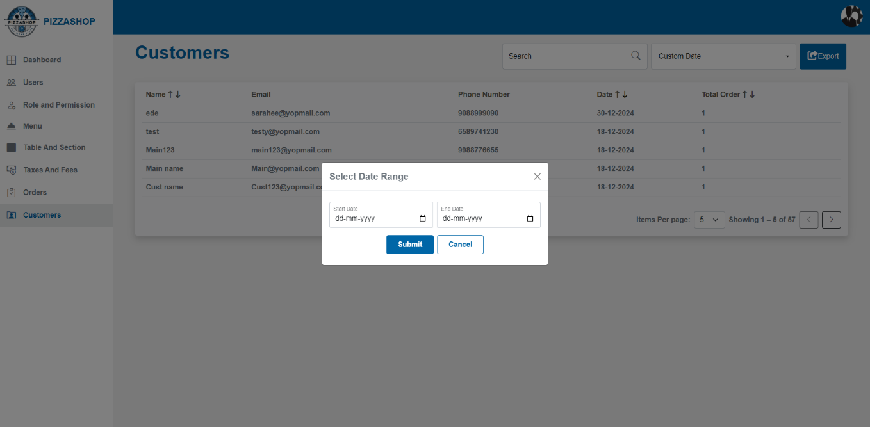

**Features of Select Date Range Modal:**

|  |  |  |  |
| --- | --- | --- | --- |
| **#** | **Feature** | **Type** | **Description** |
| 1. | Select Date | Input Field | Allows the user to select the starting date of the range. |
| 2. | End Date | Input Field | Allows the user to select the ending date of the range. |
| 3. | Submit | Button | Applies the date filter and refreshes the order list. |
| 4. | Cancel | Button | Closes the modal without applying any filters. |
| 5. | X | Button | Allows users to close the modal without clicking the Cancel button. |

Note: - 1. Only orders falling within the selected date range will be displayed.

2. Start Date and End Date must be in a valid date format.

3. Both fields are mandatory for submission.

|  |  |  |  |
| --- | --- | --- | --- |
| 3. | Export | Button | This feature allows admin to export customer details into an Excel sheet. The excel sheet will show the **Date,** **No. Of Records** and **search text** by which the order has searched and exported. When the export button is clicked, an Excel file containing the filtered customer details will be generated and downloaded to the user's system. |

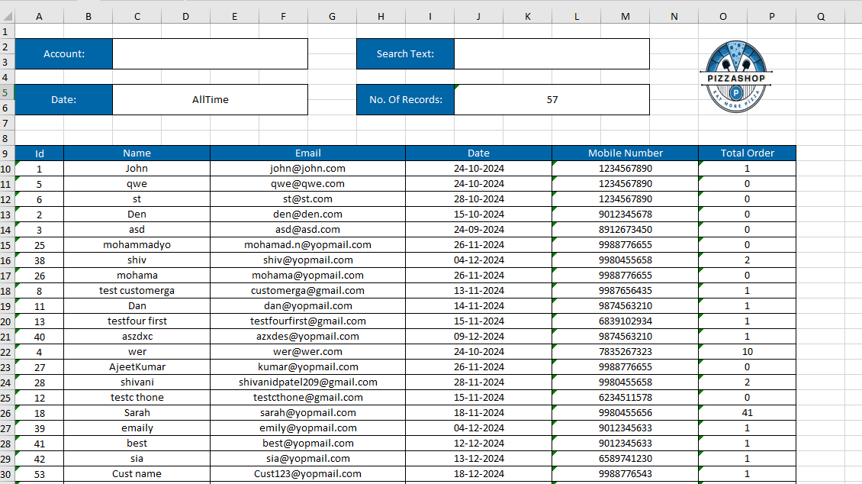Fig. Export to excel customer details

|  |  |  |  |
| --- | --- | --- | --- |
| 4. | Name | Textbox | This will show the name of the customer who has placed the order. |
| 5. | Email | Textbox | This will show the email of the customer. |
| 6. | Date | Textbox | This will show the date of the order placed. |
| 7. | Phone Number | Textbox | This will show the phone no. of the customer. |
| 8. | Sorting | Dropdown/Clickable Column Headers | Admin can sort customers by Name, Date, and Total Order in ascending or descending order. Sorting is implemented server-side, ensuring efficient performance even with large datasets. |
| 9. | Pagination | Dropdown & Navigation Buttons | Admin can select the number of items displayed per page (5, 10, 15). Navigation buttons allow switching between pages. Pagination is managed server-side to handle large datasets effectively. |

**Customer History**

The admin can view detailed customer history by clicking anywhere on a row in the customer list. Once a row is clicked, a **Customer Detail Popup** will appear on the screen, displaying the customer’s information, including their history.

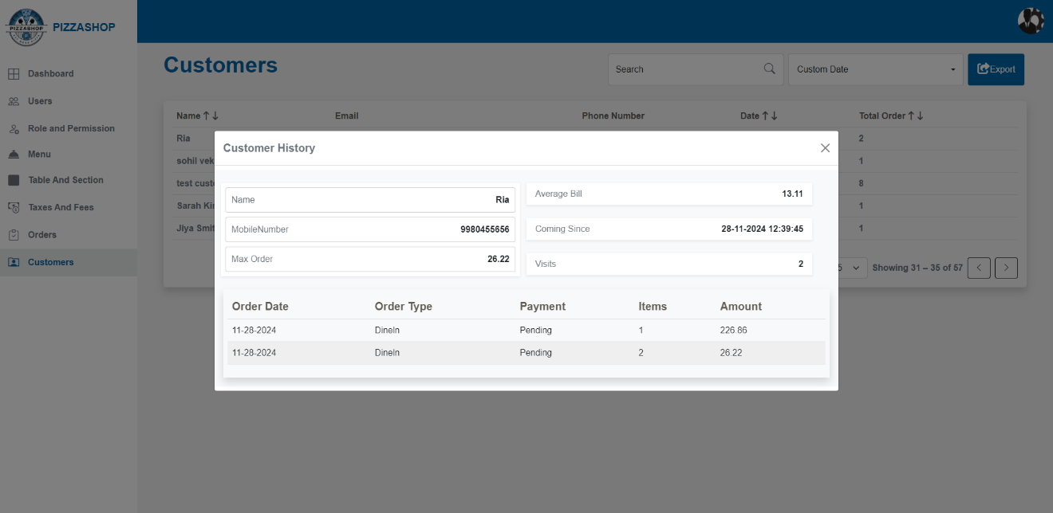

Fig. Customer History

**Features:**

|  |  |  |  |
| --- | --- | --- | --- |
| **#** | **Feature** | **Type** | **Description** |
| 1. | Name | Textbox | This will show the name of the customer. |
| 2. | Average Bill | Textbox | This will show the average bill amount of the customer. |
| 3. | Mobile Number | Textbox | This will show the mobile number of the customer. |
| 4. | Coming Since | Textbox | This will show when the customer first started coming. |
| 5. | Max Order | Textbox | This will show the highest order value for the customer. |
| 6. | Visits | Textbox | It will show how many times a customer has visited Pizza Shop. |
| 7. | Order Date | Textbox | It will show the date of the order placed. |
| 8. | Order Type | Textbox | It will show the type of order. |
| 9. | Payment | Textbox | This will show the mode of payment used by the customer. |
| 10. | Items | Button | It will show the number of food items ordered. |
| 11. | Amount | Button | It will show the amount of the order placed. |
| 12. | X | Button | This will close the popup. |

**3. Account Manager Dashboard**

**Description: -**

The Account Manager feature in a Pizza Shop is designed to facilitate the management of user accounts, ensuring that administrators can effectively oversee user access, roles, and resources associated with each account.

The Account Manager is a crucial component of the Pizza Shop that empowers administrators to maintain control over user accounts and ensure secure, efficient access to resources. By providing comprehensive management features, it helps in optimizing user interactions with the system while maintaining security and compliance standard.

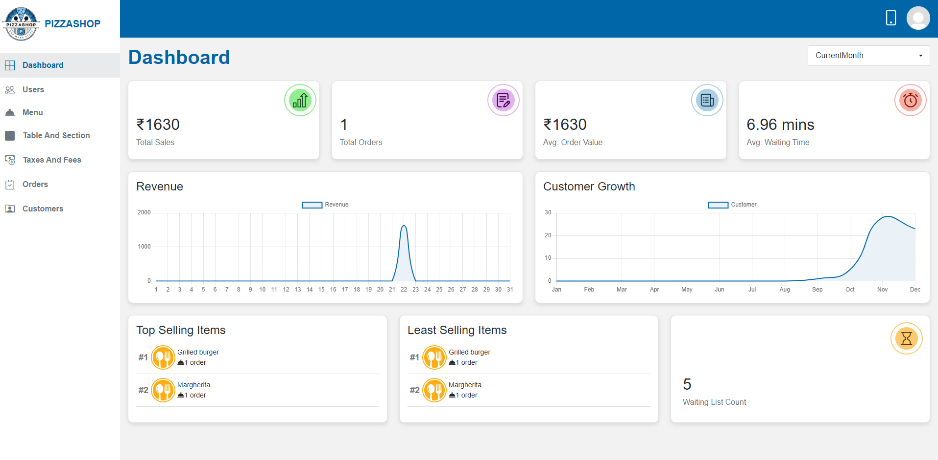Fig. Account Manager Dashboard

**Features of Account Manager Dashboard**

**1. My Profile Icon (My Profile)**

**Description:**

This section describes the functionality associated with the user profile icon in the navigation bar of the Pizza Shop. When a user clicks on the profile icon, a popup will display with username and the three clickable options: "My Profile", "Change Password" and "Logout."

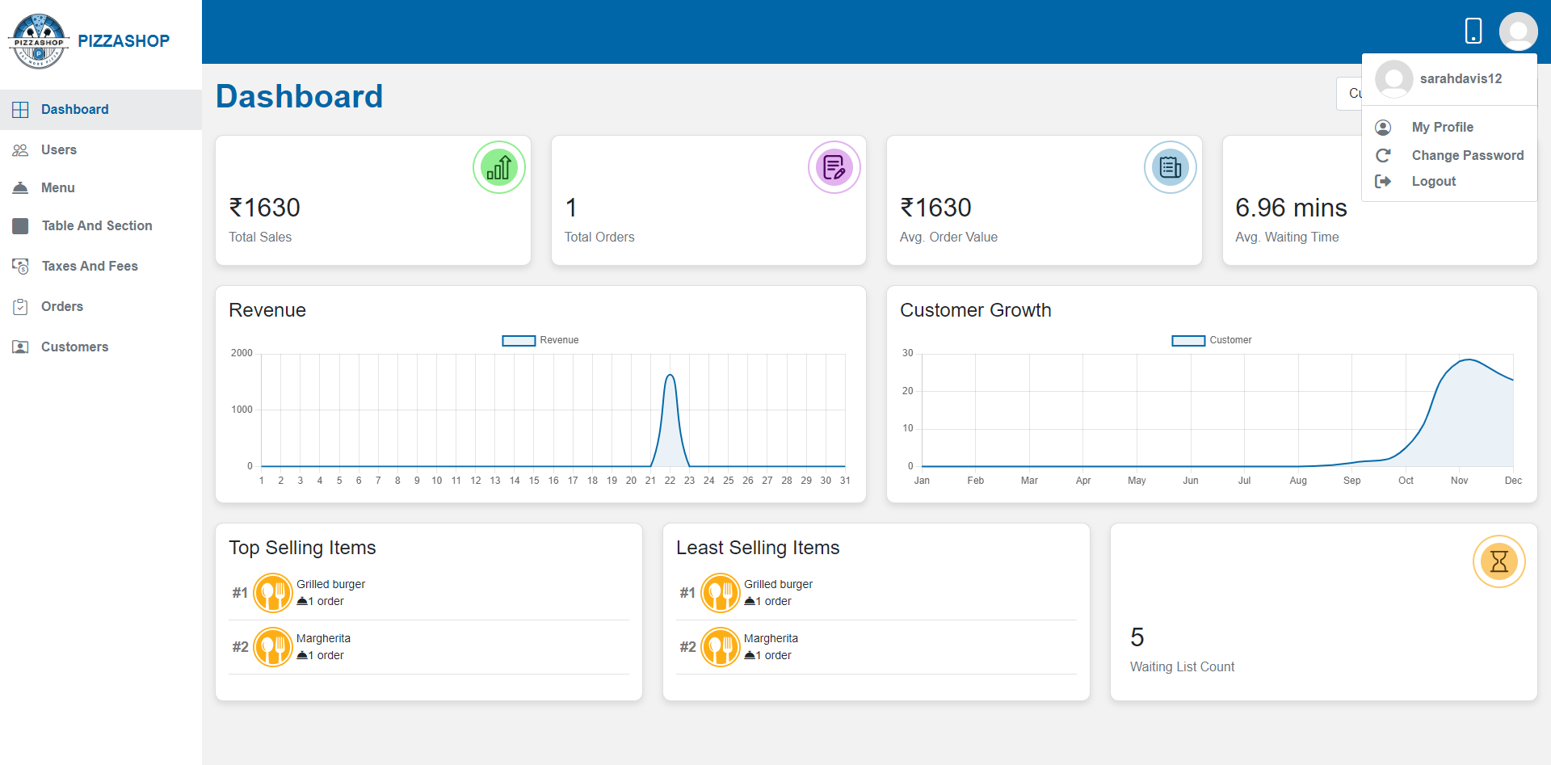Fig. My Profile popup

**1.1 My Profile**: Redirects to the user's profile page.

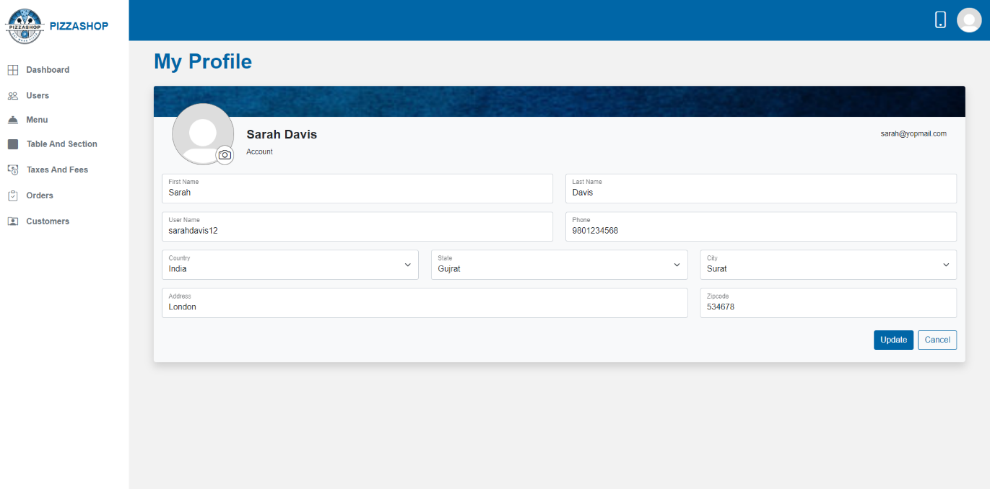Fig. My Profile

**Features:**

|  |  |  |  |
| --- | --- | --- | --- |
| **#** | **Feature** | **Type** | **Description** |
| 1. | First Name | Textbox | This will show first-name of the user. |
| 2. | Last Name | Textbox | This will show the last name of the user. |
| 3. | Username | Textbox | This will show the Username of the logged in user. |
| 4. | Phone Number | Textbox | This will show the phone number of the user. |
| 5. | Country | Textbox | It will show the country of the user. |
| 6. | State | Textbox | It will show the state of the user. |
| 7. | City | Textbox | It will show the city of the user. |
| 8. | Address | Textbox | It will show the address of the user. |
| 9. | Zip Code | Textbox | It will show zip code associated with the user address. |
| 10. | Update | Button | Updates the user’s profile. |
| 11. | Cancel | Button | Closes my profile page. |

**1.2 Change Password:** Redirects to the change password page.

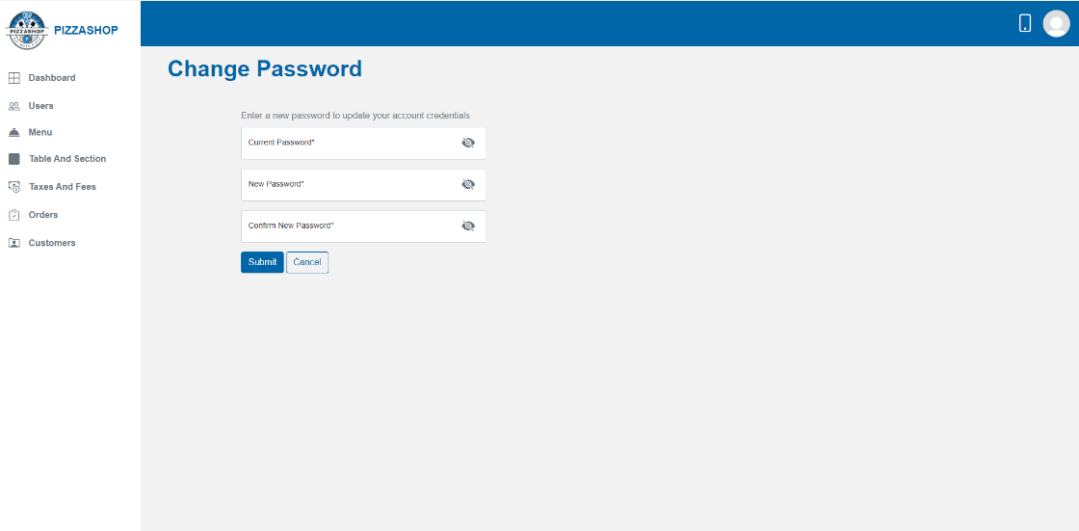

Fig. Change Password

**Features:**

|  |  |  |  |
| --- | --- | --- | --- |
| **#** | **Feature** | **Type** | **Description** |
| 1. | Current Password | Textbox | This will show the current password. |
| 2. | New Password | Textbox | This will show the new password. |
| 3. | Confirm New Password | Textbox | This will show the confirm new password. |
| 4. | Submit | Button | This will update the new password. |
| 5. | Cancel | Button | This will close the change password page. |

**1.3 Logout:** Logs the user out of the system and redirects to the login page.

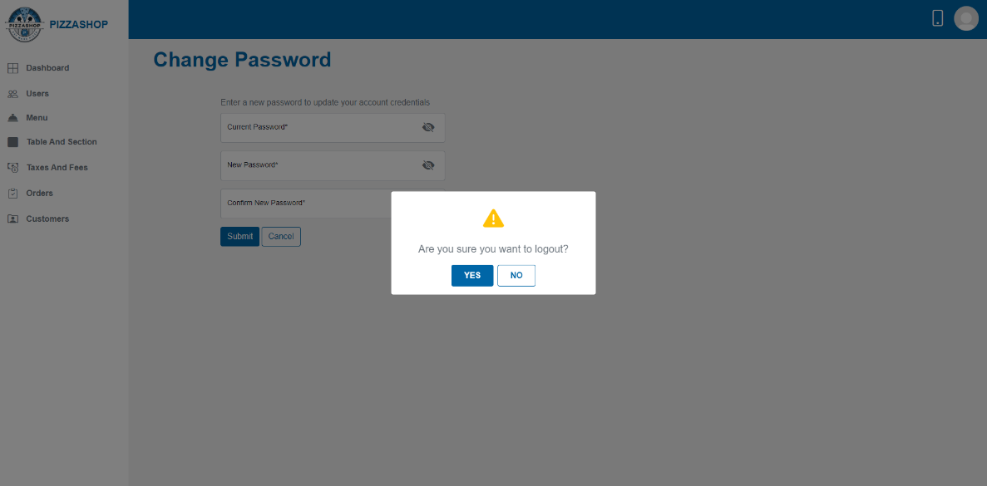

Fig. Logout

|  |  |  |  |
| --- | --- | --- | --- |
| **#** | **Feature** | **Type** | **Description** |
| 1. | Confirmation box | Confirmation box | This will ask, “Are you sure you want to log out?” |
| 2. | Yes | Textbox | This will log the user out. |
| 3. | No | Button | This will close the confirmation box, and user will remain Logged in. |

**2. Navigation Pane (Left Pane)**:

The navigation pane is located on the left side of the screen and provides quick access to various modules within the system. Each menu item in this pane leads to a specific page:

## **Features:**

|  |  |  |  |
| --- | --- | --- | --- |
| **#** | **Feature** | **Type** | **Description** |
| 1. | Dashboard | Hyperlink | Opens the main dashboard, displaying an overview of key metrics and system activity using tiles and charts. |
| 2. | Users | Hyperlink | Navigates to the **Users** page, where the admin can view, add, edit, or delete users. |
| 3. | Role and Permission | Hyperlink | Leads to the Roles page, allowing the admin to manage access levels for different user roles. |
| 4. | Taxes and Fees | Hyperlink | Opens the Taxes/Fees page, where applicable taxes and fees can be added, edit and delete by the admin. |
| 5. | Tables and Sections | Hyperlink | Directs to the **Sections/Tables** page, where the admin can view, add, update, delete and search the tables and sections. |
| 6. | Orders | Hyperlink | Brings the user to the **Orders** page, displaying all current and past orders with options for order management. |
| 7. | Customers | Hyperlink | Opens the **Customers** page, where customer information can be viewed and managed. |
| 8. | Menu | Hyperlink | Opens the **Menu** page, allowing the admin to add, edit, or delete menu items/category/modifier group/modifier. |

**3. Tiles and Charts**

**Description:**

The **Account Manager Dashboard** provides a quick, high-level overview of the key metrics in the Pizza Shop. Each tile on the dashboard represents a different metric that helps the Account Manager monitor customer activity, demand, and order statistics effectively. This dashboard enables the Account Manager to monitor restaurant operations, customer activity, and trends at a glance.

## **Features:**

|  |  |  |  |
| --- | --- | --- | --- |
| **#** | **Feature** | **Type** | **Description** |
| 1. | Total sales | Tile | This feature calculates and displays the total revenue generated by the restaurant for a given period (today, Last 7 days, Last 30 days, Current Month or a custom date). |
| 2. | Total Orders | Tile | * Displays the total number of orders placed in the Pizza Shop. Show total orders for today, Last 7 days, Last 30 days, Current Month or a custom date as per the options selected from the dropdown. * Update automatically as new orders are placed. |
| 3. | Avg. Order Value | Tile | * This feature calculates and displays the average value of orders placed within a specific time frame (Today, Last 7 days, Last 30 days, Current Month or a custom date). |
| 4. | Avg. Waiting Time | Tile | * This feature calculates and displays the average waiting time for customers from the time an order is placed until it is served. |
| 5. | Revenue | Chart | * The Revenue chart displays the restaurant's total revenue trends over a selected period, helping the management analyse financial performance. * The system shall plot revenue trends over time (Today, Last 7 days, Last 30 days, Current Month or a custom date). * The system shall fetch and display the total revenue data from the database based on selected time intervals. |
| 6. | Customer Growth | Chart | * The Customer Growth chart visualizes the growth in the number of customers over a specific time frame, enabling the management to track customer acquisition and retention. * The system shall plot the number of unique customers visiting the restaurant over time. |
| 7. | Top Selling and Least Selling Items | List | * Two lists show the top-selling and least-selling items based on order frequency over a selected period (today, Last 7 days, Last 30 days, Current Month or a custom date). * Display two separate lists showing the food items with the highest and lowest demand. |
| 8. | Waiting List Count | Tile | * Shows the current number of customers in the waiting list. Display the count of active waiting tokens for tables as per the option selected from dropdown like today, Last 7 days, Last 30 days, Current Month or a custom date as per the options selected from the dropdown. * Update in real-time as customers are added to or removed from the waiting list. |
| 9. | New Customers | Tile | * Show the count of first-time visitors. * Filter by time (today, Last 7 days, Last 30 days, Current Month or a custom date) to view new customer growth trends. * Update automatically as new customer profiles are created. |

# **3.1 Users**

**Description: -**

This User module is part of an Account Manager Dashboard designed to manage various aspects of the application, including user management.

This module will allow Account Manager to manage users effectively through functionalities such as searching, adding, editing, and deleting user accounts.

**Note: - Account Manager can create User as per different role such as Chef, Account Manager.**

Users List: Here is list of all active/inactive users.

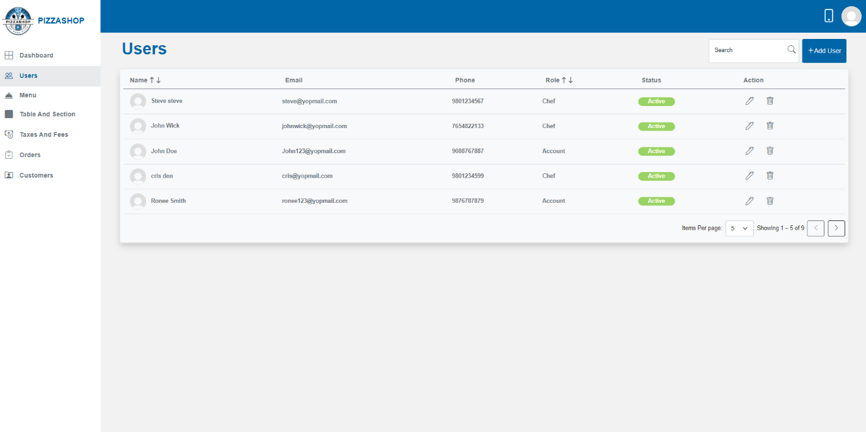 Fig. Users List

**Features:**The features of the User List for the Super Admin and Account Manager are the same, but consider the **Account Manager** instead of the **Super Admin**.

|  |  |  |  |
| --- | --- | --- | --- |
| S. No. | **Reference** | **Page No.** | **Description** |
| 1. | Features of user list: | 11 | By clicking on the Reference with Ctrl (Features of User list: + Ctrl) or Page No. with Ctrl (11 + Ctrl), it will redirect to the reference. |

**Add New User:**

Account Manager can create User as per different role such as Chef, Account Manager. By clicking on the **New User** button, the **Add New User** page will appear on the screen.

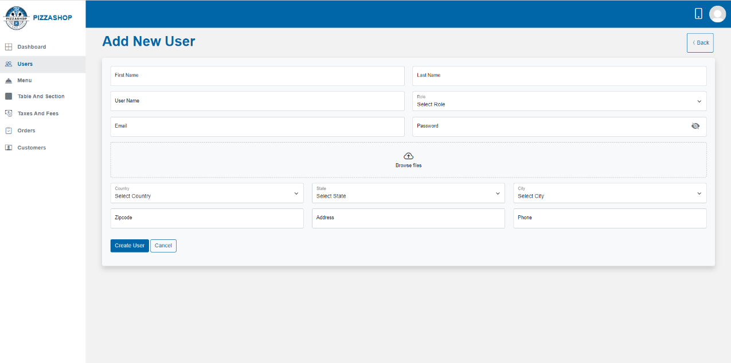

Fig. Add New User

**Features:**The features of the Add New User for the Super Admin and Account Manager are the same, but consider the **Account Manager** instead of the **Super Admin**.

|  |  |  |  |
| --- | --- | --- | --- |
| S. No. | **Reference** | **Page No.** | **Description** |
| 1. | Features of New User: | 19 | By clicking on the Reference with Ctrl (Features of New User: + Ctrl) or Page No. with Ctrl (11 + Ctrl), it will redirect to the reference. |

Note: - 1. If the user selects a state before selecting a country or selects the city before selecting the state and country a validation message should appear on the screen stating, 'Please select country first,' as shown in the image below.

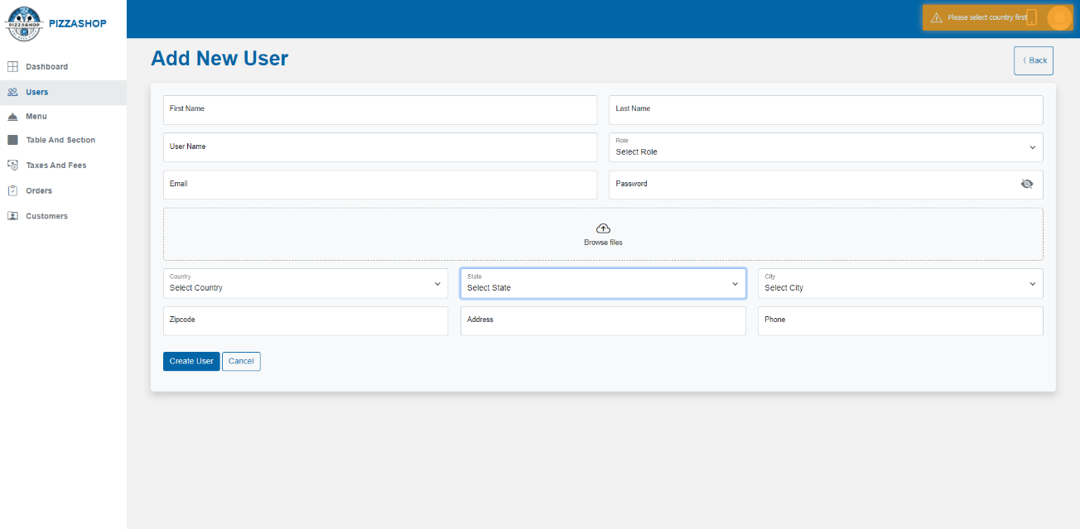

Fig. Country, State, City validation

2. If the user selects a city before selecting a state, a validation message should appear on the screen stating, 'Please select state first,' as shown in the image below.

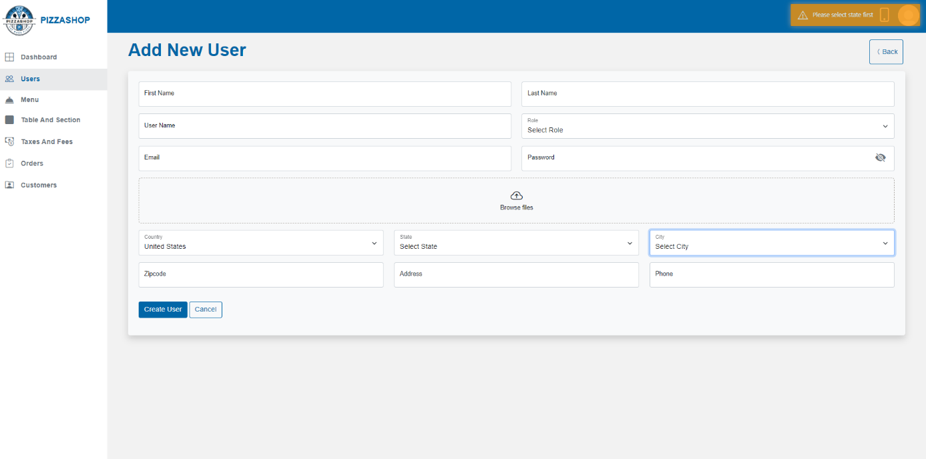Fig. State, City validation

**Edit User: -**

Account Manager can edit the specific user from the list on clicking the "Pencil" icon from the Action column on Users page. On clicking the edit icon, the “Edit User” page will appear as shown in the below image.

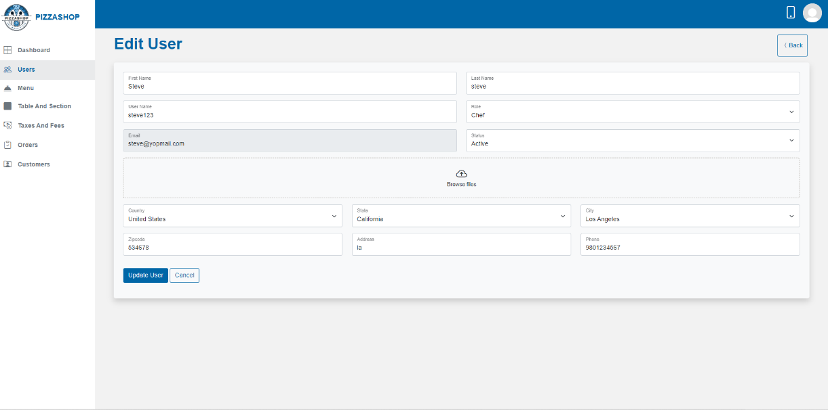

Fig. Edit User

**Features:**The features of the Edit User for the Super Admin and Account Manager are the same, but consider the **Account Manager** instead of the **Super Admin**.

|  |  |  |  |
| --- | --- | --- | --- |
| S. No. | **Reference** | **Page No.** | **Description** |
| 1. | Features of Edit User: | 23 | By clicking on the Reference with Ctrl (Features of Edit User: + Ctrl) or Page No. with Ctrl (14 + Ctrl), it will redirect to the reference. |

**Delete User: -**

Account Manager can delete the specific user from the list on clicking the "Trash" icon from the Action column on Users page. On clicking on trash icon, a confirmation box will show asking that “Are you sure you want to delete User?” and contains “Yes” and “No” Buttons. This box will require the administrator to confirm their action before proceeding with the deletion.

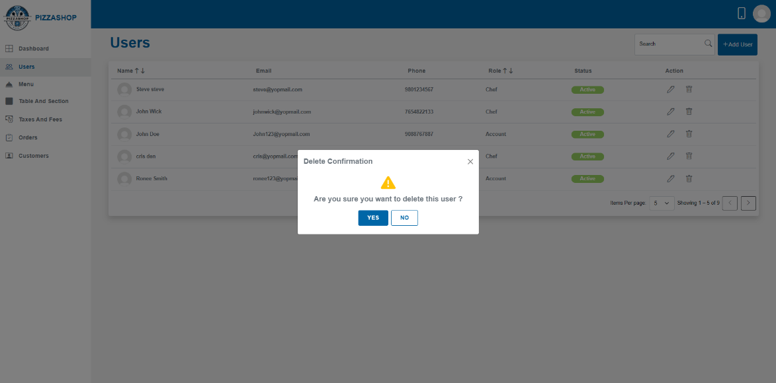

Fig. Delete User

**Features:**The features of the Delete User for the Super Admin and Account Manager are the same, but consider the **Account Manager** instead of the **Super Admin**.

|  |  |  |  |
| --- | --- | --- | --- |
| S. No. | **Reference** | **Page No.** | **Description** |
| 1. | Features of Delete User: | 25 | By clicking on the Reference with Ctrl (Features of Delete User: + Ctrl) or Page No. with Ctrl (16 + Ctrl), it will redirect to the reference. |

**3.2 Menu**

Description**:**

A menu in a restaurant is a list of food and beverage items available for customers to order. The account manager can view the list of food items, add the categories. The account manager can also edit or delete both categories and items and set the availability of food items. Additionally, the admin can search for food items.

The Module Menu serves as the central navigation point for accessing various components of the restaurant management system, including items and modifiers. In the items we have Category and in Modifiers we have Modifier Group.

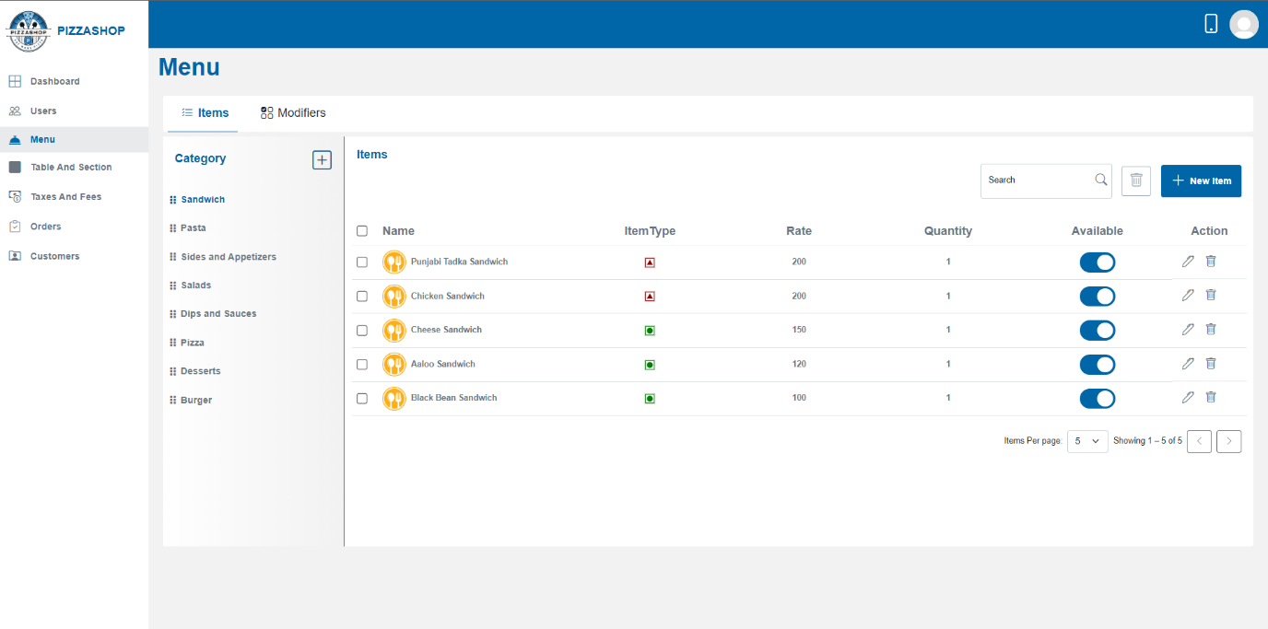Fig. Menu

**Features:**The features of the Menu for the Super Admin and Account Manager are the same, but consider the **Account Manager** instead of the **Super Admin**.

|  |  |  |  |
| --- | --- | --- | --- |
| S. No. | **Reference** | **Page No.** | **Description** |
| 1. | Features of Menu: | 29 | By clicking on the Reference with Ctrl (Features of Menu: + Ctrl) or Page No. with Ctrl (19 + Ctrl), it will redirect to the reference. |

**3.2.1 Items>> Category: -**

Food categories are classifications used to organize various types of food based on their characteristics, ingredients, preparation methods. Account Manager can add, edit and delete the categories.

**Add Category: -**

Account Manager can add a new category to the restaurant by clicking the plus icon. On clicking the plus icon, the “Add Category” popup will appear on the screen.

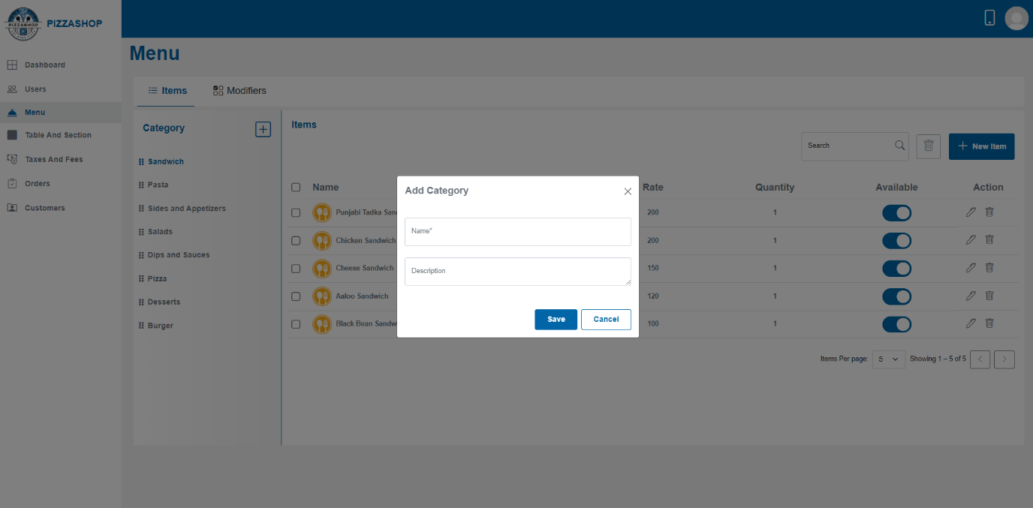Fig. Add Category

**Features:**The features of the Add Category for the Super Admin and Account Manager are the same, but consider the **Account Manager** instead of the **Super Admin**.

|  |  |  |  |
| --- | --- | --- | --- |
| S. No. | **Reference** | **Page No.** | **Description** |
| 1. | Features of Add Category: | 30 | By clicking on the Reference with Ctrl (Features of Add Category: + Ctrl) or Page No. with Ctrl (20 + Ctrl), it will redirect to the reference. |

**Edit category: -**

Admin can edit the details of an existing Category by clicking the pencil icon besides the name of the category. On clicking the pencil icon, the “Edit Category” popup will appear on the screen.

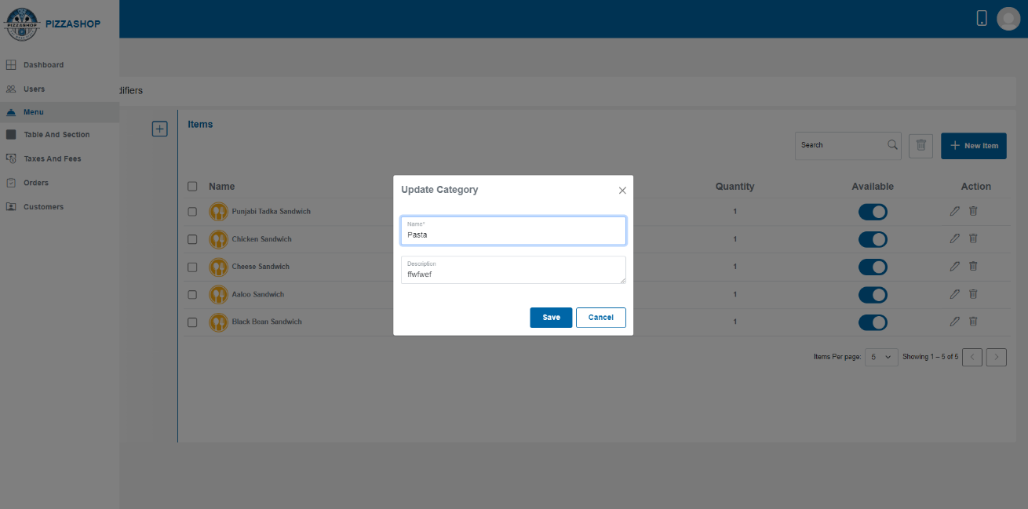

Fig. Edit Category

**Features:**The features of the Edit Category for the Super Admin and Account Manager are the same, but consider the **Account Manager** instead of the **Super Admin**.

|  |  |  |  |
| --- | --- | --- | --- |
| S. No. | **Reference** | **Page No.** | **Description** |
| 1. | Features of Edit Category: | 31 | By clicking on the Reference with Ctrl (Features of Edit Category: + Ctrl) or Page No. with Ctrl (22 + Ctrl), it will redirect to the reference. |

**Delete category: -**

Account Manager can delete the category by clicking the trash icon inside the “Edit Category” popup.

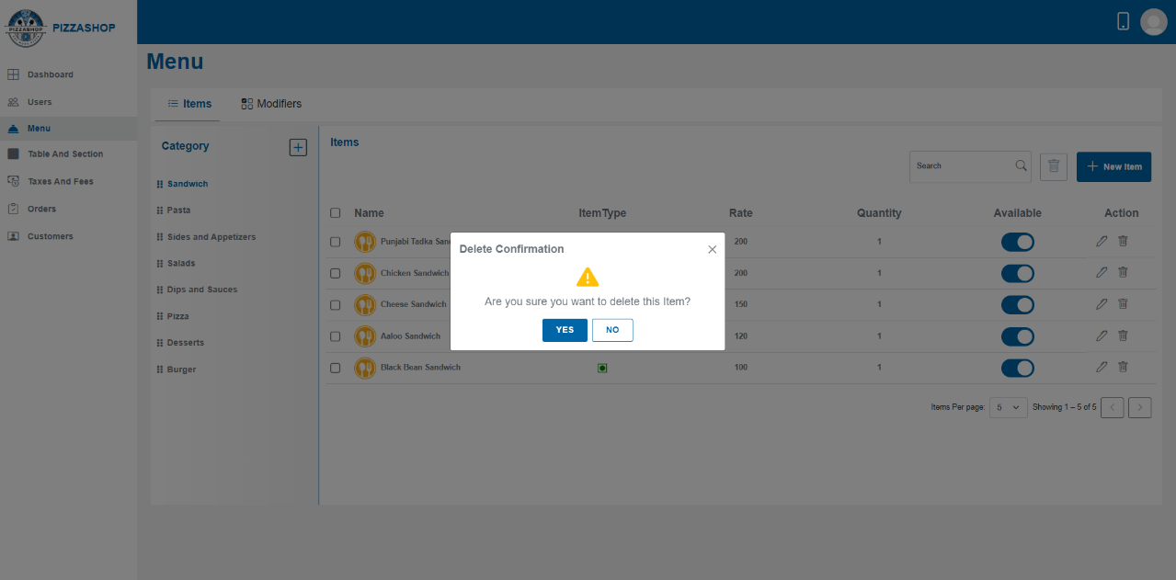

Fig. Delete Category

**Features:**The features of the Delete Category for the Super Admin and Account Manager are the same, but consider the **Account Manager** instead of the **Super Admin**.

|  |  |  |  |
| --- | --- | --- | --- |
| S. No. | **Reference** | **Page No.** | **Description** |
| 1. | Features of Delete Category: | 32 | By clicking on the Reference with Ctrl (Features of Delete Category: + Ctrl) or Page No. with Ctrl (23 + Ctrl), it will redirect to the reference. |

**3.2.2 Items>>Items: -**

Food items are the core components of the restaurant menu, representing the dishes available for customers to order. Each food item can be associated with a category and may include various modifiers for customization. Account Manager can see the types of food category items by clicking on the food category**.**

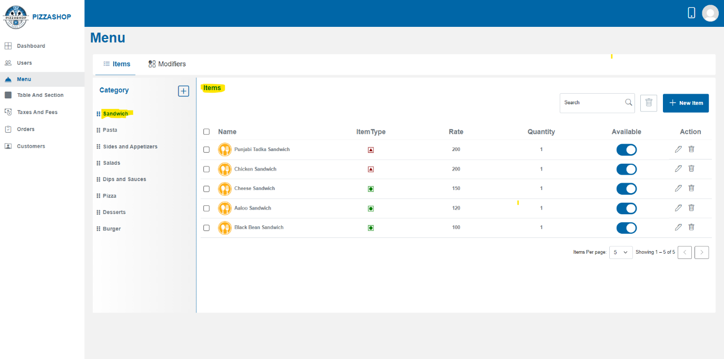Fig. Items in Sandwich Category

**Note**: The **Add Item**, **Edit Item**, and **Delete Item, Delete selected Item/Items** functionalities for the **Super Admin** and **Account** Manager are the same. While creating these features for the Account Manager, just consider the Account Manager instead of the Super Admin. By clicking on the reference and pressing Ctrl (e.g., **Add Item: + Ctrl**), or page no and pressing Ctrl (e.g., **24+ Ctrl**) you can navigate to the Add Item functionality for the Super Admin and use it as a reference to create the functionality for the Account Manager.

|  |  |  |  |  |
| --- | --- | --- | --- | --- |
| S. No. | **Functionality** | **Description of functionality** | **Click on this Reference** | **Page No.** |
| 1. | **Add Item** | Account Manager can add a new item to the restaurant by clicking the “New Item” button. | Add Item: - | 35 |
| 2. | **Edit** **Item** | Account Manager can edit the existing item by clicking the pencil icon from Action. | **Edit Item: -** | 36 |
| 3. | **Delete Item** | Account Manager can delete the existing item by clicking the trash icon from Action. | **Delete Item: -** | 38 |

4. **Delete Selected Item/Items: -**

Account manager can delete a selected Item/Items. Account manager selects an Item/items from the list by checking the checkbox(s) besides the item and clicks the "Delete" button next to search.

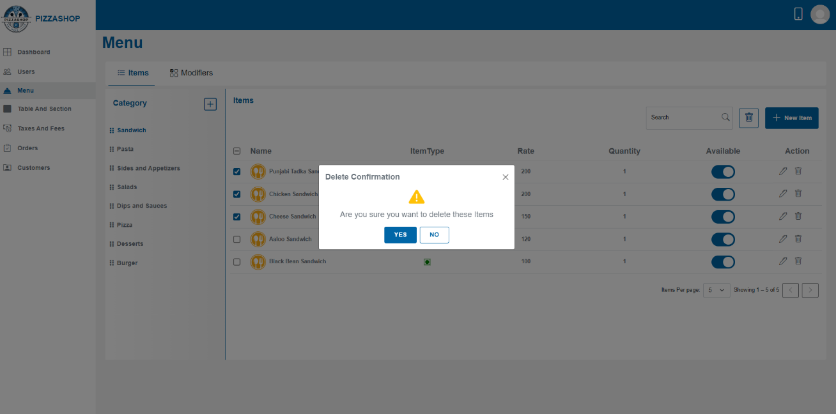

Fig.Delete selected Item/Items

**Features:**

|  |  |  |  |
| --- | --- | --- | --- |
| **#** | **Feature** | **Type** | **Description** |
| 1. | Message | Label | The confirmation box will display a clear message, such as: "Are you sure you want to delete these items?” |
| 2. | Yes | Button | 1.Proceed with the deletion of the Item/Items from the system.  2. Display a success message indicating that the "Menu item deleted successfully.”.  3. Refresh the items listing to reflect the change, removing the deleted item/items from the list. |
| 3. | No | Button | 1. Close the confirmation box. |

**3.2.3 Modifiers>>Modifier Group: -**

A **modifier group** is a category of related options that allows customers to customize their order. Each group contains specific choices or modifiers that pertain to a particular aspect of the item. For example, for a pizza, modifier groups could be:

* **Size Options**: Small, Medium, Large.
* **Crust Options**: Thin, Thick, Gluten-Free.
* **Sauce Options**: Tomato, BBQ, Alfredo.
* **Cheese Options**: Mozzarella, Cheddar, No Cheese.
* **Topping Options**: Pepperoni, Mushrooms, Onions, etc.

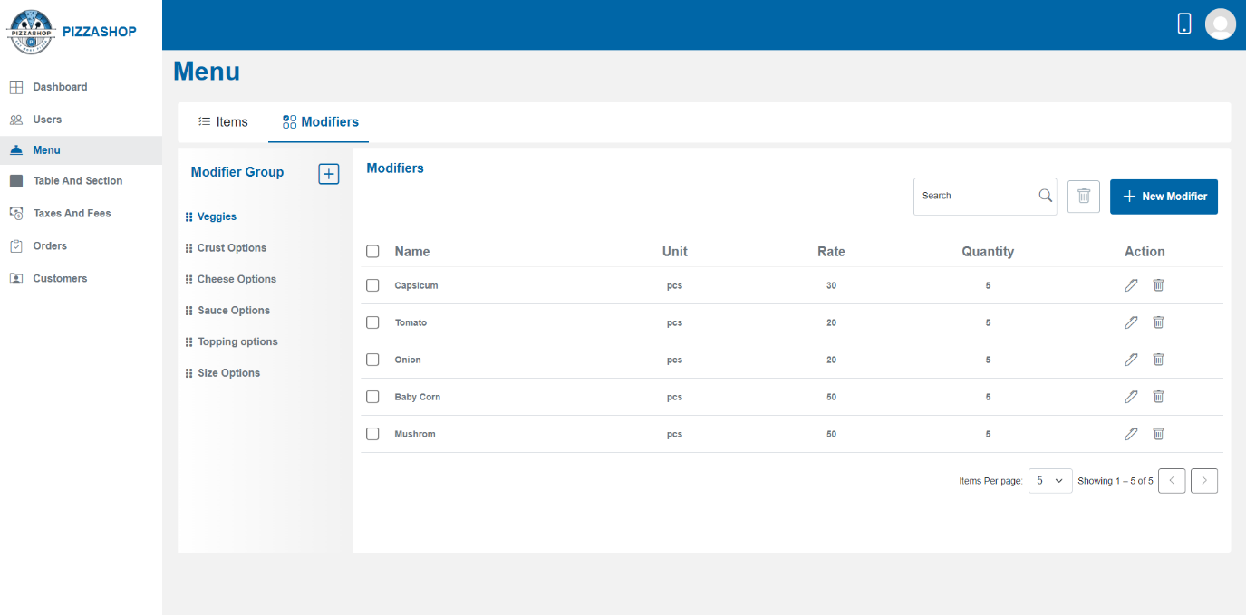Fig. Modifier Group and Modifiers

**Features:**The features of the Modifier group for the Super Admin and Account Manager are the same, but consider the **Account Manager** instead of the **Super Admin**.

|  |  |  |  |
| --- | --- | --- | --- |
| S. No. | **Reference** | **Page No.** | **Description** |
| 1. | Features of Modifier Group and Modifier: - | 41 | By clicking on the Reference with Ctrl (Modifier Group and Modifier: - + Ctrl) or Page No. with Ctrl (29 + Ctrl), it will redirect to the reference. |

**Note**: The **Add Modifier group**, **Edit** **Modifier Group**, and **Delete Modifier Group** functionalities for the **Super Admin** and **Account** Manager are the same. While creating these features for the Account Manager, just consider the Account Manager instead of the Super Admin. By clicking on the reference and pressing Ctrl (e.g., **Add Modifier group: - + Ctrl**), or page no and pressing Ctrl (e.g., **29 +Ctrl**) you can navigate to the **Add Modifier group** functionality for the Super Admin and use it as a reference to create the functionality for the Account Manager.

|  |  |  |  |  |
| --- | --- | --- | --- | --- |
| S. No. | **Functionality** | **Description of functionality** | **Click on this Reference** | **Page No.** |
| 1. | **Add Modifier group** | Account Manager can add a new modifier group to the restaurant by clicking the plus icon besides the Modifier Group. | Add Modifier Group: - | 41 |
| 2. | **Edit** **Modifier Group** | Account Manager can edit the details of an existing Modifier group by clicking the pencil icon besides the name of the modifier. | Edit Modifier Group: - | 44 |
| 3. | **Delete Modifier Group** | Account Manager can delete the modifier group by clicking the Delete button inside the “Edit Modifier” popup. | Delete Modifier Group: - | 45 |

**3.2.4 Modifiers>>Modifier: -**

A **modifier** is an individual choice within a modifier group. These are the specific customizations that the customer can choose from. For example:

* In the **Crust Options** group: Thin Crust, Thick Crust, or Gluten-Free Crust are individual **modifiers**.
* In the **Topping Options** group: Pepperoni, Mushrooms, or Onions are individual **modifiers**.

### **Example:** For a pizza order:

* **Crust** (modifier group): Thin, Thick, Gluten-Free (modifiers)
* **Toppings** (modifier group): Pepperoni, Mushrooms, Onions, Extra Cheese (modifiers)

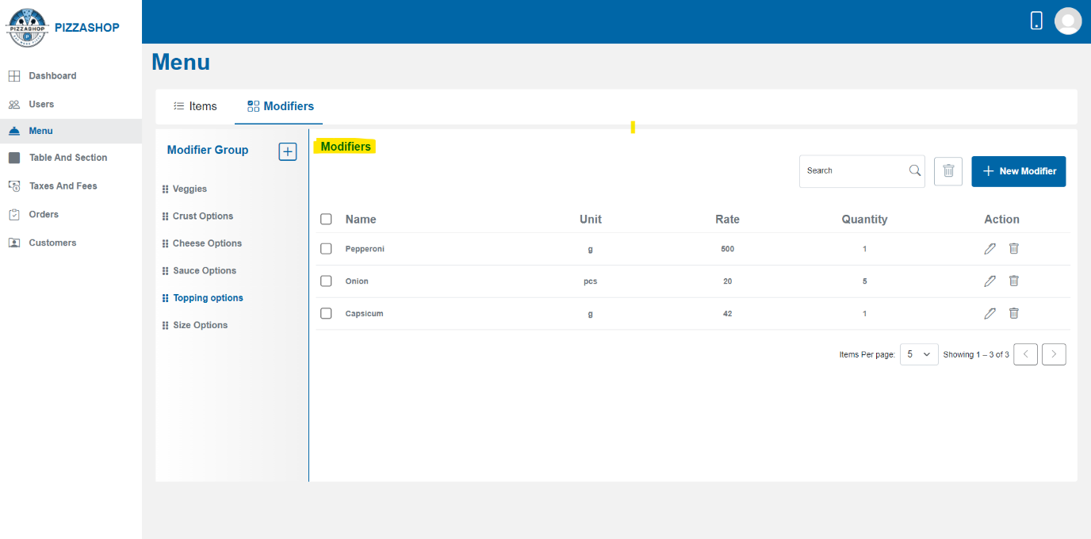Fig. Modifiers

**Note**: The **Add Modifier**, **Edit** **Modifier**, and **Delete Modifier** functionalities for the **Super Admin** and **Account** Manager are the same. While creating these features for the Account Manager, just consider the Account Manager instead of the Super Admin. By clicking on the reference and pressing Ctrl (e.g., **Add Modifier: - + Ctrl**), or page no and pressing Ctrl (e.g**., 33 +Ctrl**) you can navigate to the **Add Modifier group** functionality for the Super Admin and use it as a reference to create the functionality for the Account Manager.

|  |  |  |  |  |
| --- | --- | --- | --- | --- |
| S. No. | **Functionality** | **Description of functionality** | **Click on this Reference** | **Page No.** |
| 1. | **Add Modifier** | Account Manager can add a new modifier by clicking the “New Modifier” button. | Add Modifier: - | 48 |
| 2. | **Edit** **Modifier** | Account Manager can edit the existing modifier by clicking the pencil icon from Action. | Edit Modifier: - | 49 |
| 3. | **Delete Modifier** | Account Manager can delete the existing modifier by clicking the trash icon from Action. | Delete Modifier: - | 50 |

4. **Delete Selected Modifier/Modifiers: -**

Account manager can delete a selected modifier/modifiers. Account manager selects a modifier/modifiers from the list by checking the checkbox(s) besides the modifier and clicks the "Delete" button next to search.

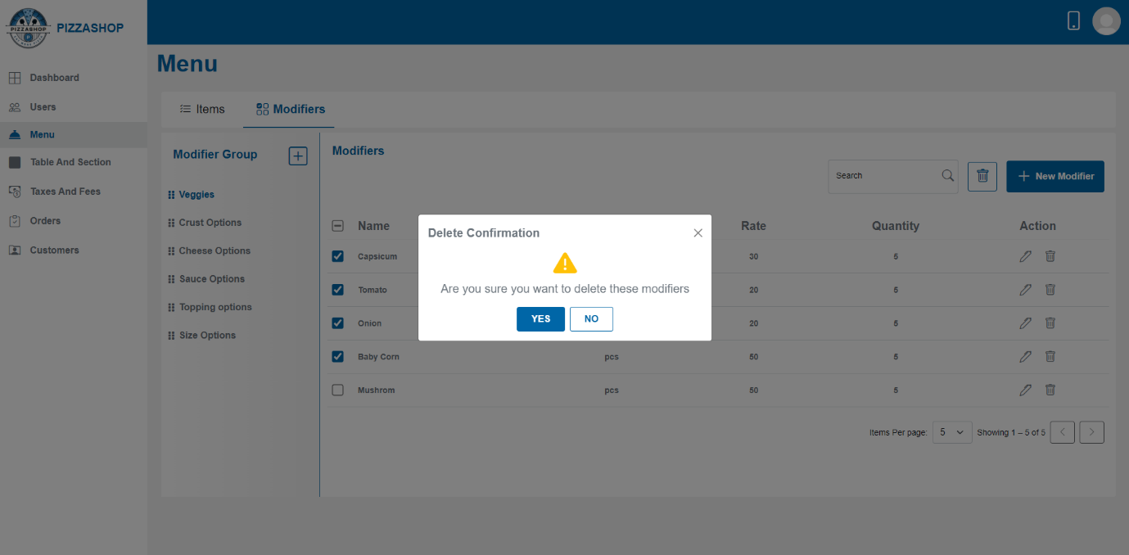Fig. Select modifier/modifiers to delete

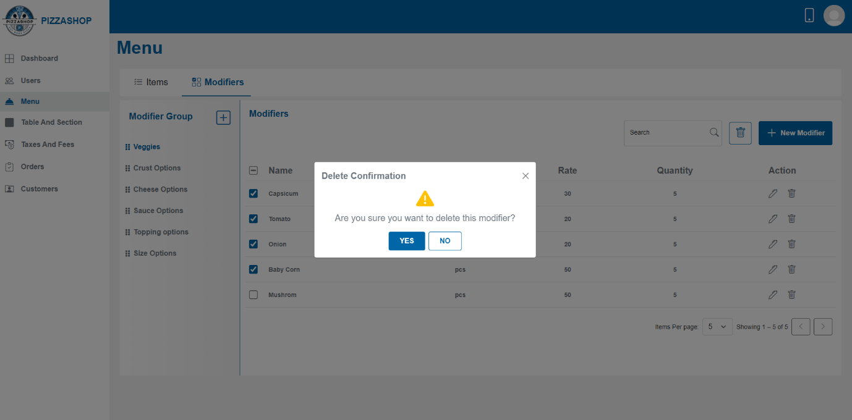Fig. Delete Confirmation

**3.3 Tables And Sections**

Description:

The Pizza Shop includes various sections of the restaurant (e.g., ground floor, first floor, outdoor seating) where tables are located. This functionality allows for effective management of seating arrangements, making it easy to add, update, and manage sections and tables.

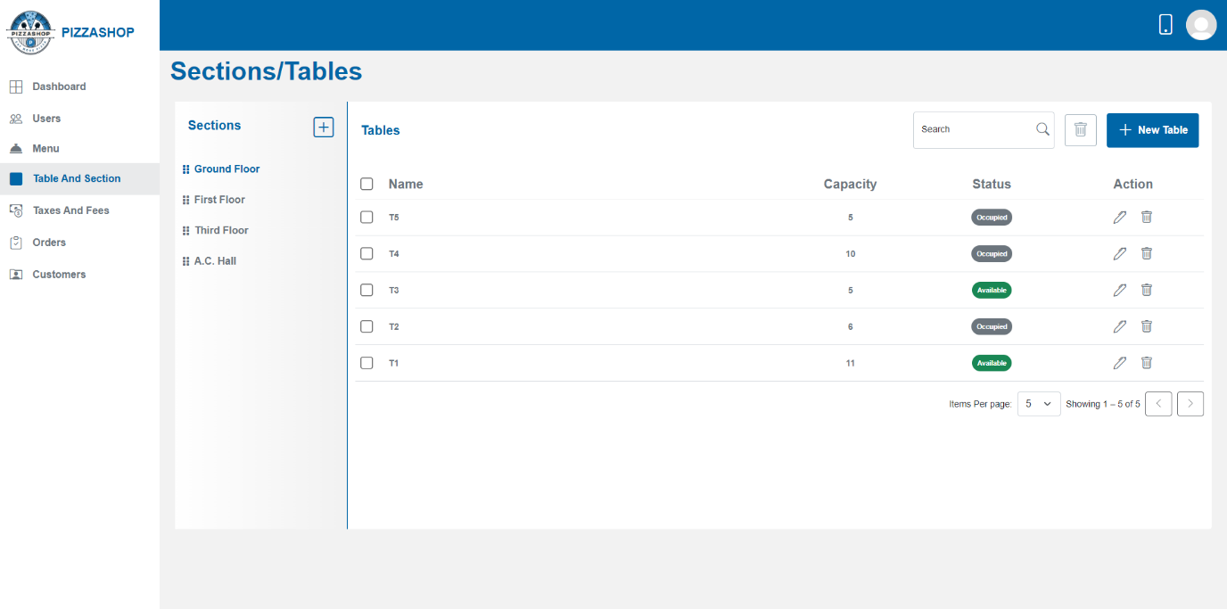

Fig. Tables/Sections

**Features:**The features of the Tables/Sections for the Super Admin and Account Manager are the same, but consider the **Account Manager** instead of the **Super Admin**.

|  |  |  |  |
| --- | --- | --- | --- |
| S. No. | **Reference** | **Page No.** | **Description** |
| 1. | Features of Tables/Sections: | 52 | By clicking on the Reference with Ctrl (Features of Tables/Sections: + Ctrl) or Page No. with Ctrl (37 + Ctrl), it will redirect to the reference. |

**3.3.1 Sections**

**Description: -**

Sections represent different areas of the restaurant (e.g., ground floor, first floor, outdoor).

**Note**: The **Add Section**, **Edit** **Section**, and **Delete Section** functionalities for the **Super Admin** and **Account** Manager are the same. While creating these features for the Account Manager, just consider the Account Manager instead of the Super Admin. By clicking on the reference and pressing Ctrl (e.g., **Add Section: - + Ctrl**), or page no and pressing Ctrl (e.g**., 38 +Ctrl**) you can navigate to the **Add Section** functionality for the Super Admin and use it as a reference to create the functionality for the Account Manager.

|  |  |  |  |  |
| --- | --- | --- | --- | --- |
| S. No. | **Functionality** | **Description of functionality** | **Click on this Reference** | **Page No.** |
| 1. | **Add Section** | Account Manager can add a new section to the restaurant by clicking the plus icon and the added sections will show under sections like Ground floor. | Add Section: - | 54 |
| 2. | **Edit** **Section** | Account Manager can edit the details of an existing section by clicking the pencil icon besides the name of the section | Edit Section: - | 55 |
| 3. | **Delete Section** | Account Manager can delete the section by clicking the Delete button inside the “Edit Section” popup. | Delete Section: - | 56 |

#### **3.3.2 Tables**

**Description: -**

Tables represent individual seating units within a section.

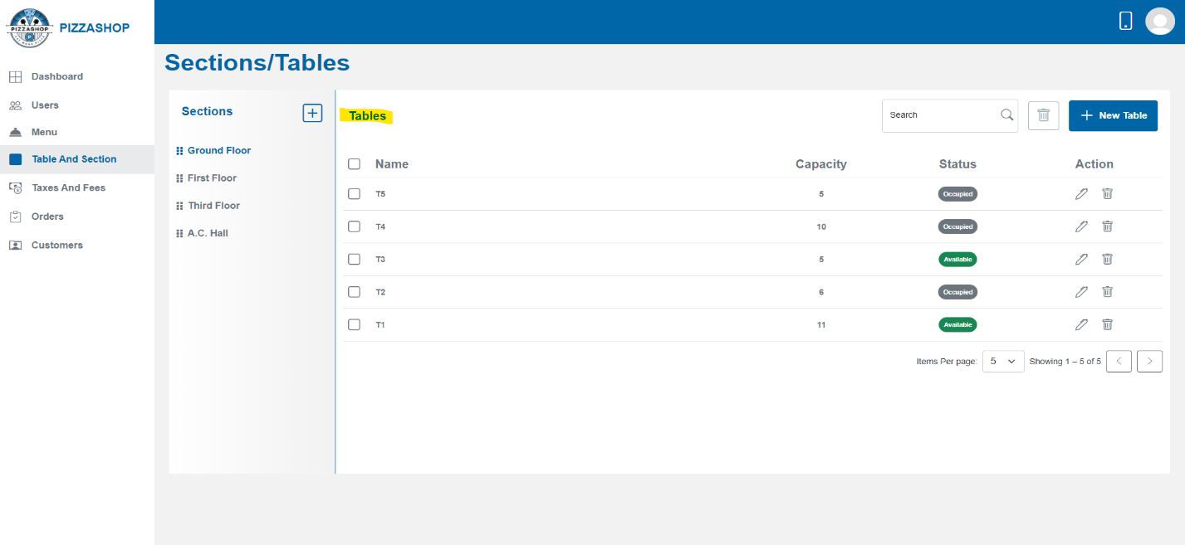Fig. Tables

**Search Table: -**

Admin can search for a specific table by table name.

**Delete Selected Table: -**

Account Manager can delete selected table/tables from a section. Account Manager selects table/tables from the list by checking the checkbox(s) and clicks the "Delete" button next to search.

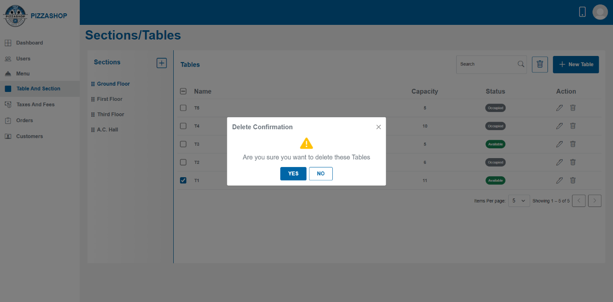Fig. Delete Selected Table T1

**Features:**

|  |  |  |  |
| --- | --- | --- | --- |
| **#** | **Feature** | **Type** | **Description** |
| 1. | Message | Label | The confirmation box will display a clear message, such as: "Are you sure you want to delete 1 table?” |
| 2. | Yes | Button | 1.Proceed with the deletion of the table from the system.  2. Display a success message indicating that the "Table deleted successfully.”.  3. Refresh the table listing to reflect the change, removing the deleted table from the list. |
| 3. | No | Button | 1. Close the confirmation box. |

**Note**: The **Add Table**, **Edit** **Table**, and **Delete Table** functionalities for the **Super Admin** and **Account** Manager are the same. While creating these features for the Account Manager, just consider the Account Manager instead of the Super Admin. By clicking on the reference and pressing Ctrl (e.g., **Add Table: - + Ctrl**), or page no and pressing Ctrl (e.g**., 42 +Ctrl**) you can navigate to the **Add Table** functionality for the Super Admin and use it as a reference to create the functionality for the Account Manager.

|  |  |  |  |  |
| --- | --- | --- | --- | --- |
| S. No. | **Functionality** | **Description of functionality** | **Click on this Reference** | **Page No.** |
| 1. | **Add Table** | Account Manager can add a new table to a specific section by clicking on the “New Table” button. | Add Table: - | 60 |
| 2. | **Edit** **Table** | Account Manager can edit the existing table by clicking the pencil icon from the Actions column. | Edit Table: - | 61 |
| 3. | **Delete Table** | Account Manager can delete the table by clicking the trash icon from the Actions column. | Delete Table: - | 62 |

**3.4 Taxes And Fees**

In a **Pizza Shop**, taxes and fees play a crucial role in ensuring that the business complies with local regulations and provides accurate pricing to customers. These are typically automated within the system to simplify the billing process.

**Taxes** are mandatory charges applied by the government, which vary based on location and local laws.

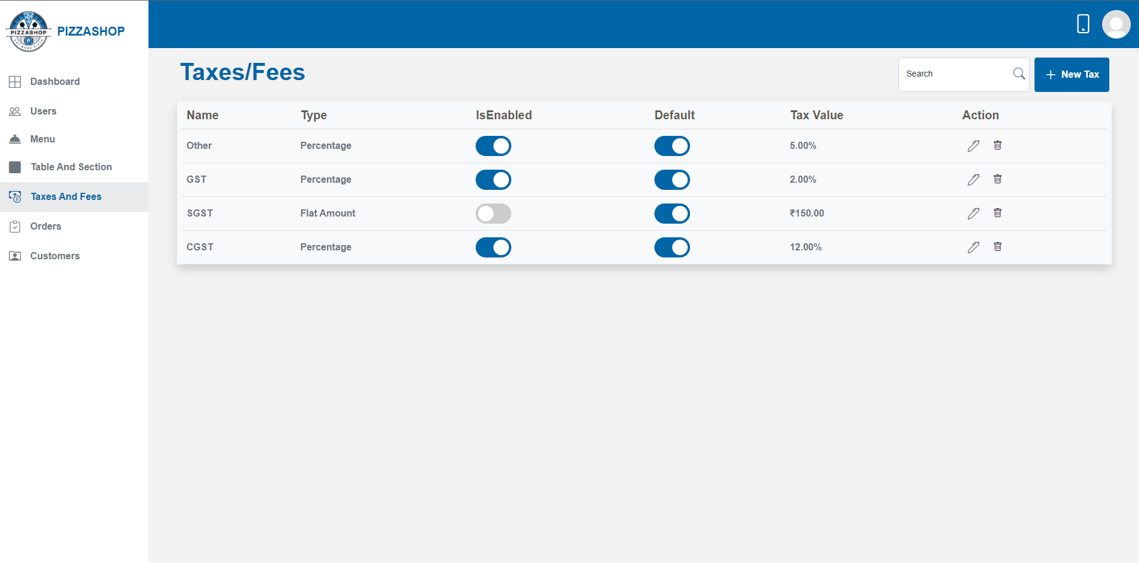Fig. Taxes/Fees

**Features:**

|  |  |  |  |
| --- | --- | --- | --- |
| **#** | **Feature** | **Type** | **Description** |
| 1. | Search | Textbox | Account Manager can search the tax-by-tax name. |
| 2. | New Tax | Button | By clicking on this “Add Tax” popup will appear. Account Manager can add the new tax. |
| 3. | Name | Textbox | This will show the name of the tax. |
| 4. | Type | Dropdown | This will show the type of tax. |
| 5. | IsEnabled | Button | If it is enabled means the particular tax will be applicable for every menu item. |
| 6. | Default | Button | If Default is on means the default taxes will be applicable for every menu item. |
| 7. | Tax Value | Textbox | This will show the amount of the tax based on the type of the tax. |
| 8. | Action | Clickable Icons | Action contains the icons for editing and deleting the taxes. 1. Pencil Icon - By clicking on the pencil icon, the "Edit Tax” popup will appear on the screen. 2. By clicking on the delete icon “Delete Confirmation” popup will appear on the screen. |

**Add Tax: -**

Account Manager can add new tax by clicking on the “New Tax” button. On clicking the New Tax button “Add New Tax” popup will appear on the screen.

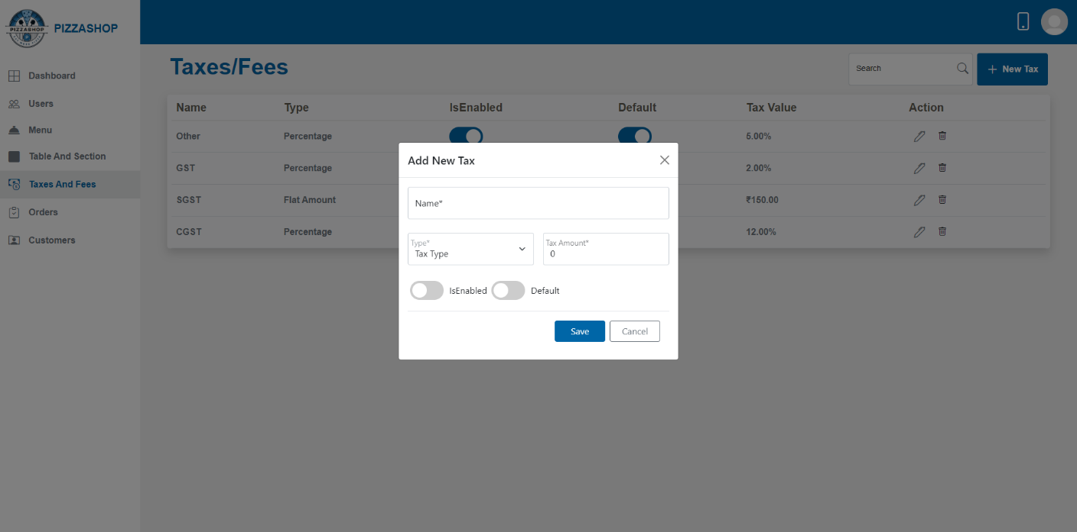 Fig. Add New Tax

**Features:**

|  |  |  |  |
| --- | --- | --- | --- |
| **#** | **Feature** | **Type** | **Description** |
| 1. | Name | Textbox | This will show the name of the tax. |
| 2. | Type | Dropdown | This will show the type of tax. |
| 3. | Tax Amount | Textbox | This will show the tax amount. |
| 4. | IsEnabled | Button | If it is enabled and default is on means the particular tax will be applicable for every menu item. |
| 5. | Default | Button | If Default is on means the particular tax will be applicable for every menu item. |
| 6. | Save | Button | By clicking on this it validates the input fields to ensure all required fields are filled and correctly formatted. If validation passes, this will add the new tax to the system and display the confirmation message indicating that the “Tax created successfully”. |
| 7. | Cancel | Button | This will discard any changes made in the form and close the “Add New Tax” popup. |
| 8. | X | Button | This will close the “Add New Tax” popup. |

**Edit Tax: -**

Account Manager can edit the existing tax by clicking the pencil icon from the Actions column. On clicking the pencil icon "Edit Tax" popup will appear on the screen.

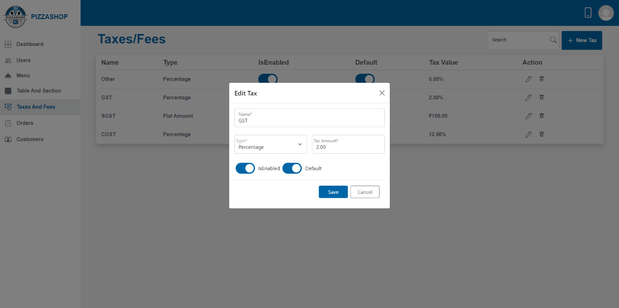Fig. Edit Tax

**Features:**

|  |  |  |  |
| --- | --- | --- | --- |
| **#** | **Feature** | **Type** | **Description** |
| 1. | Name | Textbox | This will show the name of the tax. |
| 2. | Type | Dropdown | This will show the type of tax. |
| 3. | Tax Amount | Textbox | This will show the tax amount. |
| 4. | IsEnabled | Button | If it is enabled means the particular tax will be applicable for every menu item. |
| 5. | Default | Button | If Default is on means the particular tax will be applicable for every menu item. |
| 6. | Save | Button | This will save the modified details of the tax. |
| 7. | Cancel | Button | This will discard any changes made in the form and close the “Edit Tax” popup. |
| 8. | X | Button | This will close the “Edit Tax” popup. |

**Delete Tax: -**

Account Manager can delete the tax by clicking the trash icon from the Actions column. On clicking the trash icon "Delete Confirmation" popup will appear on the screen as shown in the below image.

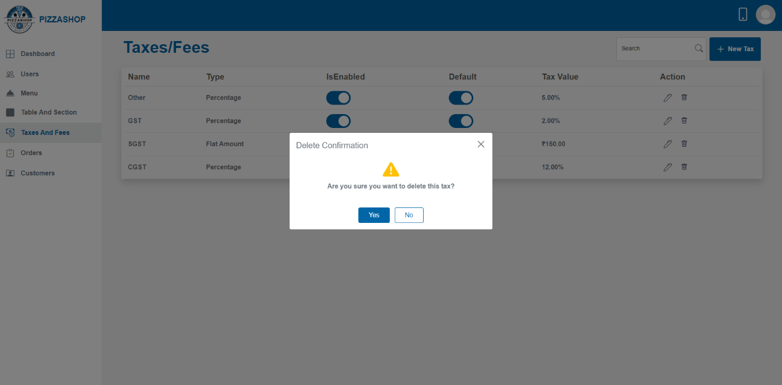Fig. Delete Tax

**Features:**

|  |  |  |  |
| --- | --- | --- | --- |
| **#** | **Feature** | **Type** | **Description** |
| 1. | Message | Label | The confirmation box will display a clear message, such as: "Are you sure you want to delete this tax?” |
| 2. | Yes | Button | 1.Proceed with the deletion of the tax from the system.  2. Display a success message indicating that the "Tax deleted successfully.”.  3. Refresh the tax listing to reflect the change, removing the deleted tax from the list. |
| 3 | No | Button | Close the confirmation popup. |
| 4 | X | Button | This will close the confirmation popup |

**3.5 Orders**

**Description:**

In a **Pizza Shop**, **orders** refer to the collection of customer requests for food and beverages made during their dining experience. The orders are typically linked to specific tables of the sections in the restaurant and are handled by staff such as Account Managers or servers.

* First the Account manager creates the customer order from the **Order App** and then the Orders will display in the **Orders Module** in the **Account Manager Dashboard.**

**Order List in the Orders Module in Account Manager Dashboard**:

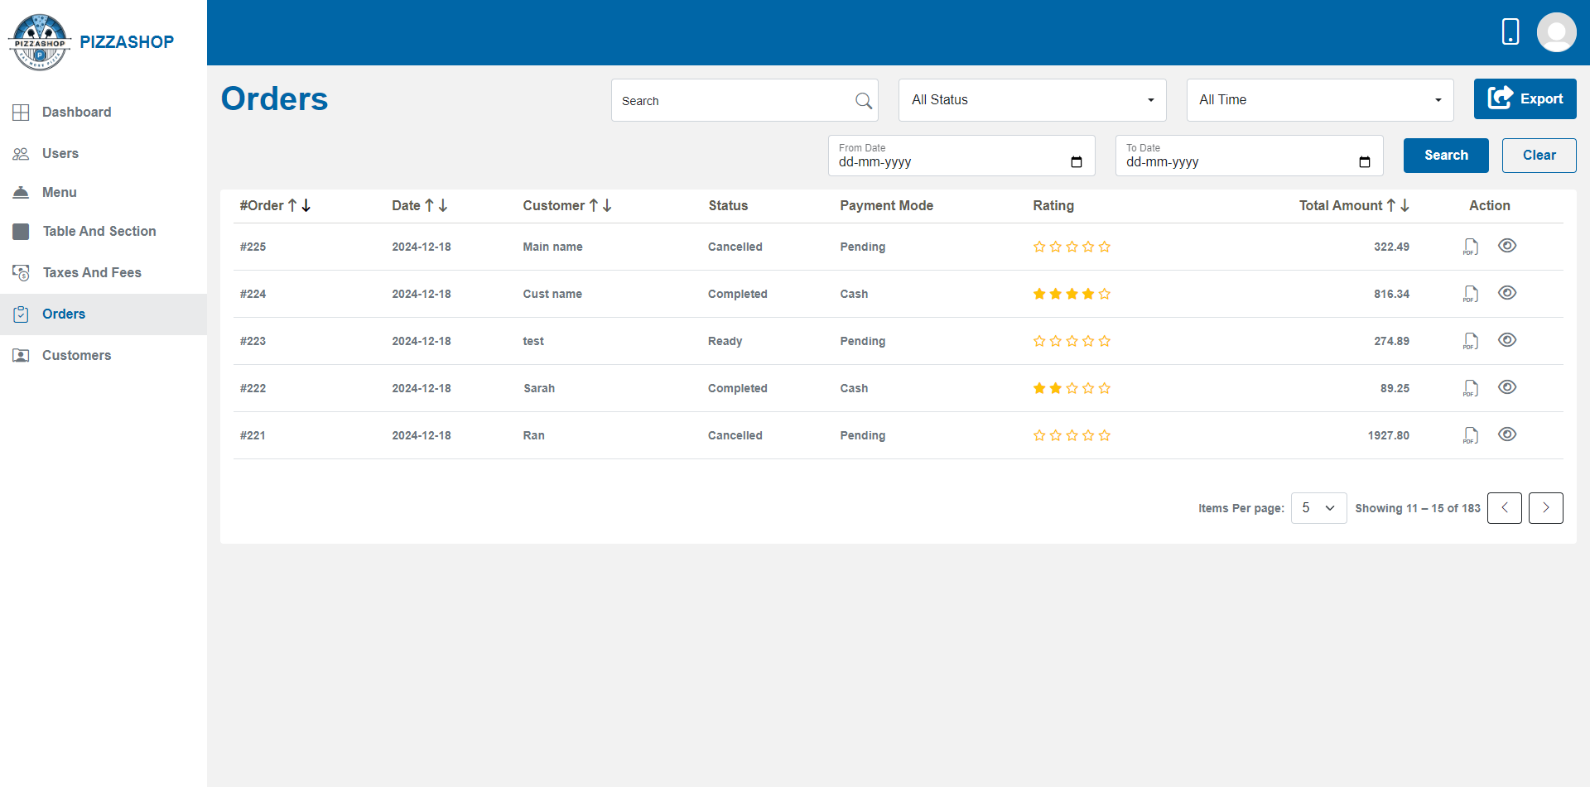Fig. Order List in Account Manager Dashboard

**Features:**

|  |  |  |  |
| --- | --- | --- | --- |
| **#** | **Feature** | **Type** | **Description** |
| 1. | Search | Textbox | This will search the order by orderid and show the search result. |
| 2. | Status | Dropdown | This will show the orders as per the status of order: All Status, Pending, In Progress, Served, Completed, Cancelled, On Hold, Failed. All Status should be the default option in the dropdown. |
| 3. | Date Range | Dropdown | This will show the orders as per the Date Range selected: Last 7 days, Last 30 days, All time, Current Month, Custom Date. All Time should be the default option in the dropdown |
| 4. | Clear | Button | This will clear all the dropdowns and show the default option in the dropdown and clear the searched results of orders. |
| 5. | Export | Button | This feature allows admin to export order details into an Excel sheet. The excel sheet will show the **order status,** **search text** by which the order has searched and exported and contains the Date, No. Of Records, Total Amount. When the export button is clicked, an Excel file containing the filtered order details will be generated and downloaded to the user's system. |

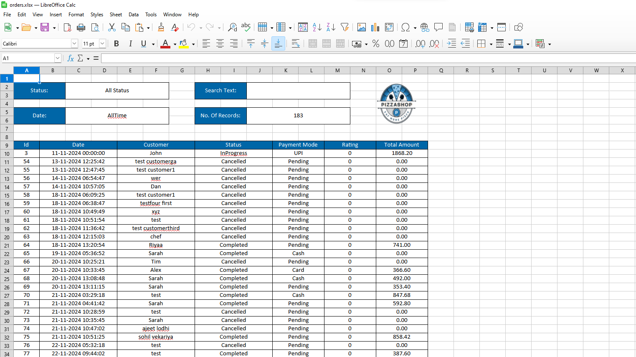Fig. Export to excel order List

|  |  |  |  |
| --- | --- | --- | --- |
| 6. | Order Id | Text | This will show the order id for the customer order. |
| 7. | Date | Text | This will show the date of the order placed by the customer. |
| 8. | Customer | Text | This will show the customer's name. |
| 9. | Total Amount | Text | This will show the total amount of the order including the taxes like additional or default tax if applicable. |
| 10. | Status | Text | This will show the status of the order: Pending, Completed, InProgress, Running etc. |
| 11. | Payment Mode | Text | This will show the payment mode: Online, Crad, Cash done by the customer for the order. |
| 12. | Rating | Text | This will show the customer's rating for the order. |
| 13. | Action | Icon | Action contains the icons for downloading the invoice and viewing the order details. 1. Download file Icon - By clicking on the download file icon, admin can download the invoice as pdf. 2. By clicking on the eye icon admin can see the order details. |

**Download Invoice**

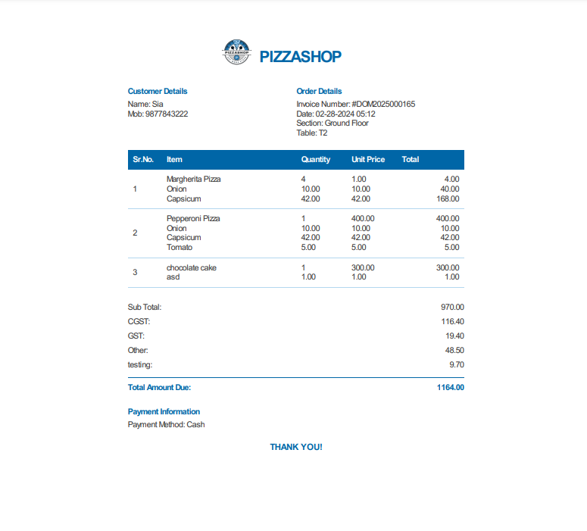

Fig. Download invoice As Pdf

**View the Order Details**

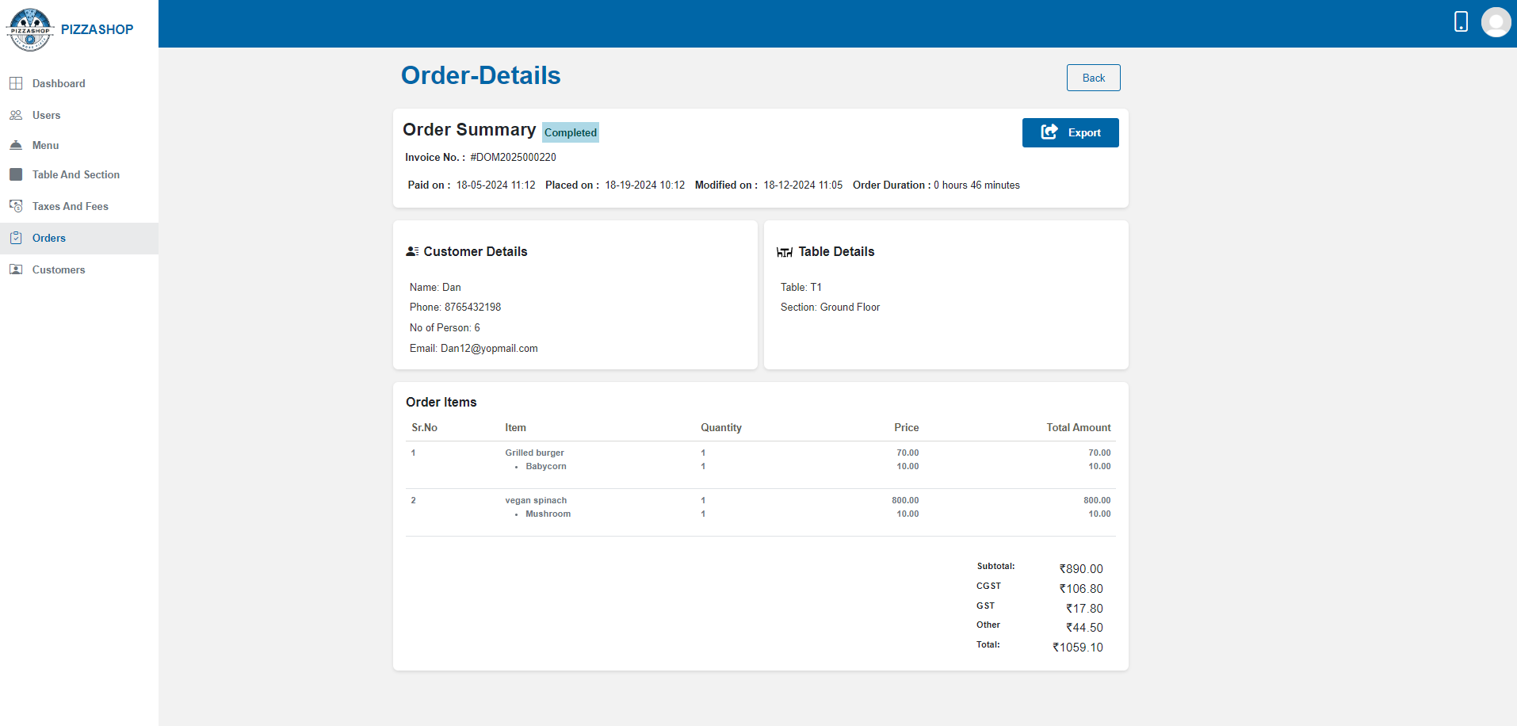Fig. View the order details.

**3.6 Customers**

**Description: -**

In a restaurant management system, **customers** refer to the individuals or groups who visit the restaurant to dine or place orders.

**Steps to Create a Customer as an Account Manager:**

1.Log in as an Account Manager.

2.Navigate to the Order App, where inside in the tables menu you can view all the sections (e.g. ground floor, First floor, Roof Top) of Pizza Shop.

3. Expand the desired section to see the available tables in that area.

4. Select the table and click on the Assign button the customer details popup will appear on the screen.

5. Enter the customer's details in the popup and click the "Assign" button.

6. Once the details are submitted, the customer will be created.

7. The Super Admin can view all customers in the "**Customer**" menu.

**Customer List in Account Manager Dashboard:**

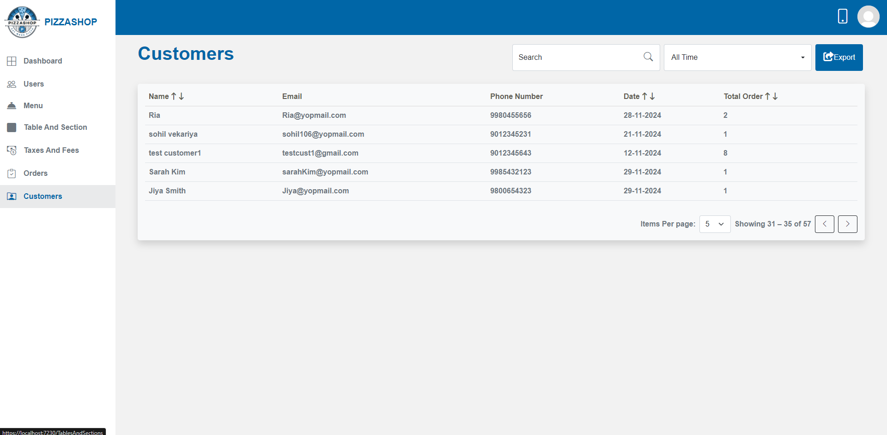

Fig. Customers List

**Features:**

|  |  |  |  |
| --- | --- | --- | --- |
| **#** | **Feature** | **Type** | **Description** |
| 1. | Search | Textbox | This will search the customer-by-customer name and show the search result. |
| 2. | Date Range | Dropdown | This will show the customers as per the Date Range selected: All Time, Today, Last 7 days, Last 30 days, All time, Current Month, Custom Date. All Time should be the default option in the dropdown. |
| 3. | Name | Textbox | This will show the name of the customer who has placed the order. |
| 4. | Email | Textbox | This will show the email of the customer. |
| 5. | Date | Textbox | This will show the date of the order placed. |
| 6. | Phone Number | Textbox | This will show the phone no. of the customer. |
| 7. | Export | Button | This feature allows admin to export customer details into an Excel sheet. The excel sheet will show the **Date,** **No. Of Records** and **search text** by which the order has searched and exported. When the export button is clicked, an Excel file containing the filtered customer details will be generated and downloaded to the user's system. |

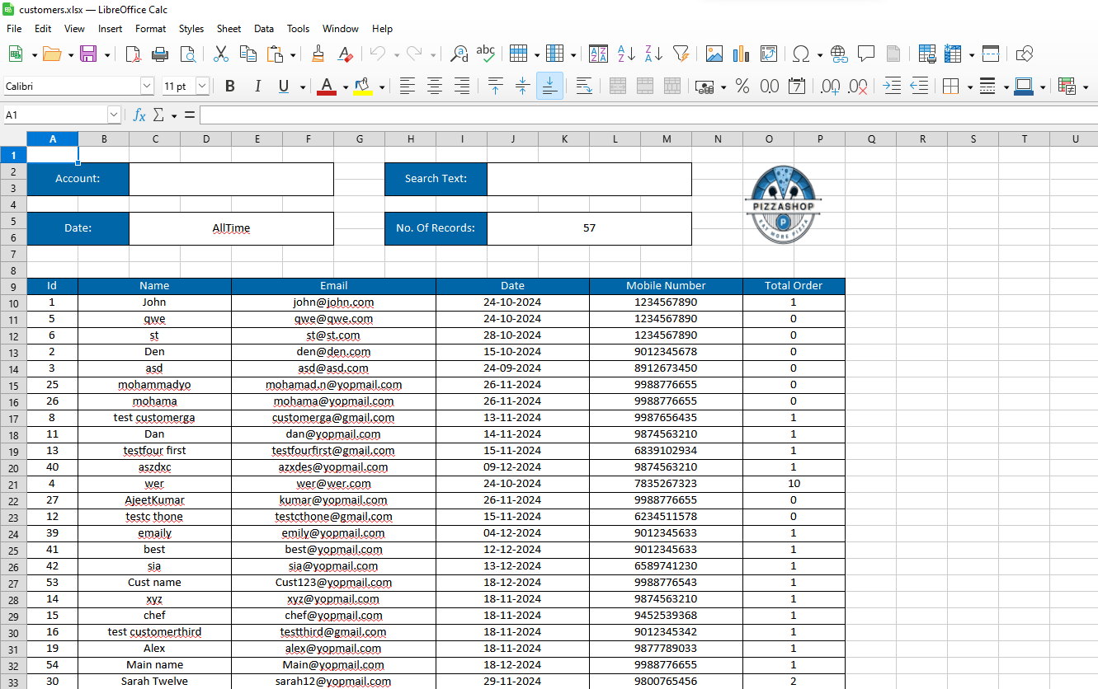Fig. Export to excel customer details

**Customer History**

The admin can view detailed customer history by clicking anywhere on a row in the customer list. Once a row is clicked, a **Customer Detail Popup** will appear on the screen, displaying the customer’s information, including their history.

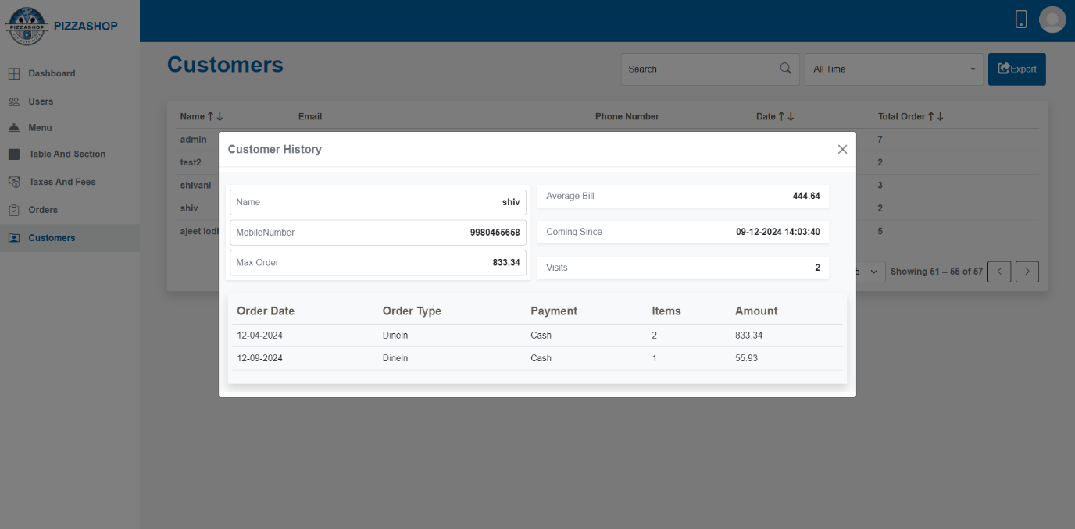

Fig. Customer History

**Features:**

|  |  |  |  |
| --- | --- | --- | --- |
| **#** | **Feature** | **Type** | **Description** |
| 1. | Name | Textbox | This will show the name of the customer. |
| 2. | Average Bill | Textbox | This will show the average bill amount of the customer. |
| 3. | Mobile Number | Textbox | This will show the mobile number of the customer. |
| 4. | Coming Since | Textbox | This will show when the customer first started coming. |
| 5. | Max Order | Textbox | This will show the highest order value for the customer. |
| 6. | Visits | Textbox | It will show how many times a customer has visited Pizza Shop. |
| 7. | Order Date | Textbox | It will show the date of the order placed. |
| 8. | Order Type | Textbox | It will show the type of order. |
| 9. | Payment | Textbox | This will show the mode of payment used by the customer. |
| 10. | Items | Button | It will show the number of food items ordered. |
| 11. | Amount | Button | It will show the amount of the order placed. |
| 12. | X | Button | This will close the popup. |

**3.7 Order App**

On the dashboard, the navigation bar includes the  (Order App) icon, as shown in the image below.

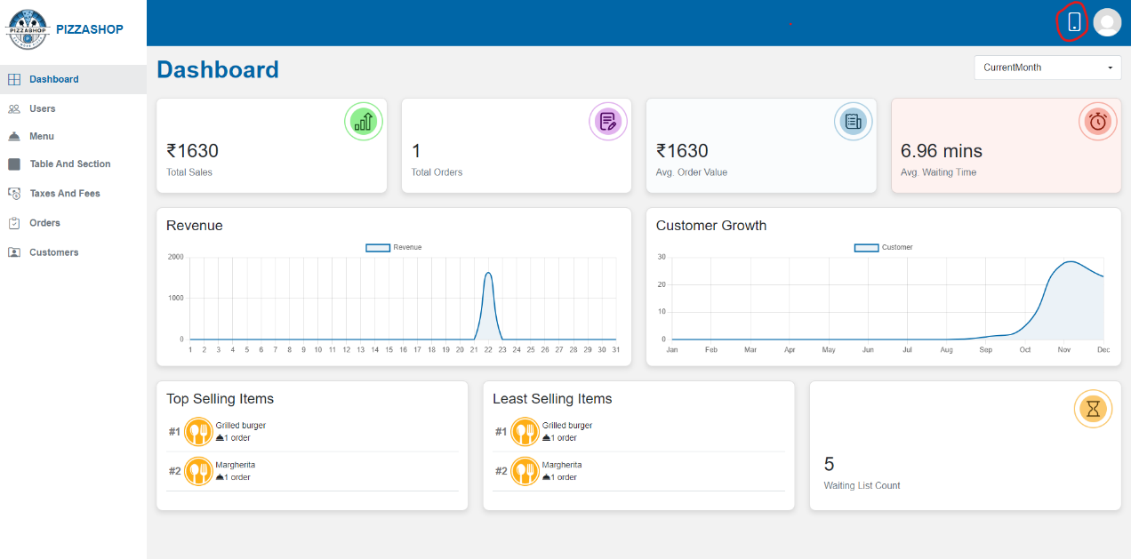

Fig. Account Manager Dashboard Containing the Order App

When the Account Manager clicks on the **Order App** icon, they will be redirected to the Order App. The following interface will appear, with the **Tables** menu selected by default.

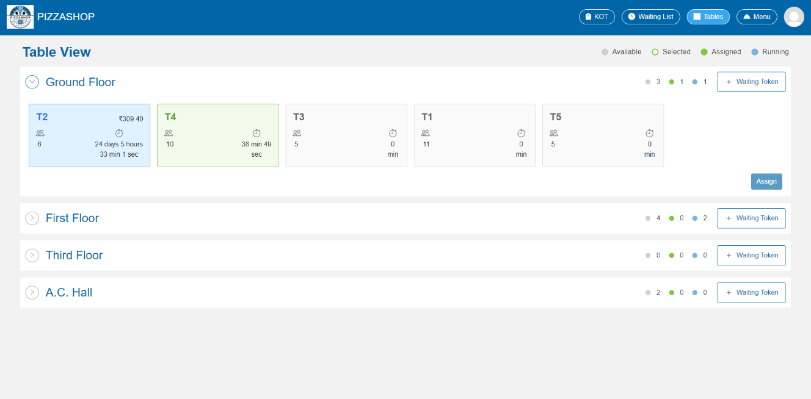

Fig. Order App with default Tables menu

**3.7.1 Table Module in Order App**

**Description: -**

In the Order App, the Table Menu provides an essential interface for the Account Manager to manage table-specific orders. The **Table Menu** is central to order management in a restaurant, ensuring that the Account Manager can handle customer requests efficiently, track order progress, and manage table reservations seamlessly.

The Table Menu shows a real-time overview of all available, occupied, and reserved tables in the restaurant.

Each table is displayed with its status (available, selected, running or reserved), the number of seats etc.

**List Of Tables as per the Sections:**

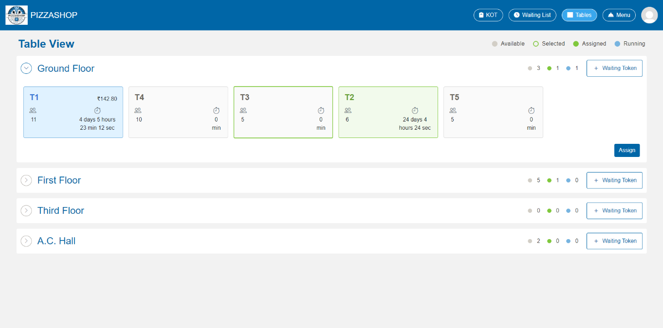Fig. Order App having tables menu selected by default

**Features:**

|  |  |  |  |
| --- | --- | --- | --- |
| **#** | **Feature** | **Type** | **Description** |
| 1. | Table Status>>Available |  | The table card in grey shows the availability of the table. |
| 2. | Table Status>>Selected |  | The table card with the green border shows that the table is selected to assign the customer. |
| 3. | Table Status>>Assigned |  | The table card in green shows the availability of the table. |
| 4. | Table Status>>Running |  | The table card in sky blue shows the table has running order. |
| 5. | Waiting Token | Button | By clicking on this the waiting token details popup will appear on the screen. The account manager can create the waiting token for assigning the table to the customers section wise. |
| 6. | Table card |  | The table card in the different colors according to their status like assign, available contains the table details like name of table, no. of person per table and the time of the order placed. |
| 7. | Assign | Button | By clicking this the customer detail popup will appear on the screen to assign the table to the customer. |

**Table Assignment**:

* In the **Table** view, the Account Manager can see all the table sections of the restaurant, and by expanding the sections, the tables within that sections will be displayed with the status whether it is Available, Selected, Assigned, Running or Reserved as shown in the below image.

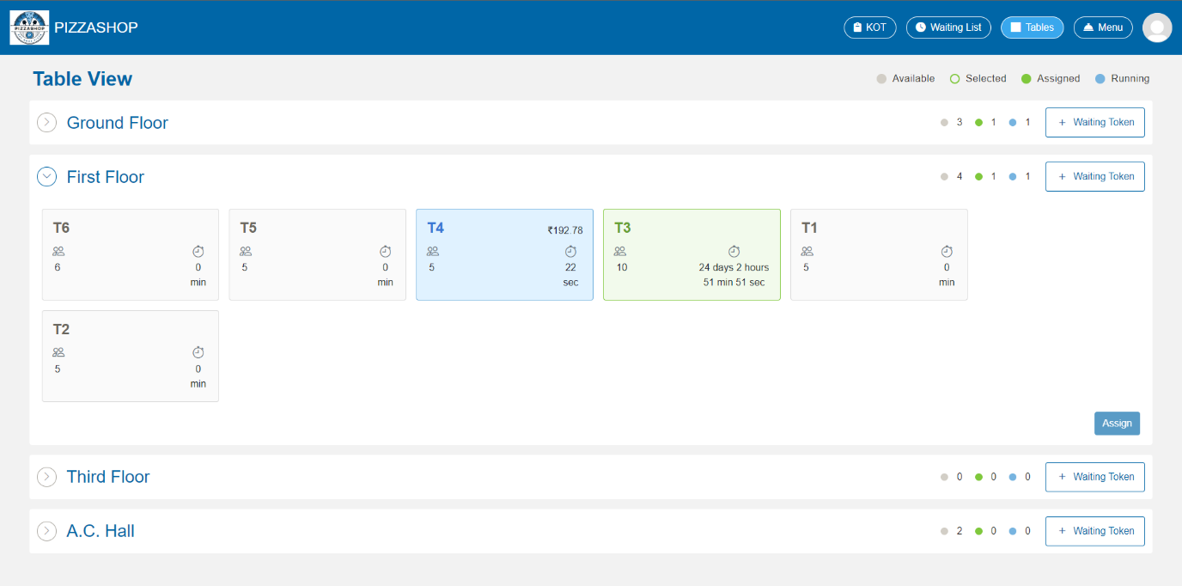Fig. Tables Menu in Order App

* On the First Floor, tables **T1, T2,T5 and T6,** and on the are highlighted in grey, indicating that these tables are available in their respective sections. If the table is available then on clicking that table, the table will be selected with the green border, and the **Assign** button will be active as shown and highlighted in the below image.

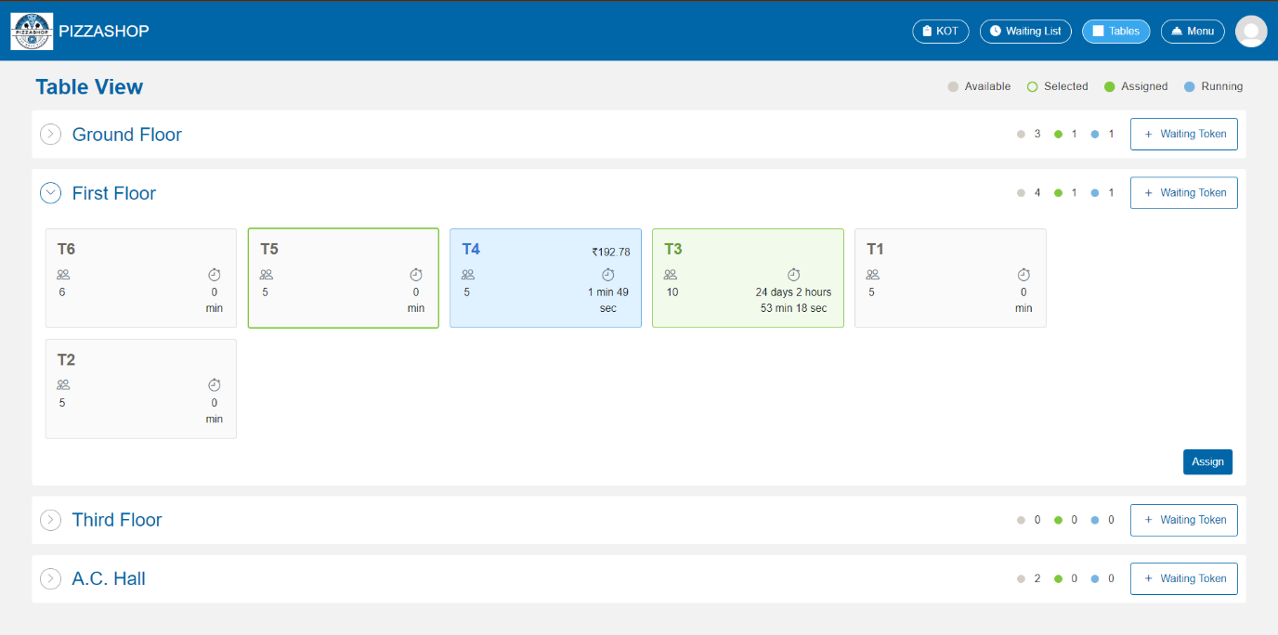Fig. Selected table T5 and Assign button

* On clicking the **Assign** button, the **Customer Details** popup will appear on the screen and the account manager can fill the customer details to assign that table to the customer whose details is filling by the manager in the popup.

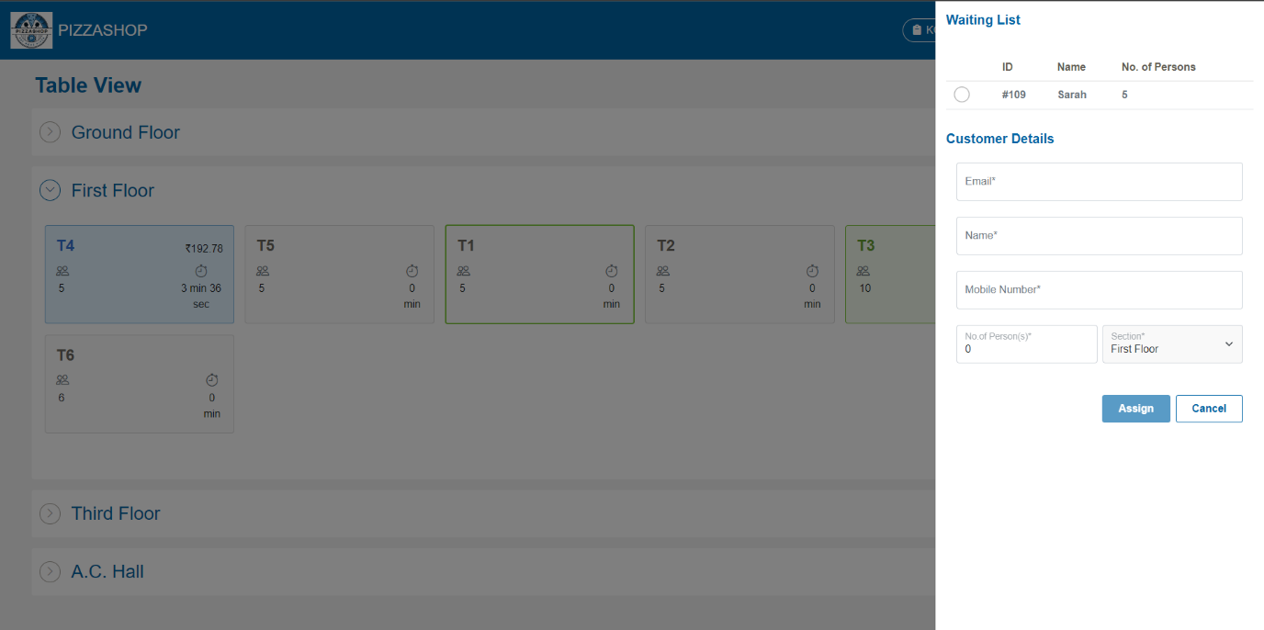Fig. Adding customer details for table assignment manually

After filling the customer details in the popup and clicking on the Assign button The table will be assigned to the customer whose details is filled by the customer in the customer detail popup.

**Note:** -1. The **Account Manager** should be able to fetch the customer's details by entering the **email address** in the **Waiting Token Details** form. For example, as we can see in the below image.

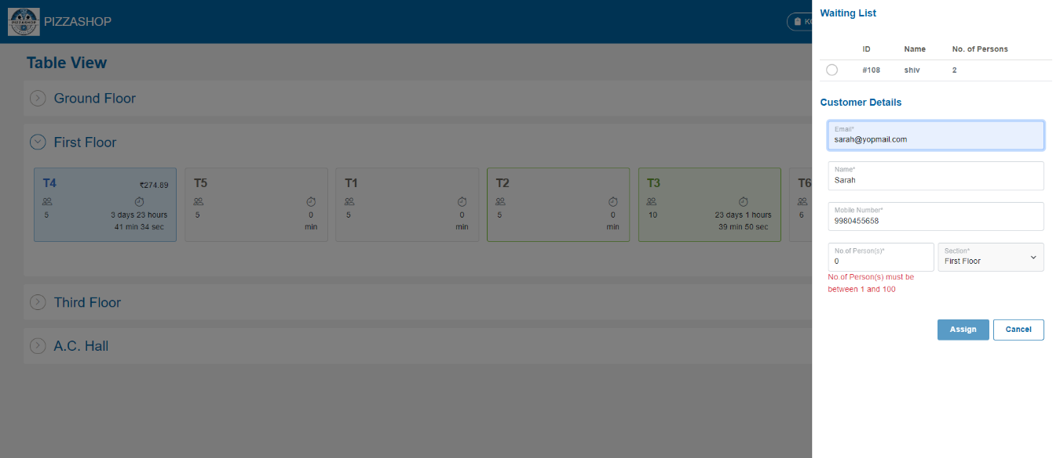Fig. Fetch customer’s detail based on email

2. "The account manager should not be able to add customer details to the customer detail popup if another table has already been assigned to the same customer and they have a running order an error message should appear on the screen stating, “This customer has a running order.”

3. If the account manager tries to select the table which status is running, to assign the customer an error message should appear on the screen stating, “You cannot select this table.

* The **Customer Detail** pop-up will display the **Waiting List** for a specific section if any waiting tokens have been generated. In the example below, for the **First Floor**, one waiting token has been generated, and its details are displayed under the waiting list. By clicking the radio button next to the ID, the corresponding waiting list details will automatically populate the **Customer Detail** pop-up, as shown in the image below.

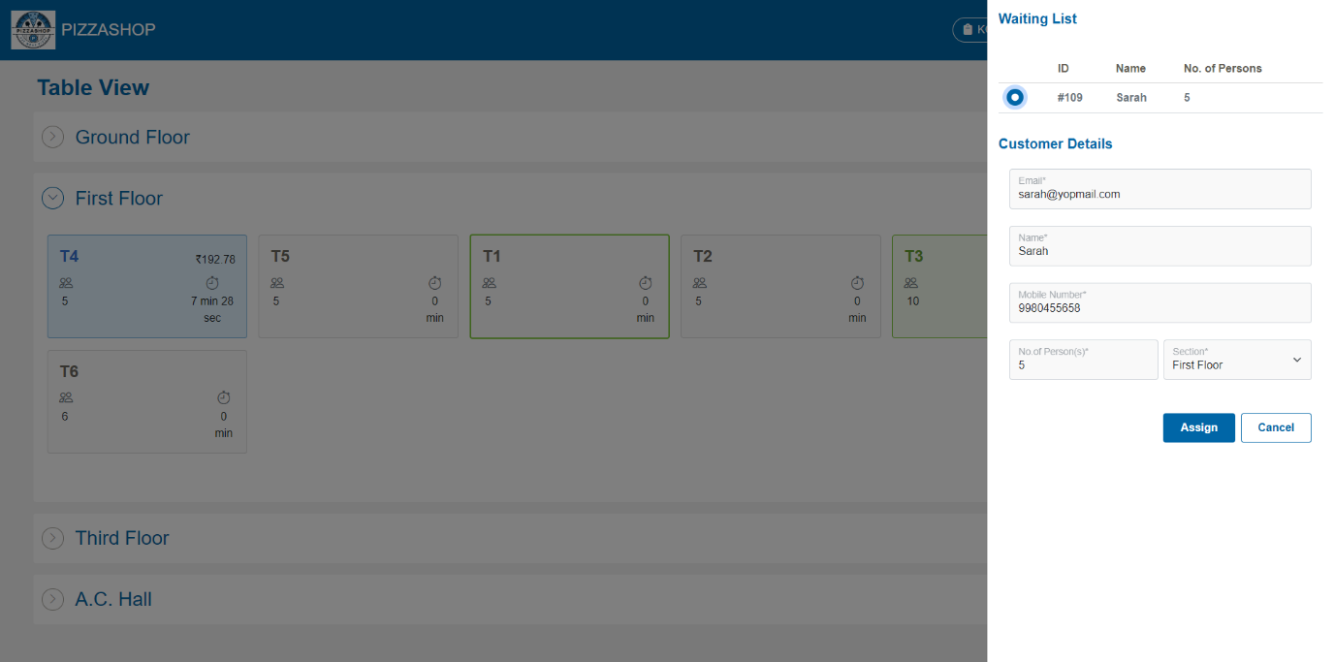Fig. Adding customer details for table assignment from waiting list

**Features:**

|  |  |  |  |
| --- | --- | --- | --- |
| **#** | **Feature** | **Type** | **Description** |
| 1. | Waiting List | Heading/Label | This will show the heading for the waiting list. |
| 2. | Id | Textbox | This will show the id of the customer. |
| 3. | Name | Textbox | This will show the name of the customer for which the waiting token has been generated. |
| 4. | No. of Persons | Textbox | This will show the quantity of the person. |
| 5. | Customer details | Heading/Label | This will show the heading for Customer details. |
| 7. | Mobile Number | Textbox | This will show the Mobile Number of the customer. |
| 8. | First Name | Textbox | This will show the first name of the customer. |
| 9. | Last Name | Textbox | This will show the last name of the customer. |
| 10. | Email | Textbox | This will show the email of the customer. |
| 11. | No. of Person(s) | Textbox | This will show the no. of customers per table. |
| 12. | Section | Dropdown | This will show the sections of Pizza Shop like Ground Floor, First Floor, A.C Hall, Roof Top etc. |
| 13. | Assign | Button | By clicking on this it validates the input fields to ensure all required fields are filled and correctly formatted. If validation passes, this will assign the specific table to the customer. |
| 14. | Cancel | Button | This will close the popup. |

**Table Merging**:

**Table Merging** in a **Pizza Shop** allows the Account Manager, to combine two or more tables to accommodate larger groups or parties. This functionality is crucial for flexibility in seating arrangements and improving customer service.

* To merge tables, the Account Manager selects the tables to be combined. The system then treats the selected tables as a single unit for the purpose of seating and order management.
* For e.g. by selecting tables T6 and T2, the account manager is assigning that table to the single customer as shown in the below image.

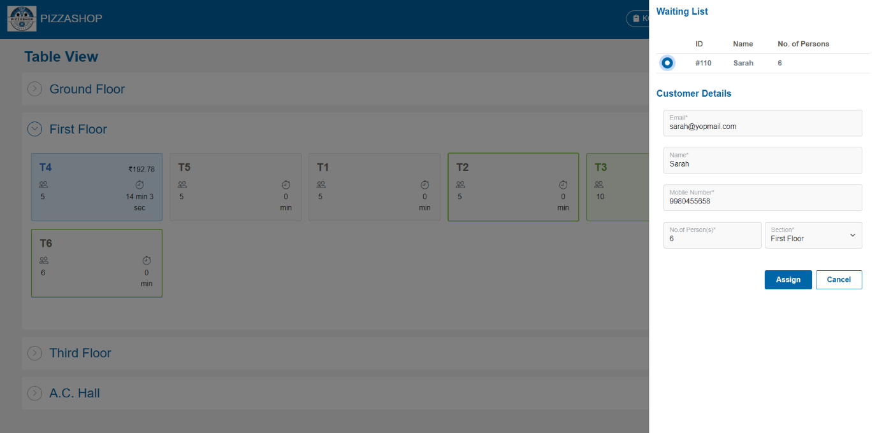Fig. Assigning two table to the customer

After assigning the table the account manager can add the food items to the merged tables as shown in the below image.

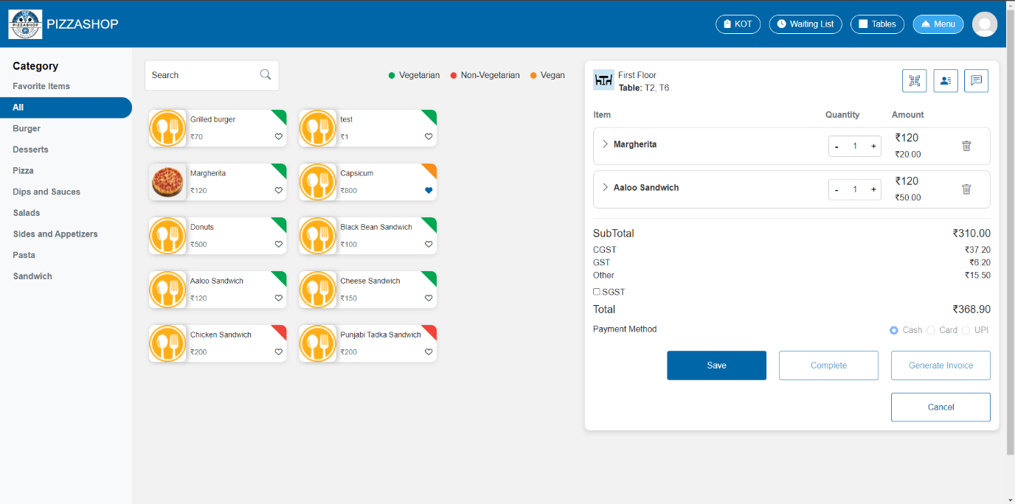Fig. Adding food items to the merged table T2 and T6

* Account Manager can see the food items of merged table T2, and T6 in KOT as shown in the below image.

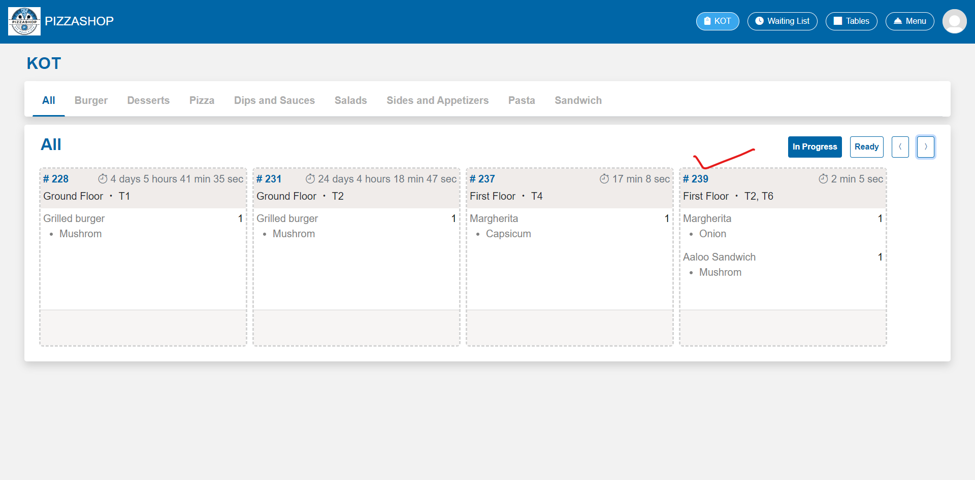Fig. KOT for merged table T2, T6

**Waiting Token**:

* By clicking on the waiting token button, a **Waiting token details** pop up appear on the screen. The account manager can create a waiting token for the customers when all tables or the specific table of the section requested by the customer at Pizza Shop are fully occupied.

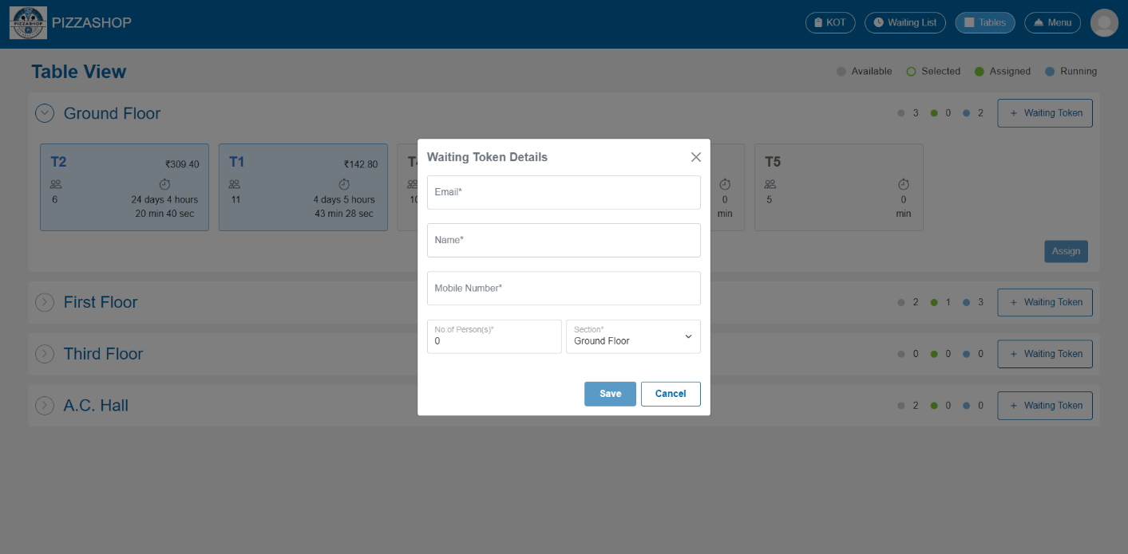Fig. Waiting token details

**Features:**

|  |  |  |  |
| --- | --- | --- | --- |
| **#** | **Feature** | **Type** | **Description** |
| 1. | Email | Textbox | This will show the email address of the customer. |
| 2. | Name | Textbox | This will show the name of the customer. |
| 3. | Mobile Number | Textbox | This will show the mobile number of the customer to whom the waiting token is generated. |
| 4. | No. Of Person(s) | Textbox | This will show the quantity of people per table. |
| 5. | Section | Dropdown | This will show for which section the waiting token is generated. |
| 6. | Save | Button | By clicking on this it validates the input fields to ensure all required fields are filled and correctly formatted. If validation passes, this will generate the waiting token for the customer and display the confirmation message indicating that the “Waiting token generated successfully”. |
| 7. | Cancel | Button | This will discard any changes made in the form and close the “**Waiting token details**” popup. |
| 8. | X | Button | This will close the “**Waiting token details**” popup. |

**3.7.2 Menu module in order app**

**Description: -**

The food menu serves as a listing of available food items as per the category within the Pizza Shop Management system, allowing Account manager to add the food Items as per the category requested by the customer to the assigned table and create the order.

Menu contains all types of food categories such as Favourite Items, All, Appetite, Appetizer, Deserts, Pizzas, Pasta, Dips and Sauces, Sand witches etc. On clicking the categories, the respective food items will appear on the screen and According to the categories account manager can add the food items to the table.

* By clicking on the Menu module, the account manager can see the listing of available food items as per the category as shown in the below image.

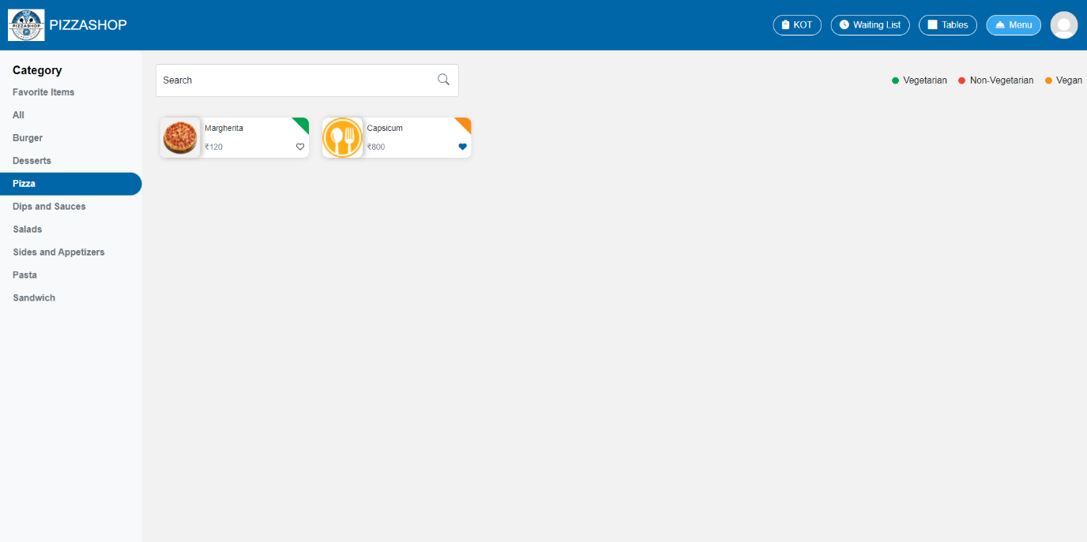Fig. Menu as per the category Pizzas

**Adding Menu Items requested by the customer to the assigned table**:

* After assigning a table to the customer, the **Account Manager** will be redirected to the **Menu Module** of the **Order App**.
* In this module, all the categories of the food items will be display inside **Category section.** The menu items are organized by categories (e.g., appetizers, main courses, desserts, Pizzas, Sand witches, Burgers, Beverages), making it easy for the Account Manager to select and add items requested by the customer to the specific table and create the order.
* By Clicking on the specific category all the menu items of that category will be display on the screen. As shown in the below image.

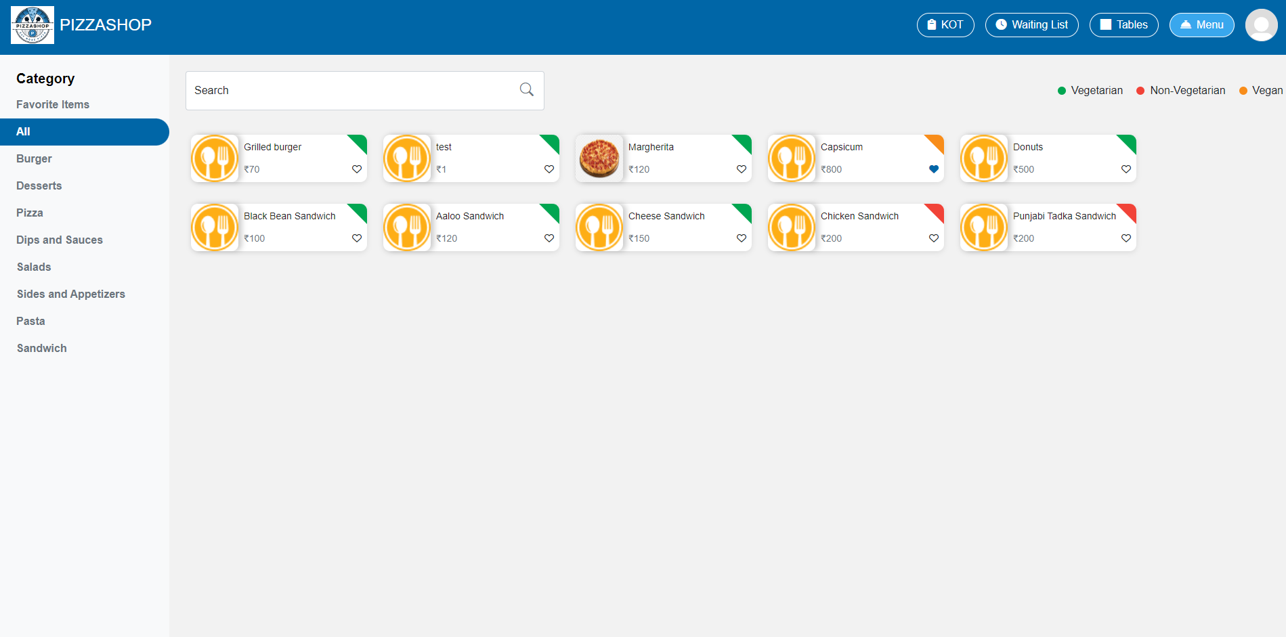Fig. Menu Module in Order App

**Features:**

|  |  |  |  |
| --- | --- | --- | --- |
| **#** | **Feature** | **Type** | **Description** |
| 1. | Category | Heading/Label | Heading for the category section. |
| 2. | Category>>Favourite Items | Menu | A section where user can save and quickly access their favourite food items, which are frequently ordered. |
| 3. | Category>>All | Menu | This will show the food items of all category. |
| 4. | Category>>Appetite | Menu | This will show the available food items of appetite category such as light meals or snacks. By clicking on this the food items of appetite category will appear on the screen and Account manager can add the items of appetite category requested by the customer to the assigned table. |
| 5. | Category>>Appetizers | Menu | Dedicated to appetizers, showcasing all available starter dishes. This will show the available food items of appetizers category. By clicking on this the food items of appetizers category will appear on the screen and Account manager can add the items of appetite category requested by the customer to the assigned table. |
| 6. | Search | Text | This will search for the food item based on the category. |

Note: -For e.g. If the User selects the **Pizzas category** from the Category and click on the heart icon form the item name (As heart is clicked by the user from Capsicum Pizza that is highlighted in yellow in the below image) then the particular item should show in the **Favourite items category.**

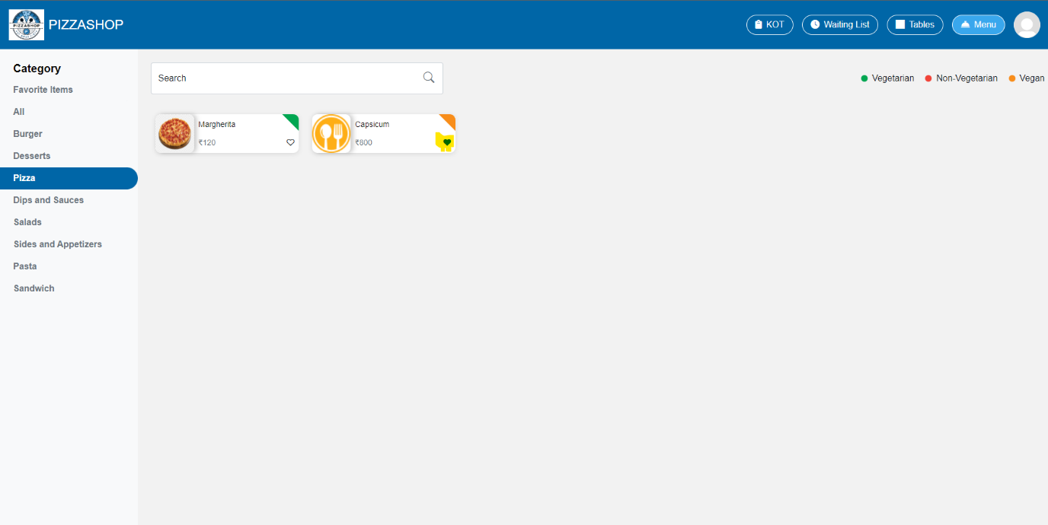Fig. Add Items to Favourite Items category

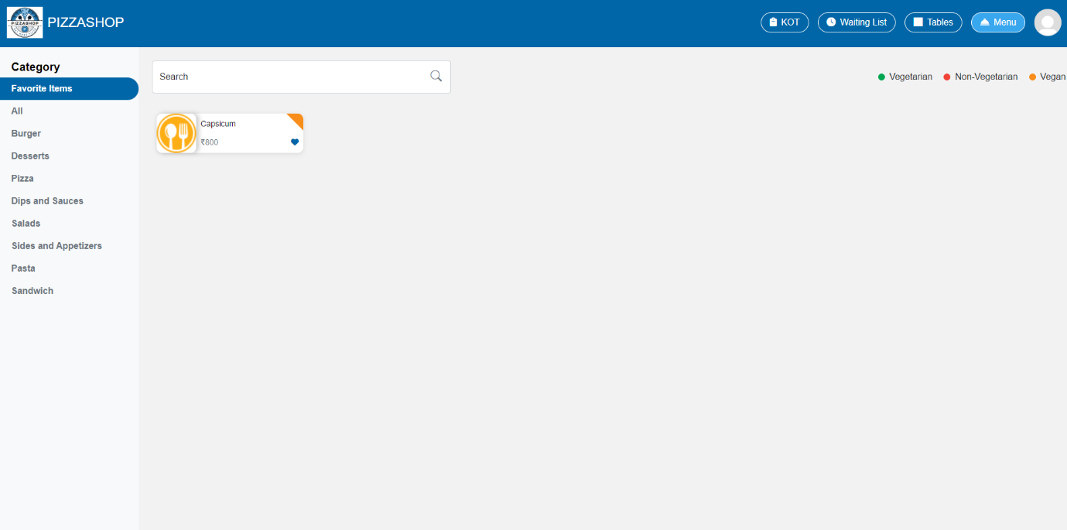

Fig. Favourite Items

* When clicking on an item (e.g. Capsicum Pizza), a popup will appear to add modifiers to the item. The account manager can select one or more modifiers by clicking on them, as shown in the image below.

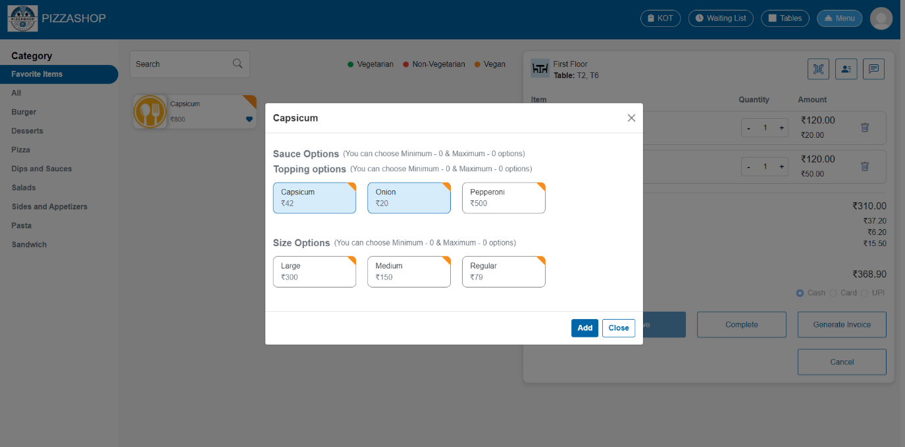Fig. Add Modifier with Item

* After selecting the modifiers, clicking the **Add** button will add the menu item to the table below the **Items**, along with the selected modifiers.
* For example, if the account manager selects **Margherita Pizza** and **Capsicum** **Pizza** from the **Pizzas** category and **Grilled Burger** from the **Burgers** category, and adds the corresponding modifiers, these items will be added to **Table T2 and T6**, as demonstrated in the image below.

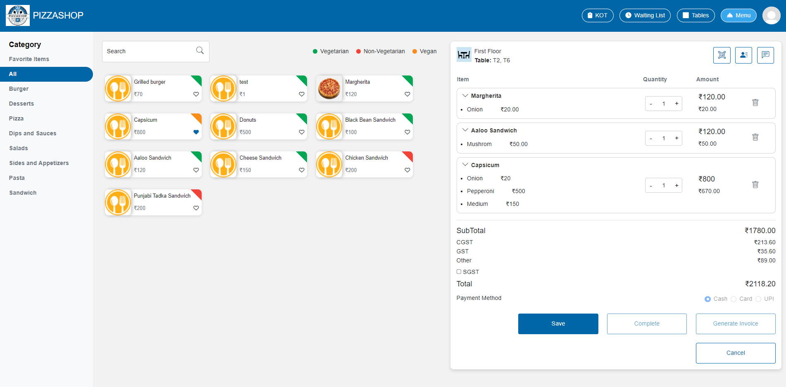Fig. Menu Items added to the table

**Table Section**

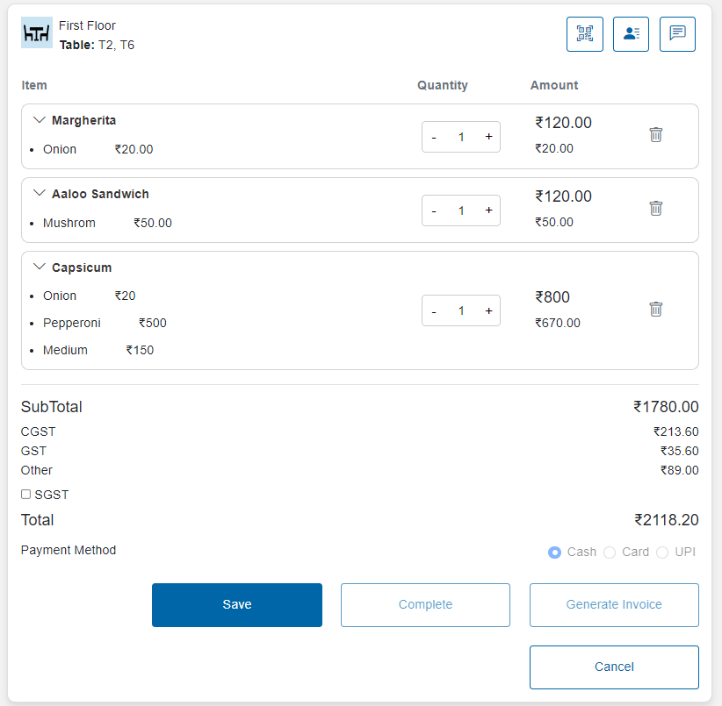

Fig. Table Section

**Features:**

|  |  |  |  |
| --- | --- | --- | --- |
| **#** | **Feature** | **Type** | **Description** |
| 1 | Name of the floor | Textbox | This will show the name of the floor for e.g. Ground floor. |
| 2 | Name of the table | Textbox | This will show the name of the table for e.g. T-1. |

**3.** **QR Code (Button):**

By clicking the QR Code button, a QR Code will be displayed on the screen. By scanning the QR Code, the account manager can access a link that will redirect them to the Menu page.

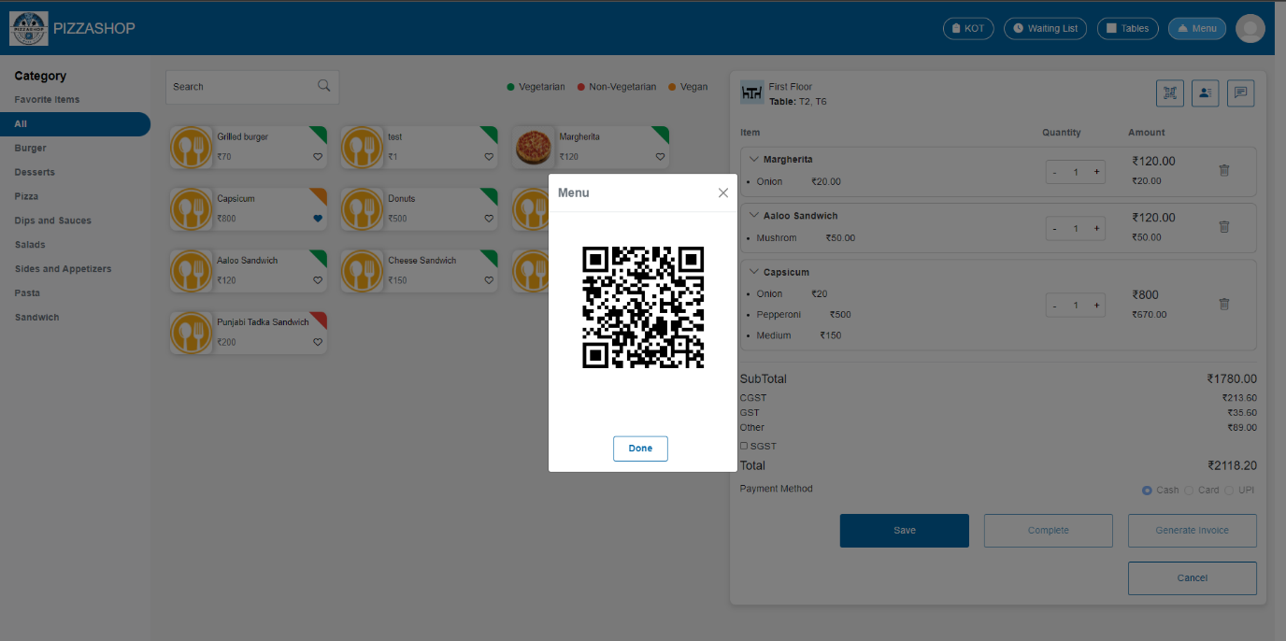Fig. Scan the QR-Code to see the Menu

|  |  |  |  |
| --- | --- | --- | --- |
| **#** | **Feature** | **Type** | **Description** |
| 1. | QR Code | Scannable QR Code | By scanning the QR Code a link should be displayed on the screen that should show the menu items available in Pizza Shop. |
| 2. | Done | Button | By clicking on this button, the menu popup closes. |
| 3. | X | Button | This will close the “Menu” Popup. |

**4.Customer Details (Button):**

By clicking the customer details button, the “Customer details” popup will show in this popup the account manager can see the customer details who has placed the order. The customer detail is editable here.

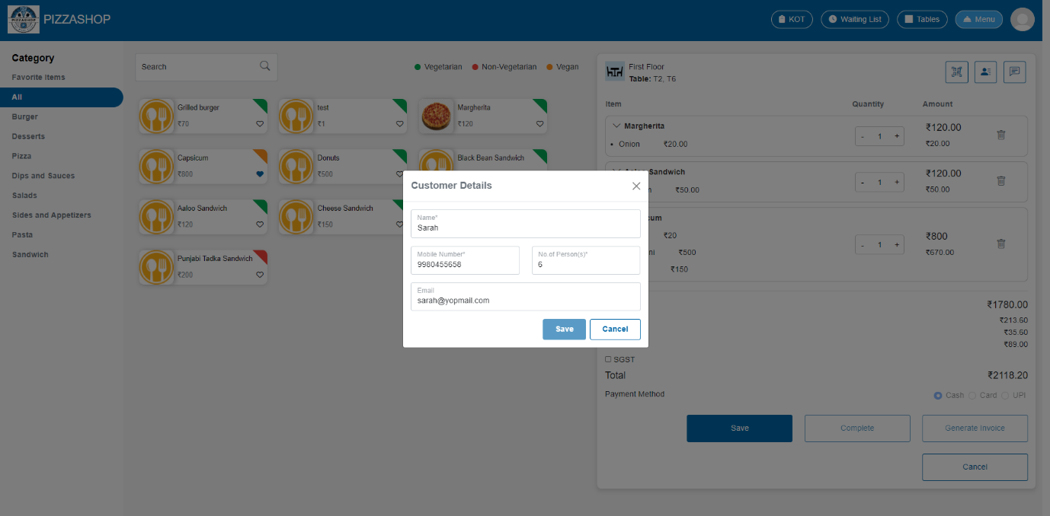Fig.Customer Details

**Features:**

|  |  |  |  |
| --- | --- | --- | --- |
| **#** | **Feature** | **Type** | **Description** |
| 1. | Name | Textbox | This will show the name of the customer. |
| 2. | Mobile Number | Textbox | This will show the Mobile Number of the customer. |
| 3. | No. of Person | Textbox | This will show the quantity of customers. |
| 4. | Email | Textbox | This will show the email of the customer. |
| 5. | Save | Button | By clicking on this it validates the input fields to ensure all required fields are filled and correctly formatted. If validation passes, this will save the customer details. |
| 6. | Cancel | Button | This will discard any changes made in the form and close the “Customer detail” popup. |
| 7. | X | Button | This will close the “Customer detail” popup. |

**5. Order Wise Comment (Button):**

The system allows the Account Manager to add order-specific comments based on suggestions provided by the customer while creating the order. This functionality ensures that any special requests or additional information from the customer are captured and recorded within the system, facilitating clear communication between the customer, Account Manager, and kitchen staff.

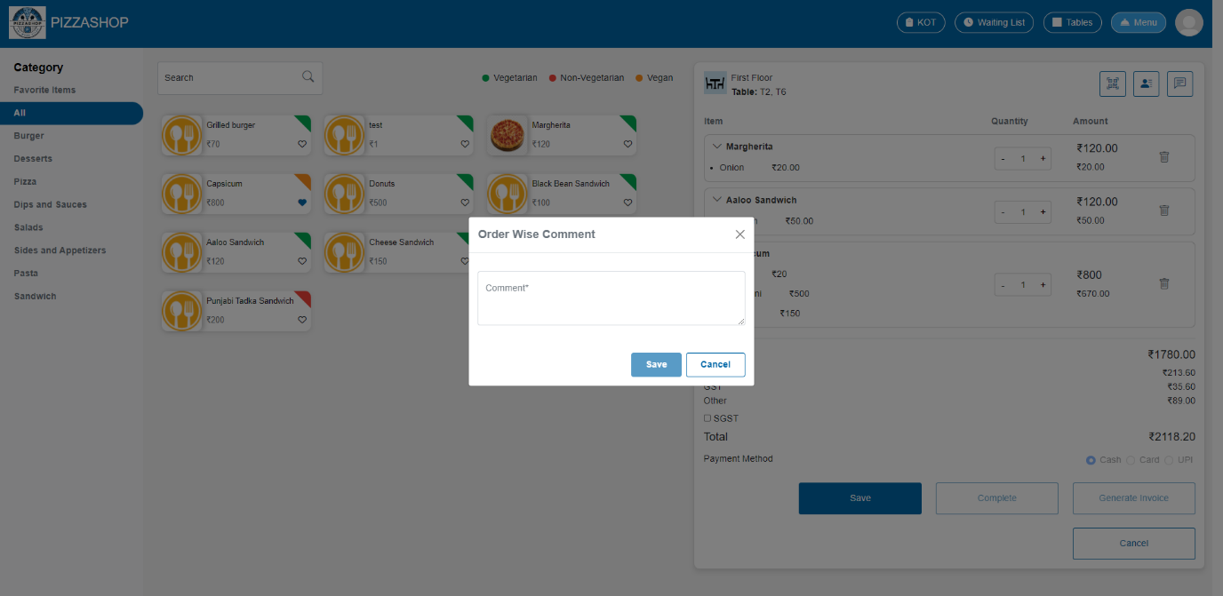Fig. Order Wise Comment

**Features:**

|  |  |  |  |
| --- | --- | --- | --- |
| **#** | **Feature** | **Type** | **Description** |
| 1. | Comment | Textbox | This will show the first name of the customer. |
| 2. | Save | Button | By clicking on this it validates the input fields to ensure all required fields are filled and correctly formatted. If validation passes, this will save the comment. |
| 3. | Cancel | Button | This will discard any changes made in the form and close the order wise comment popup. |
| 4. | X | Button | This will close the order wise comment popup. |

**6. Item wise comment:**

The user should be able to add item-specific comments. Once an item is added to the table and the order is saved, clicking on a particular item should open a "Special Instruction" popup, allowing the user to add special instructions for that specific item.

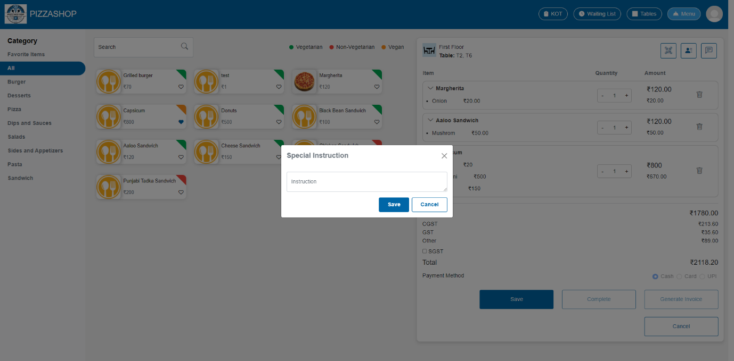Fig. Special Instruction

**Features:**

|  |  |  |  |
| --- | --- | --- | --- |
| **#** | **Feature** | **Type** | **Description** |
| 1. | Instruction | Textbox | This will show the name of the food items added to the table. |
| 2. | Save | Button | By clicking on this it validates the input fields to ensure all required fields are filled and correctly formatted. If validation passes, this will save the special instruction item wise. |
| 3. | Cancel | Button | This will discard any changes made in the form and close the special Instruction popup. |

**7. Items:**

Items will show the list of all the food items added by the Account Manager to the table with Quantity and Amount. Account manager can delete the item as well.

**Features:**

|  |  |  |  |
| --- | --- | --- | --- |
| **#** | **Feature** | **Type** | **Description** |
| 1. | Items | Textbox | This will show the name of the food items added to the table. |
| 2. | Quantity | Button | This will show the quantity of food items. |
| 3. | Amount | Textbox | This will show the amount of food items. |
| 4. | Trash Icon | Button | By clicking this the account manager can delete the food items. |

**8.Sub Total:**

The subtotal is the sum of all individual item costs before any taxes, discounts, or additional fees are applied. It reflects the total amount for the items being purchased.

**9.Total:**

The total represents the final amount due after applying any taxes, discounts, and additional fees to the subtotal. It is the amount the customer must pay to complete the transaction.

**10.Payment Method: Not needed at this point**

Payment method includes the Cash, Card, UPI. Account Manager can select the payment method from the radio button.

**11.Save:**

**Order Creation**:

* After adding the Menu Items and completing the order the Account Manager can click on the **Save** Button to create the order.
* All customer orders created by the **Account Manager** in the **Order App** can be viewed by the **Super Admin** in the **Orders Module**.
* On clicking save button a success message should show on the screen “Order Created Successfully”.

**12.Complete:**

All items must be served before completing the order. After serving the order by clicking the complete button the account manager can complete the order.

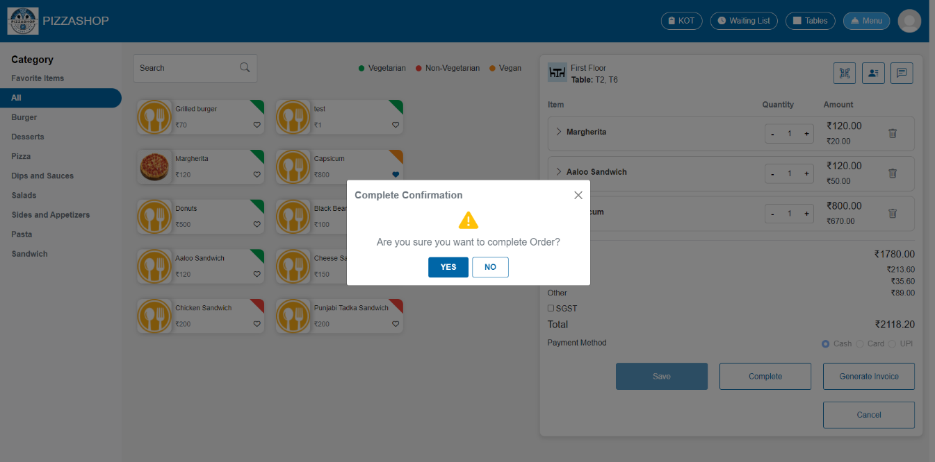Fig. Complete Order

**Features:**

|  |  |  |  |
| --- | --- | --- | --- |
| **#** | **Feature** | **Type** | **Description** |
| 1. | Message | Label | The confirmation box will display a clear message, such as: " Are you sure you want to complete order?” |
| 2. | Yes | Button | 1.Proceed with the cancelation of the order from the system.  2. Display a success message indicating that the "Order completed successfully”. |
| 3. | No | Button | Close the confirmation popup. |
| 4. | X | Button | This will close the confirmation popup. |

* If user tries to complete the order before serving, then the error message saying that “All items must be served before completing the orders” should display on the screen.

**Customer Review**

* When the user clicks the **"Yes"** button to complete the order, The order should be marked as completed.
* After the order is completed, a **Customer Review pop-up** should appear on the screen, prompting the customer to provide their feedback. A customer can give their feedback based on the Food, service, Ambience.

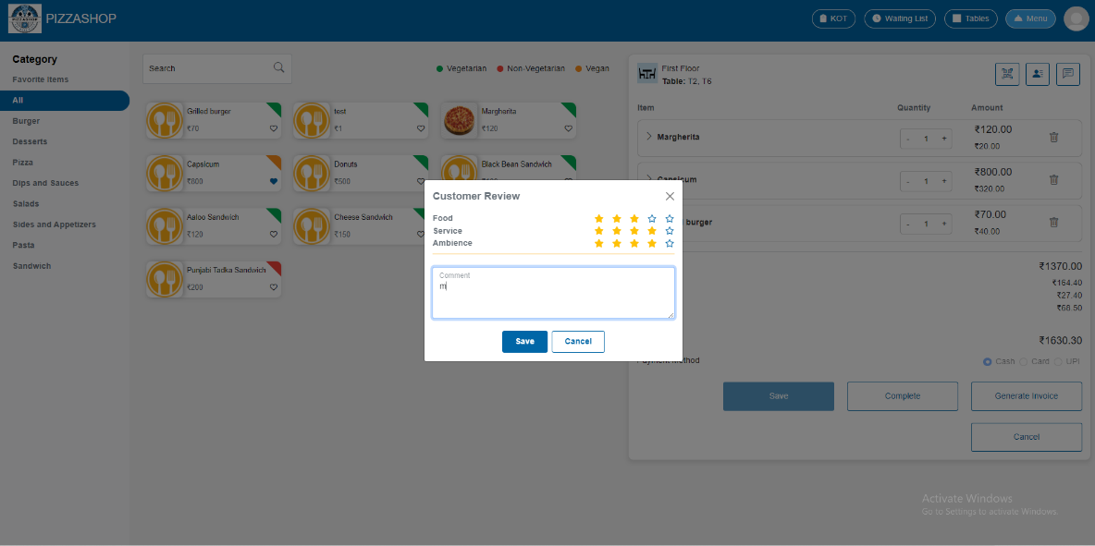

Fig. Customer Review

**Features:**

|  |  |  |  |
| --- | --- | --- | --- |
| **#** | **Feature** | **Type** | **Description** |
| 1. | Stars for review | Button | Click on the stars to rate Food, Service, and Ambience. |
| 2. | Comment | Text | This will allow the user to enter comments. |
| 3. | Save | Button | This will save customer review. |
| 4.. | Cancel | Button | This will close the review pop-up without saving the review. |
| 5.. | X | Button | This will close the review pop-up without saving the review. |

Account manager can see the order wise ratings based on the customer review in the orders list in the orders menu as shown in the below image.

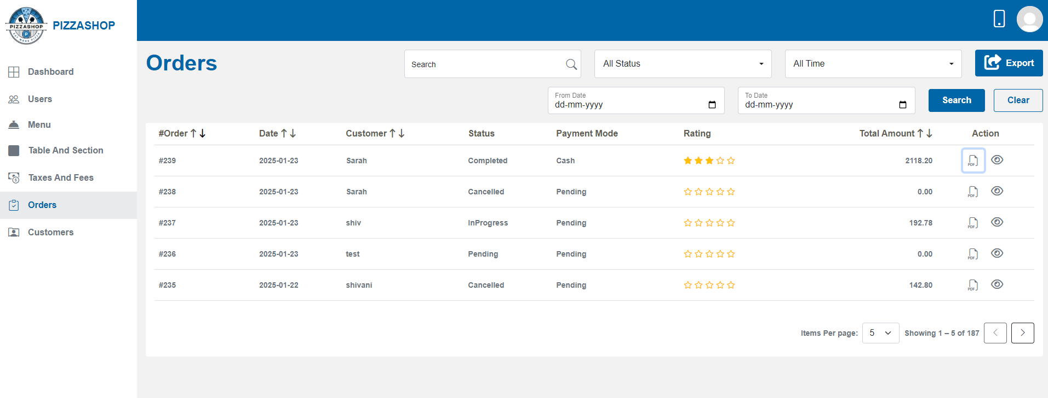

Fig. Ratings based on the customer review in Orders list

**13.Generate Invoice**: **Not needed at this point**

The “Generate Invoice” button allows the account manager to create a formal invoice based on the items selected or ordered in the system. This process involves compiling the relevant order details and generating a printable or downloadable invoice

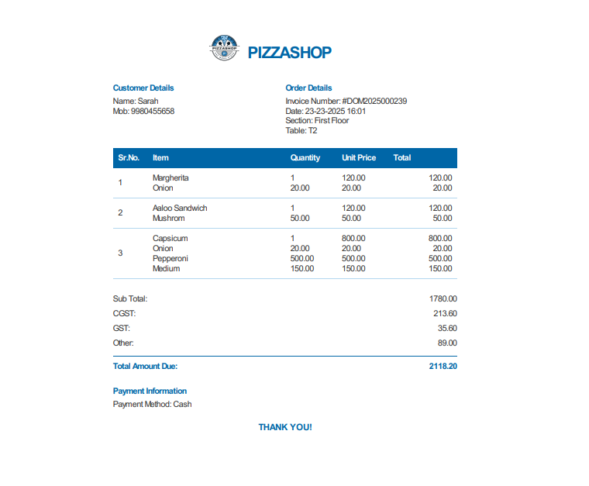Fig. Generate Invoice

**14. Cancel:**

By clicking on the “Cancel” button the Order will be cancelled, and the “Cancel Confirmation” box will appear on the screen.

**Cancel Order Confirmation box**

Account manager can cancel the order from the list on clicking the cancel button. On clicking on cancel button, a confirmation box will show asking that “Are you sure you want to cancel the order?” and contains “Yes” and “No” Buttons. This box will require the administrator to confirm their action before proceeding with the deletion.

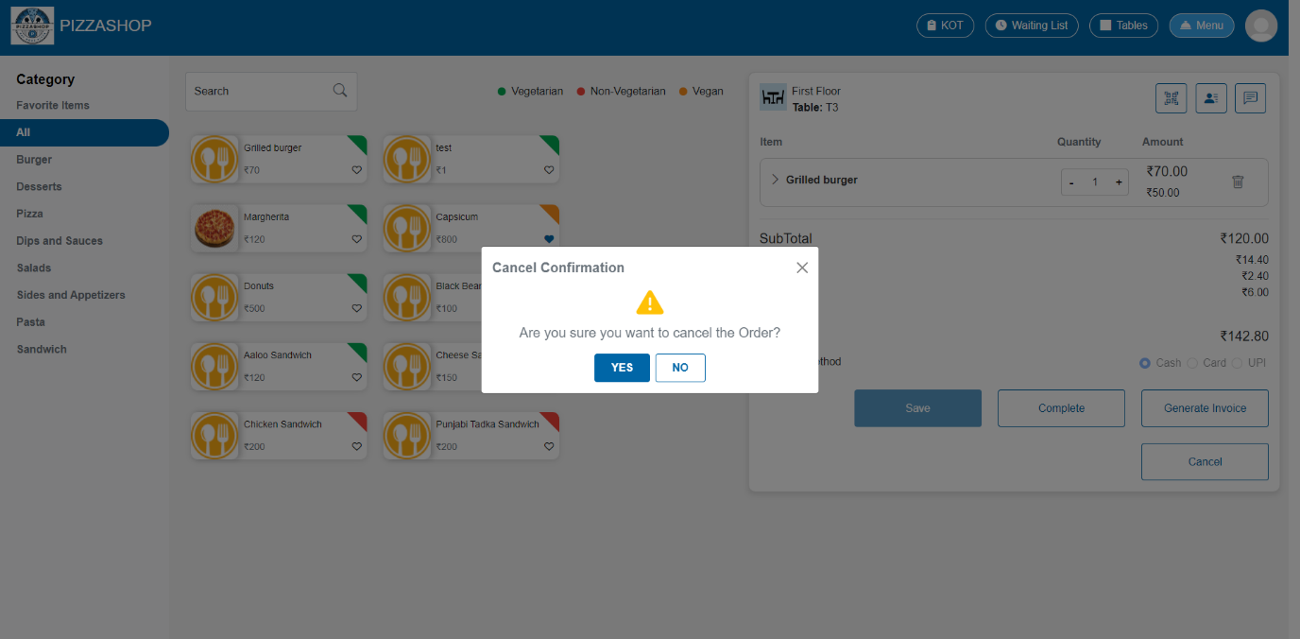Fig. Cancel Order

**Features:**

|  |  |  |  |
| --- | --- | --- | --- |
| **#** | **Feature** | **Type** | **Description** |
| 1. | Message | Label | The confirmation box will display a clear message, such as: " Are you sure you want to cancel the order?” |
| 2. | Yes | Button | 1.Proceed with the cancelation of the order from the system.  2. Display a success message indicating that the "Order cancelled successfully”. |
| 3. | No | Button | Close the confirmation popup. |
| 4. | X | Button | Close the confirmation popup. |

### **Order Cancellation Validation**

1. If the item is marked as **Ready**, the order cannot be cancelled. The system should display an error message stating: “The order item is ready, cannot cancel the order”.
2. If the item is marked as **Ready**, the order cannot be deleted. The system should display an error message stating: “You cannot delete this item because 1 quantity of <item name> is already ready”.
3. If the order contains the item that is not ready or in progress, you can delete that item.
4. An order can only be cancelled if the customer has added **items to the order**.

and the customer has **not saved** the order yet.

**3.7.3 Waiting List module in order app**

Description: -

The **Waiting List** menu in the **Order App** is designed to manage customers who are waiting for a table when the restaurant is full. This menu helps manage customer flow during busy times, improving efficiency and customer satisfaction.

**Waiting List:**

In the Waiting List, the Account Manager can view and generate the waiting tokens for customers. All available sections (e.g. Ground floor, First floor, Third floor, A.C Hall) of Pizza Shop will be displayed, and by selecting a specific floor, the Account Manager can view, edit, delete the waiting tokens for the tables on that floor. By selecting "All," they can view the waiting tokens for all floors.

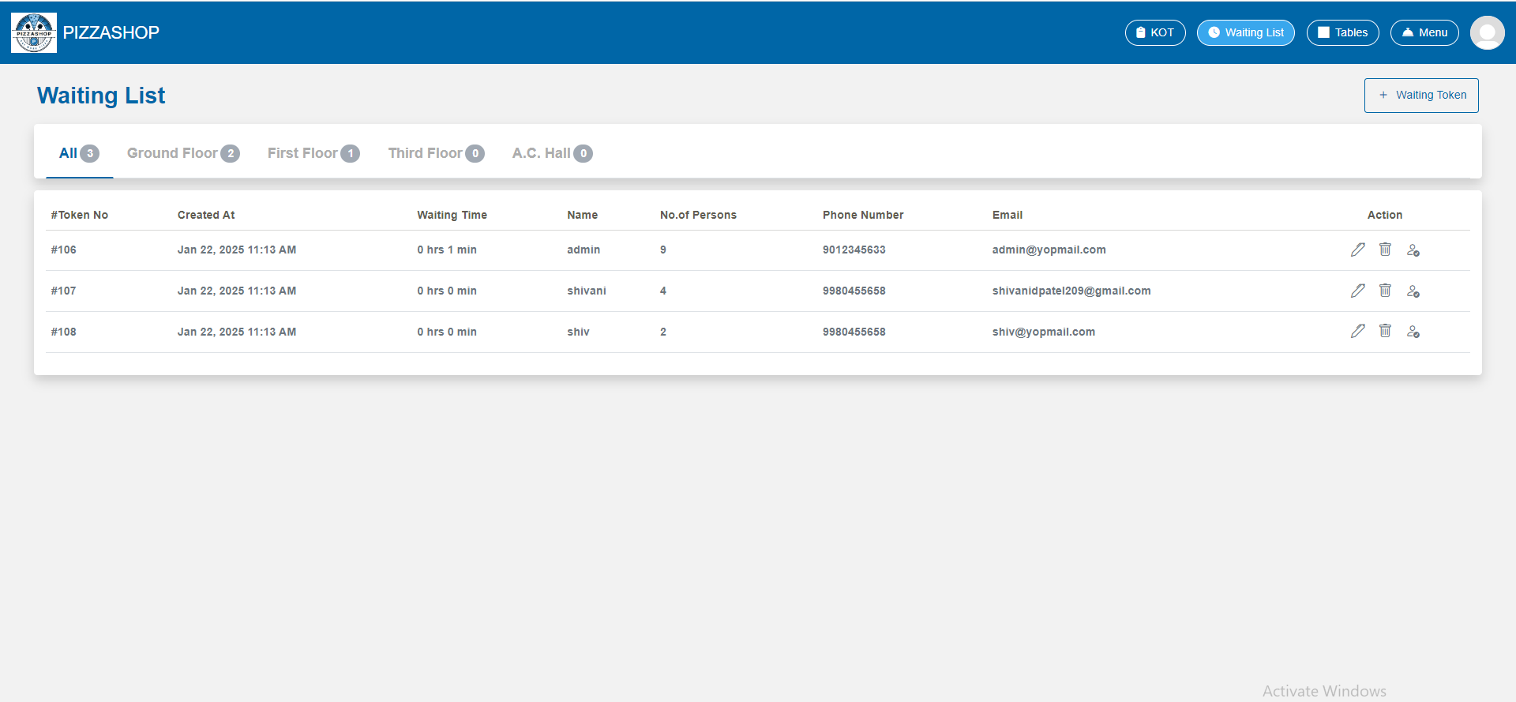Fig. Waiting List for All section

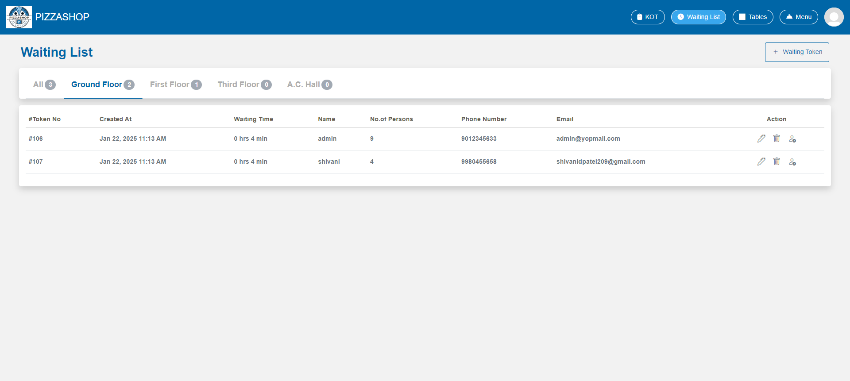Fig. Waiting List for Ground Floor

**Features:**

|  |  |  |  |
| --- | --- | --- | --- |
| **#** | **Feature** | **Type** | **Description** |
| 1. | Waiting Token | Button | By clicking the Waiting Token button, the **Waiting token details** popup will appear on the screen. |
| 2. | All | Clickable menu | This will show the waiting list created for the tables of all the sections. |
| 3. | Ground Floor | Clickable menu | This will show the waiting list created for the tables of all the ground floor. |
| 4. | First Floor | Clickable menu | This will show the waiting list created for the tables of all the first floor. |
| 5. | Token Id | Clickable menu | This will show the waiting token id of customer. |
| 6. | Created At | Textbox | This will show the date and time when the token has generated. |
| 7. | Waiting Time | Textbox | This will show the waiting time for the customer. |
| 8. | Name | Textbox | This will show the name of the customer to whom the token has generated. |
| 9. | No. Of Persons | Textbox | This will show the quantity of people. |
| 10. | Phone Number | Textbox | This will show the phone number of the customer. |
| 11. | Email | Textbox | This will show the email of the customer. |
| 12. | Action | Clickable icons |  |

**Adding Customers to the Waiting List/Creating the waiting token**:

If all tables of the section are occupied, customers can be added to the waiting list by entering their name, Email, section and contact details. The estimated wait time is provided based on current table availability.

By clicking the Waiting Token button, the **Waiting Token Details** popup will appear on the screen.

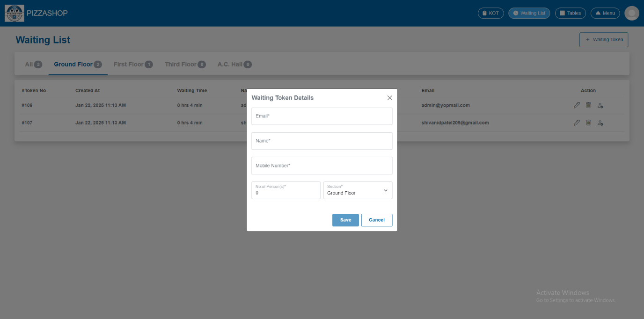Fig. Generate Waiting Token

**Features:**

|  |  |  |  |
| --- | --- | --- | --- |
| **#** | **Feature** | **Type** | **Description** |
| 1. | Mobile Number | Textbox | This will show the mobile number of the customer to whom the waiting token is generated. |
| 2. | Name | Textbox | This will show the name of the customer. |
| 3. | Email | Textbox | This will show the email address of the customer. |
| 4. | No. Of Person(s) | Textbox | This will show the quantity of people per table. |
| 5. | Section | Dropdown | This will show for which section the waiting token is generated. |
| 6. | Save | Button | By clicking on this it validates the input fields to ensure all required fields are filled and correctly formatted. If validation passes, this will generate the waiting token for the customer and display the confirmation message indicating that the “Waiting token generated successfully”. |
| 7. | Cancel | Button | This will discard any changes made in the form and close the “**Waiting Token Details**” popup. |
| 8. | X | Button | This will close the “**Waiting Token Details**” popup. |

**Note: -** The **Account Manager** should be able to fetch the customer's details by entering the **email address** in the **Waiting Token Details** form.

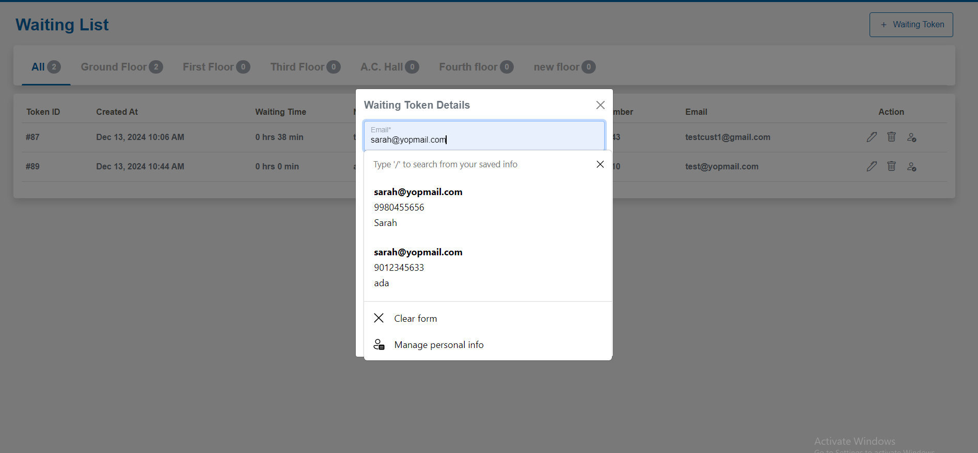Fig. Fetch customer’s detail based on email

**Edit Customers details to the Waiting List/Editing the waiting token**:

Account manager can edit the generated waiting token by clicking the pencil icon from the Actions column. On clicking the pencil icon "Waiting Token Details" popup will appear on the screen.

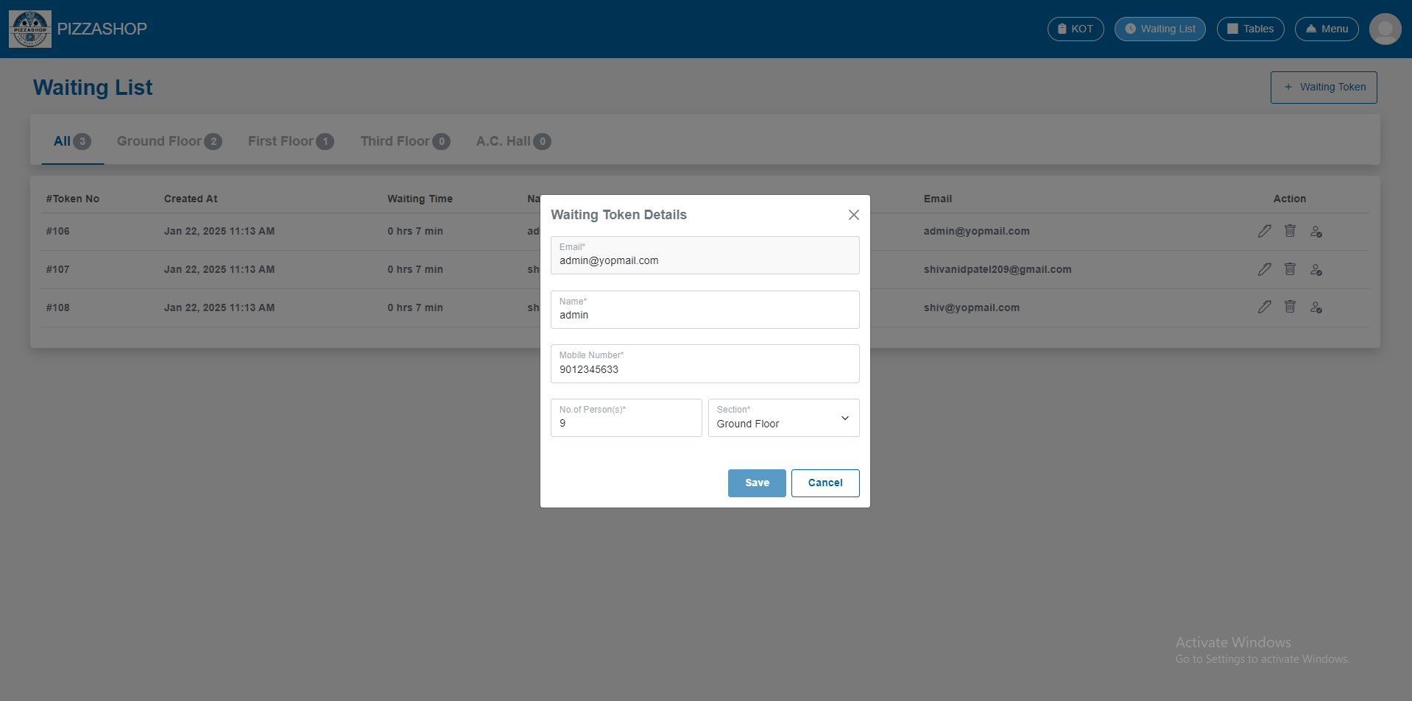 Fig. Edit generated waiting token details

**Features:**

|  |  |  |  |
| --- | --- | --- | --- |
| **#** | **Feature** | **Type** | **Description** |
| 1. | Mobile Number | Textbox | This will show the mobile number of the customer to whom the waiting token is generated. |
| 2. | Name | Textbox | This will show the name of the customer. |
| 3. | Email | Textbox | This will show the email address of the customer. |
| 4. | No. Of Person(s) | Textbox | This will show the quantity of people per table. |
| 5. | Section | Dropdown | This will show for which section the waiting token is generated. |
| 6. | Save | Button | By clicking on this it validates the input fields to ensure all required fields are filled and correctly formatted. If validation passes, this will edit the already generated the waiting token for the customer and display the confirmation message indicating that the “Waiting token generated successfully”. |
| 7. | Cancel | Button | This will discard any changes made in the form and close the “**Waiting Token Details**” popup. |
| 9. | X | Button | This will close the “**Waiting Token Details**” popup. |

**Delete the waiting token**:

Account manager can delete the generated waiting token by clicking the trash icon from the Actions column. On clicking the trash icon "Cancel Confirmation" popup will appear on the screen.

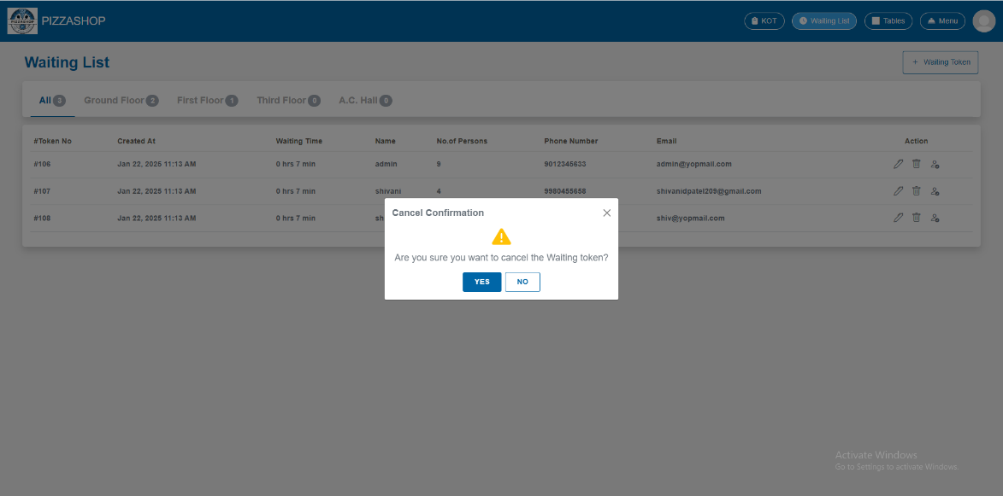

Fig. Delete Waiting Token Details

**Features:**

|  |  |  |  |
| --- | --- | --- | --- |
| **#** | **Feature** | **Type** | **Description** |
| 1. | Message | Label | The confirmation box will display a clear message, such as: " Are you sure you want to cancel the waiting token?” |
| 2. | Yes | Button | 1.Proceed with the cancelation of the waiting token from the system.  2. Display a success message indicating that the "Waiting token cancelled successfully”. |
| 3. | No | Button | Close the “Cancel Confirmation” popup. |
| 4. | X | Button | This will close the confirmation popup. |

**Assigning a Table to a Customer with a Generated Waiting Token**

When a table becomes available, the Account Manager can assign it to a customer whose waiting token has already been generated, by clicking the table icon from the Actions column. On clicking the icon next to delete "Assign Table" popup will appear on the screen.

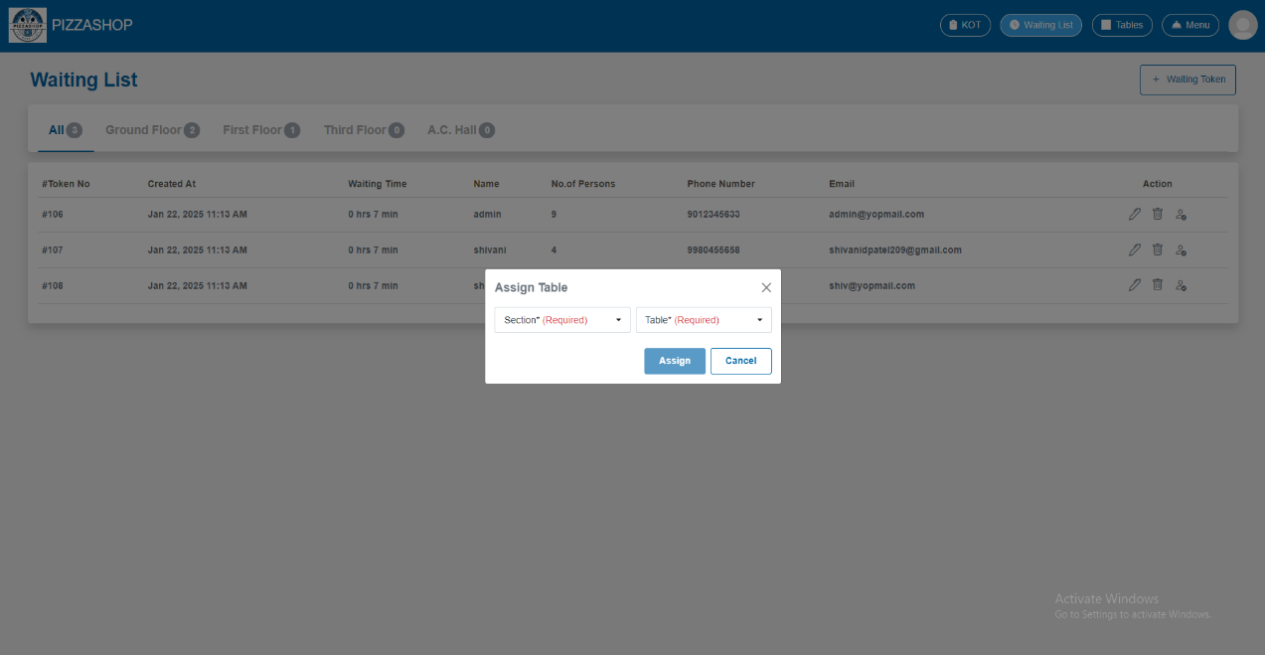

Fig. Assign Table

**Features:**

|  |  |  |  |
| --- | --- | --- | --- |
| **#** | **Feature** | **Type** | **Description** |
| 1. | Section | Textbox | This will show section in which table is assigned. |
| 2. | Table | Textbox | This will show the name of the table that is assigned to the customer. |
| 3. | Save | Button | This will assign the table to the customer and update the waiting list. By clicking on this it validates the input fields to ensure all required fields are filled and correctly formatted. If validation passes, this will assign a table to the customer and update the waiting list. and display the confirmation message indicating that the “Table assigned successfully”. |
| 4. | Cancel | Button | This will discard any changes made in the form and close the **Assign Table** popup. |
| 5. | X | Button | This will close the **Assign Table** popup. |

Note: - While assigning a table to a customer from the waiting list:

1. The T**ables dropdown** shall display only the tables that are currently **available** (not occupied or already reserved).
2. Tables that are **unavailable** (occupied, reserved) shall not be shown in the dropdown.
3. If account manager assigned table to customer, the customer should be removed from waiting list.

After assigning the table it will redirect the account manager to the menu module of the Order App as shown in the below image to continue the flow of order creation.

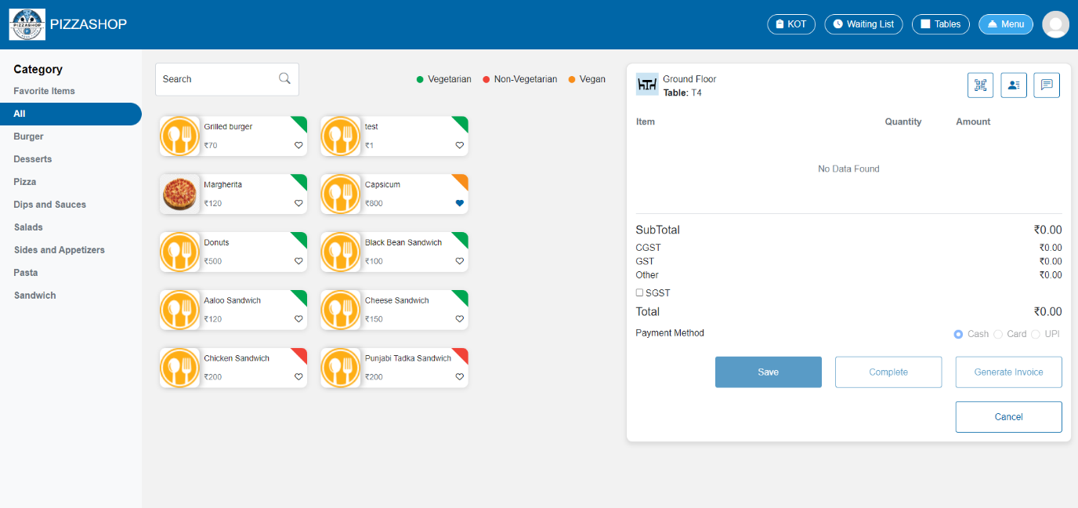Fig. Table in menu module

**3.7.4 KOT in order app**

**Description: -**In a Pizza Shop, KOT stands for Kitchen Order Ticket. It is a critical component used to manage and track orders from the dining area to the kitchen efficiently.

* In the **Menu Module**, the Account Manager adds food items to the table and then saves the order. Once the order is saved, they can see the ordered food items in a card categorized by section in the **KOT** with the status as **In Progress**.
* In **KOT**, the Account Manager can view all the food items ordered by customers, categorized according to the menu sections with status **In Progress** or **Ready** as shown in the image below.
* This allows the Account Manager to easily track and manage customer orders based on categories, ensuring smooth communication with the kitchen.

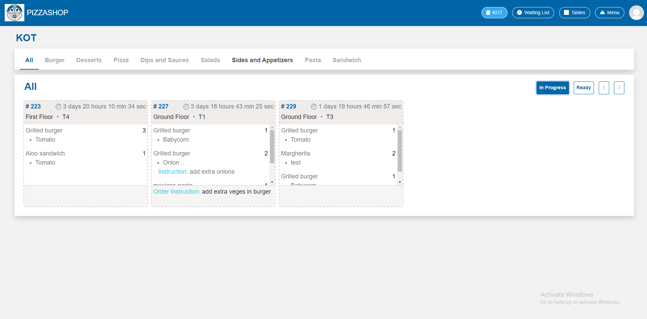 Fig. KOT for All

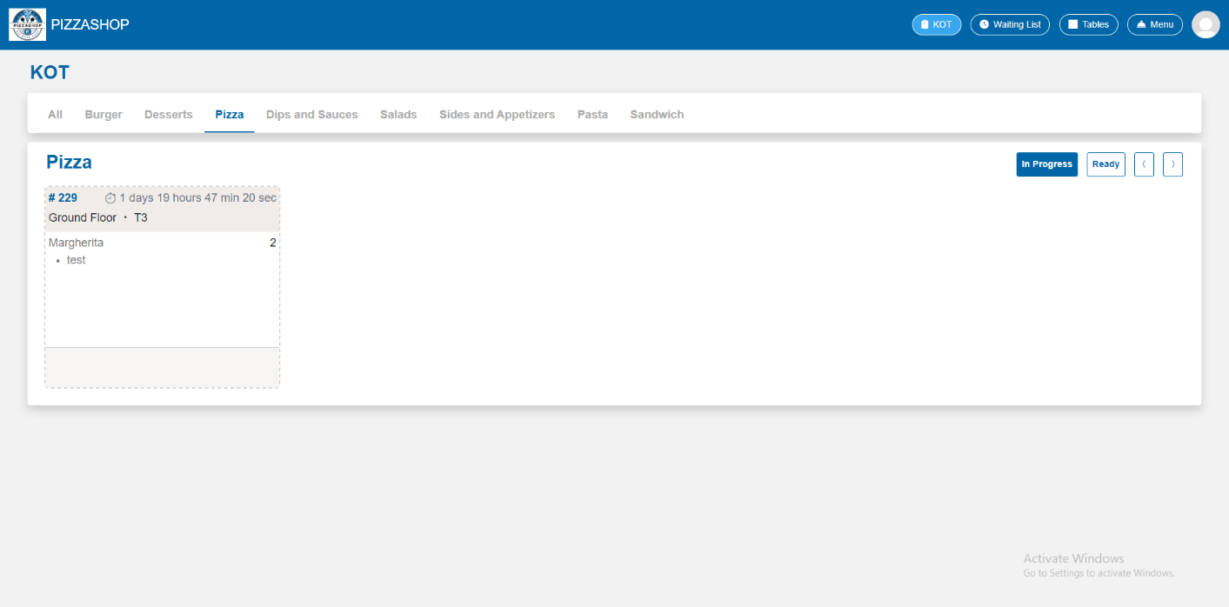Fig. KOT for Pizzas (In Progress)

**Features:**

|  |  |  |  |
| --- | --- | --- | --- |
| **#** | **Feature** | **Type** | **Description** |
| 1. | All, Dips and Sauces, Salads……. | Clickable category (menu) | By clicking on the particular category, the food item card of that category should appear on the screen with the details as shown in the image. |
| 2. | In progress | Button | By clicking on this the food item card that is processed by the chef should appear on the screen. |
| 3. | Ready | Button | By clicking on this the food item card that is prepared by the chef should appear on the screen. |
| 4. | Food item card | Contains the details about the ordered food item | It contains the order id, section, table name, time, food item name with quantity. |

* Once the food items are prepared by the chef and are ready to serve, the Account Manager can mark them as "Prepared." By clicking on the ordered food items card, a popup will appear on the screen, displaying the list of food items. The Account Manager can then select the specific items that are ready and mark them as "Prepared" by click on the **Mark as prepared** button.

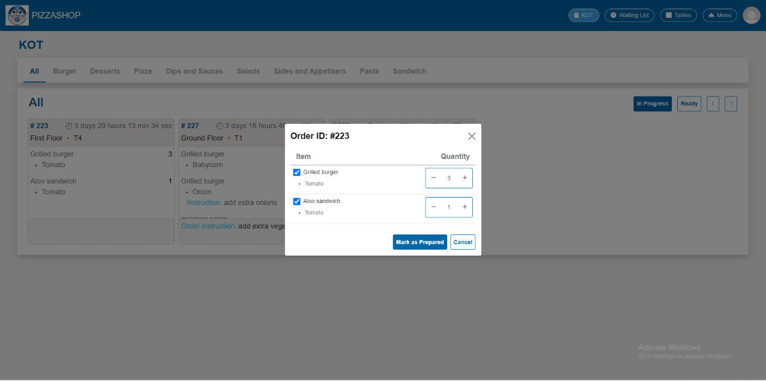Fig. Mark as prepared

**Features:**

|  |  |  |  |
| --- | --- | --- | --- |
| **#** | **Feature** | **Type** | **Description** |
| 1. | Order ID | Textbox | This will show the Order Id of the customer. |
| 2. | Item | Textbox | This will show the food items ordered by the customer. |
| 3. | Quantity | Button | This will show the quantity of items ordered. |
| 4. | Mark as prepared | Button | If the food item is prepared and ready to serve the by clicking this it’s status will be changed from In Progress to Ready. It should be removed from In Progress and added to Ready. |
| 5. | Cancel | Button | This will discard any changes made by the user and close the popup. |
| 6. | X | Button | This will close the popup. |

In the **selected category or All,** the account manager can mark all the food items or selected food items to Prepared but they can mark the food items as Prepared as per the category individually as well as shown in the below image.

For e.g. The account manager can mark the food item as prepared one at a time or all food items.

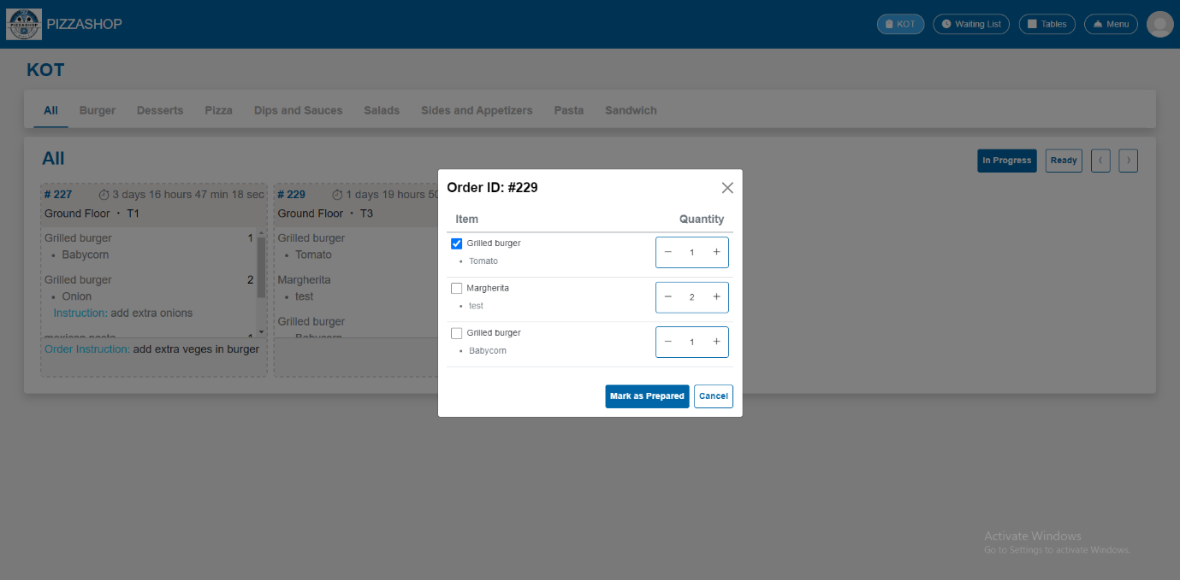 Fig. Mark individual food item as prepared

After marking the food items as prepared by clicking on the **Mark as prepared** button the status of the food item will be changed from **In Progress** to **Ready** as highlighted in the below image.

The food items should be removed from In Progress and added to the Ready.

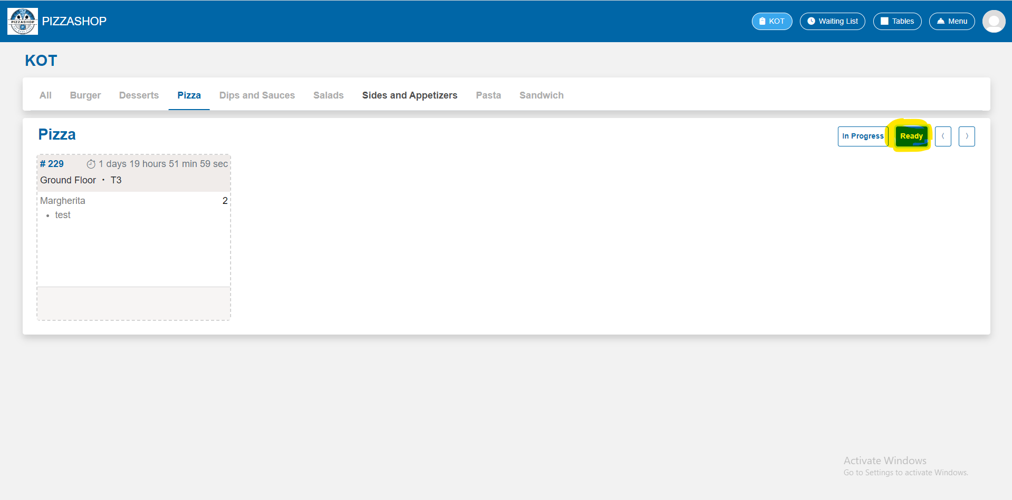Fig. Ready to Serve Pizzas

* There is a functionality that allows the Account Manager to revert food items back to "In Progress" if they were mistakenly marked as "Prepared." By clicking on the food item card in the "Ready" state, a popup will appear, allowing the Account Manager to move the item back to "In Progress."

By clicking on the **Mark as in progress** it will added to the In Progress Status.

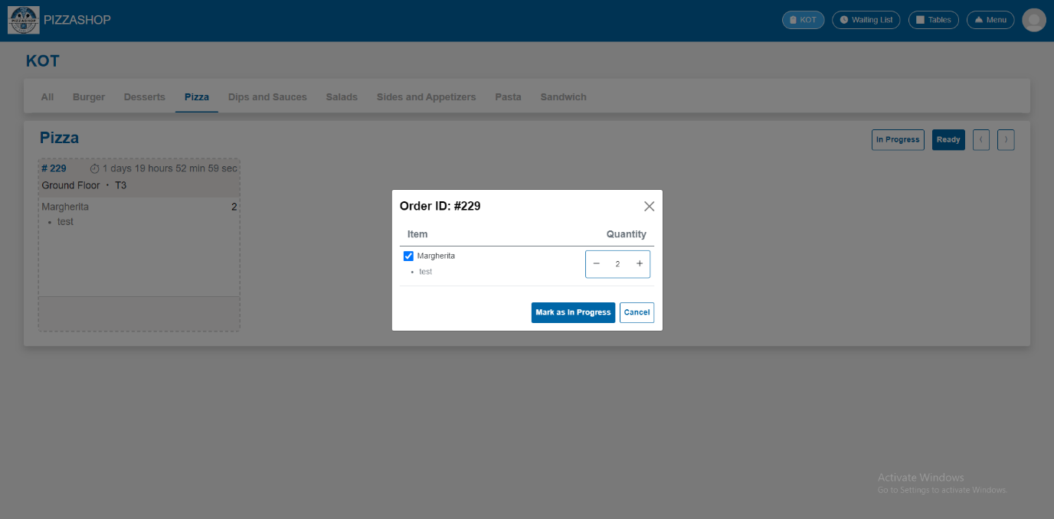Fig. Mark as in progress

**Features:**

|  |  |  |  |
| --- | --- | --- | --- |
| **#** | **Feature** | **Type** | **Description** |
| 1. | Order ID | Textbox | This will show the Order Id of the customer. |
| 2. | Item | Textbox | This will show the food items ordered by the customer. |
| 3. | Quantity | Button | This will show the quantity of items ordered. |
| 4. | Mark as in progress | Button | This will add the food items card to in progress and remove from the Ready state. |
| 5. | Cancel | Button | This will discard any changes made by the user and close the popup. |
| 6. | X | Button | This will close the popup. |

**4. Chef Dashboard**

**Description: -**

The Chef Dashboard in a Pizza Shop is a tool designed to help chef’s management and track the preparation of food orders efficiently.

The **Chef Dashboard** is essential for maintaining kitchen efficiency, especially in busy restaurants, and it plays a key role in delivering high-quality, timely service.

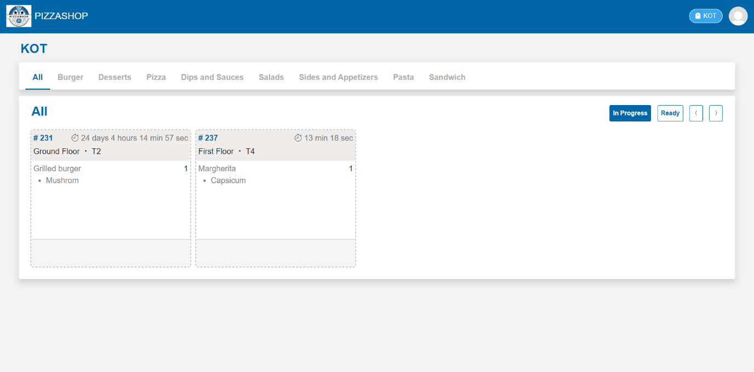Fig. Chef Dashboard

**4.1 KOT**

* In the **Menu Module**, the Account Manager adds food items to the table and then saves the order. Once the order is created, they can see the ordered food items in a card categorized by section in the **KOT** with the status as **In Progress**.
* In **KOT**, chef can view all the food items ordered by customers, categorized according to the menu sections with status **In Progress** or **Ready** as shown in the image below.
* The KOTs for each table are displayed in real-time on the Chef Dashboard, showing all incoming food orders. The orders are grouped by categories, such as Pizzas, Burgers, and Desserts, allowing chefs to manage and organize their workload effectively.

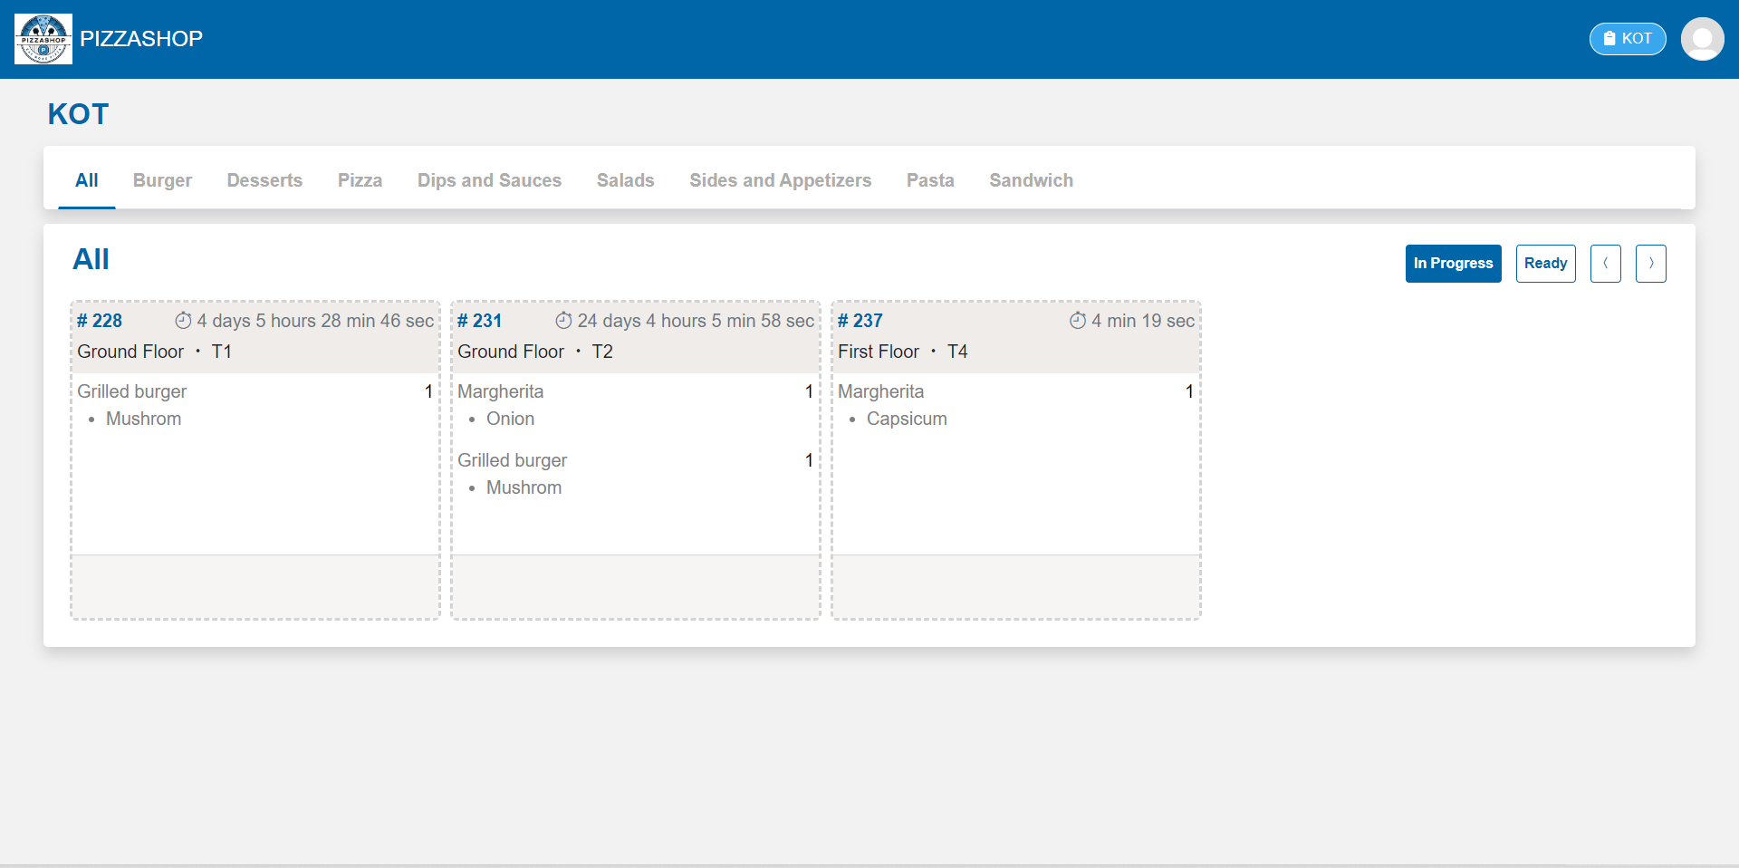

Fig. KOT for All

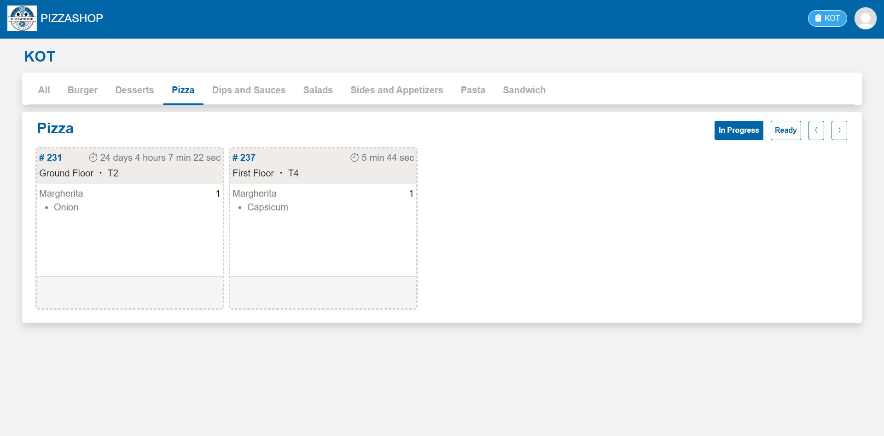Fig. KOT for Pizza

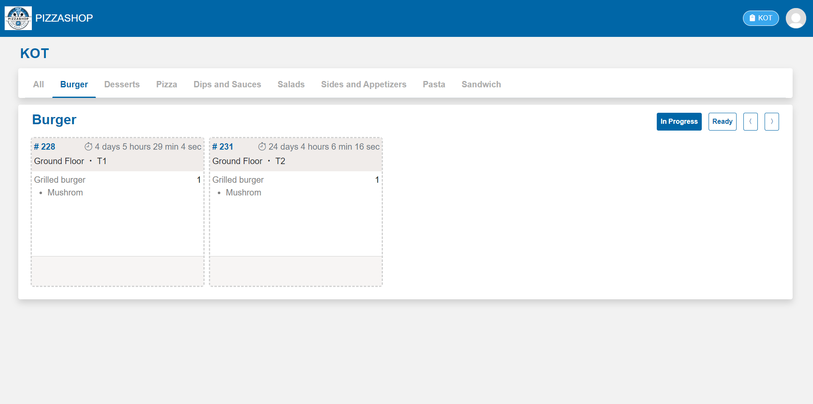Fig. KOT For Burger

**Features:**

|  |  |  |  |
| --- | --- | --- | --- |
| **#** | **Feature** | **Type** | **Description** |
| 1. | All, Sandwich, Burger……. | Clickable category (menu) | By clicking on the particular category, the food item card of that category should appear on the screen with the details as shown in the image. |
| 2. | In progress | Button | By clicking on this, a card for the food item that is processed by the chef should appear on the screen. On clicking the **In Progress** button the food Item that is not prepared but in progress (chef is still preparing) should show on the screen. |
| 3. | Ready | Button | By clicking on this, the card for the food item that is prepared by the chef should appear on the screen. On clicking the **Ready** button the food Item that is prepared by the should show on the screen. |
| 4. | Food item card | Contains the details about the ordered food item | It contains the order id, section, table name, time, food item name with quantity. |

* Once the food items are prepared by the chef and are ready to serve, the chef can mark them as "Prepared." By clicking on the ordered food items card, a popup will appear on the screen, displaying the list of food items. The Chef can then select the specific items that are ready and mark them as "Prepared" by click on the **Mark as prepared** button.

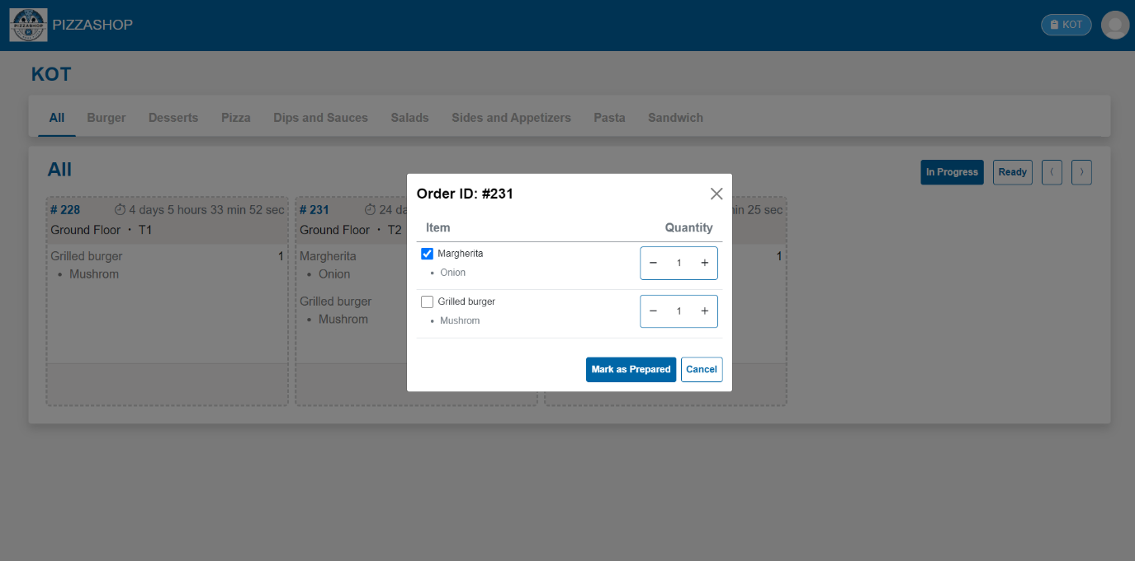Fig. Mark as prepared

**Features:**

|  |  |  |  |
| --- | --- | --- | --- |
| **#** | **Feature** | **Type** | **Description** |
| 1. | Order ID | Textbox | This will show the Order Id of the customer. |
| 2. | Item | Textbox | This will show the food items ordered by the customer. |
| 3. | Quantity | Button | This will show the quantity of items ordered. |
| 4. | Mark as prepared | Button | If the food item is prepared and ready to serve the by clicking this it’s status will be changed from In Progress to Ready. It should be removed from In Progress and added to Ready. |
| 5. | Cancel | Button | This will discard any changes made by the user and close the popup. |
| 6. | X | Button | This will close the popup. |

In the **All** menu the chef can mark all the food items or selected food items to Prepared but they can mark the food items as Prepared as per the category individually as well as shown in the below image.

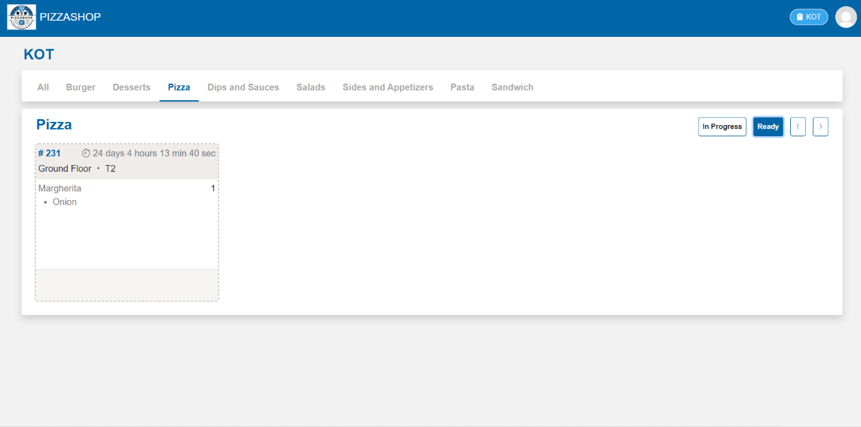Fig. Mark food item as prepared by category

After marking the food items as prepared by clicking on the **Mark as prepared** button the status of the food item will be changed from **In Progress** to **Ready** as highlighted in the below image.

The food items should be removed from In Progress and added to the Ready.

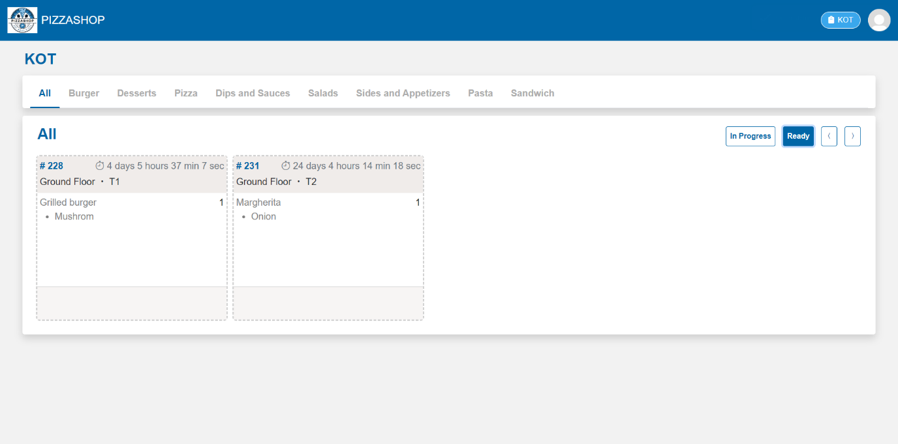Fig. Food Item card in Ready Status

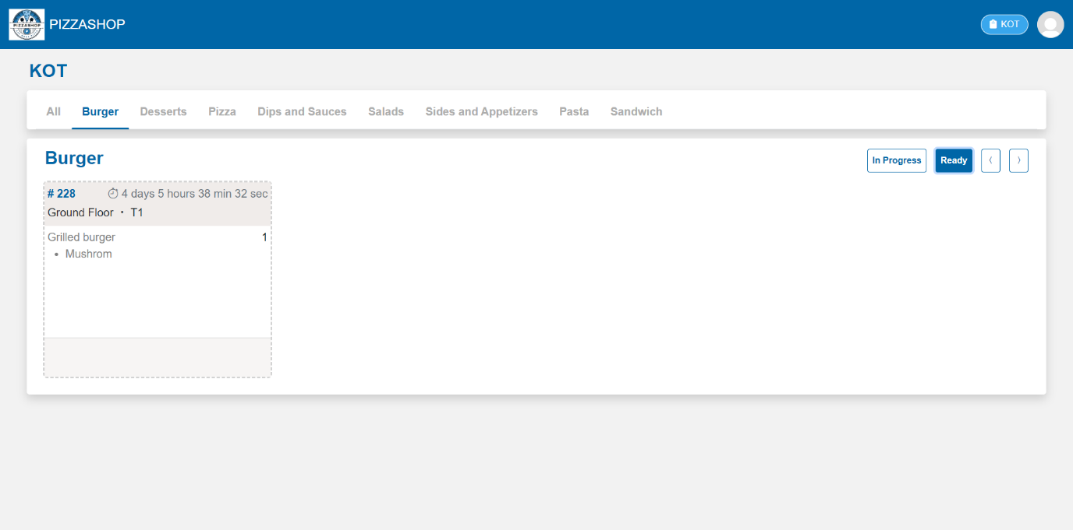Fig. Food Item card in Ready state according to the category

* There is a functionality that allows the chef to revert food items back to "In Progress" if they were mistakenly marked as "Prepared." By clicking on the food item card in the "Ready" state, a popup will appear, allowing the Account Manager to move the item back to "In Progress."

By clicking on the **Mark as in progress** it will add to the In Progress Status.

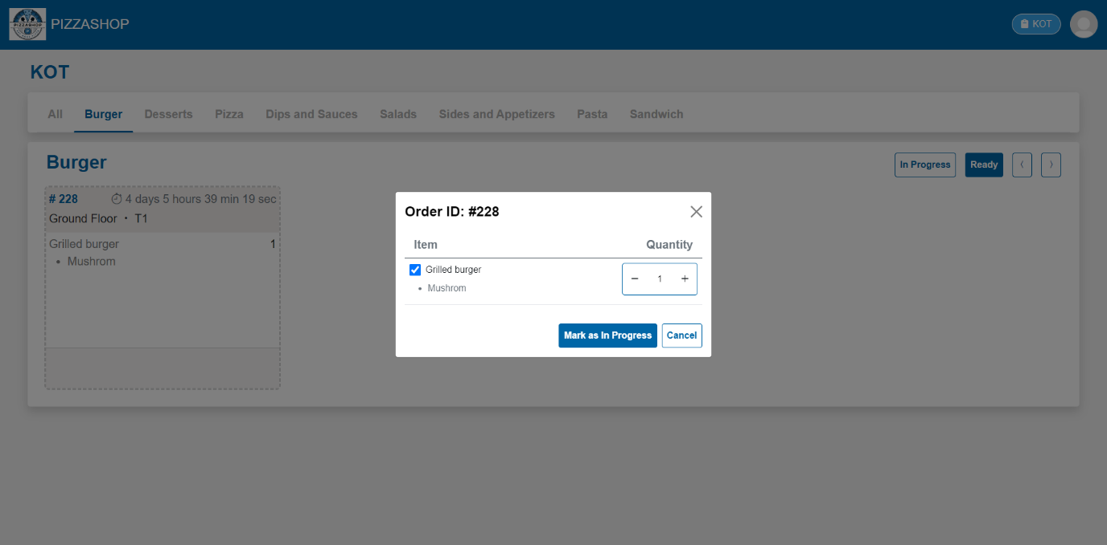Fig. Mark as in progress

Food items will be added in the **In Progress** Status as shown in the below image.

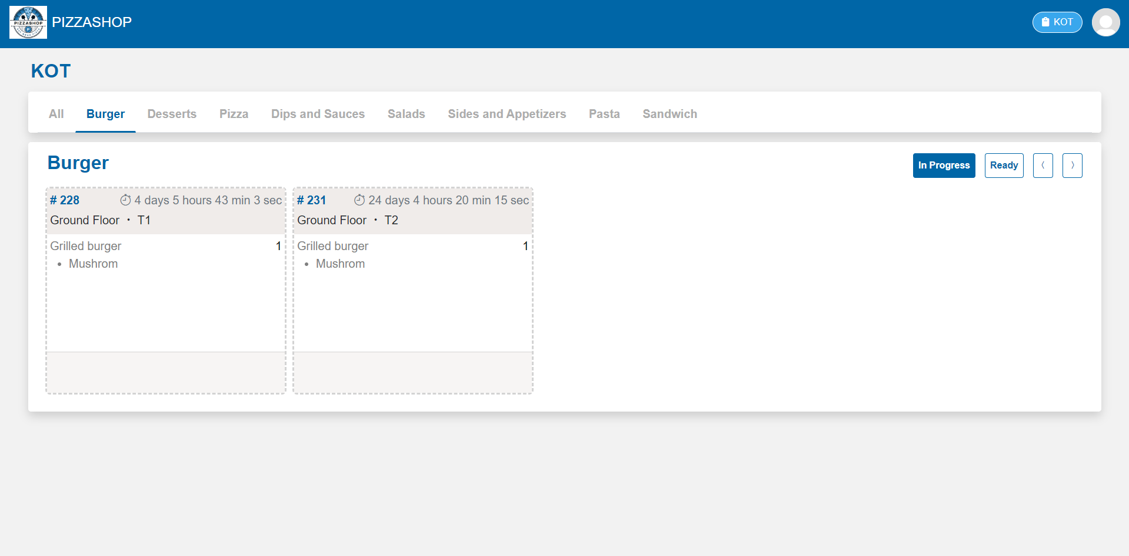 Fig. Food Items are added in In Progress